INTERIM RECOVERY PLAN NO. 109

Lesueur-Coomallo Floristic Community D1

Interim Recovery Plan

2002-2007

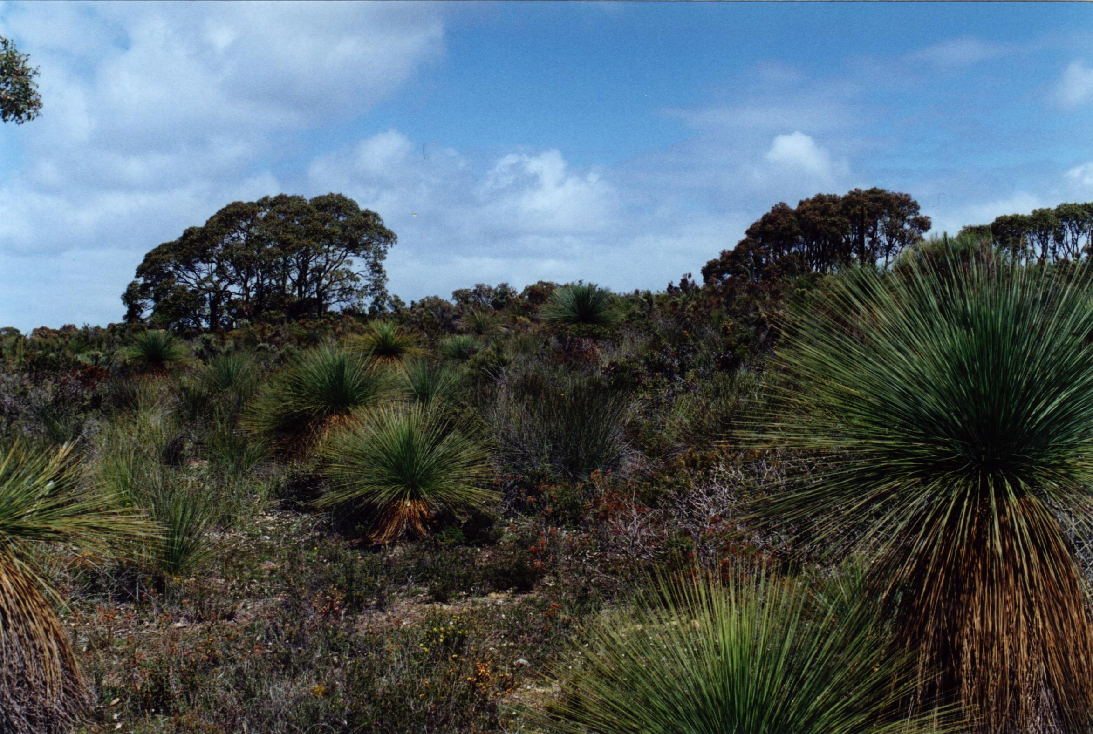
Sheila Hamilton-Brown

Photograph: Sheila Hamilton-Brown

July 2002

Department of Conservation and Land Management
Western Australian Threatened Species and Communities Unit
PO Box 51, Wanneroo, WA 6946

  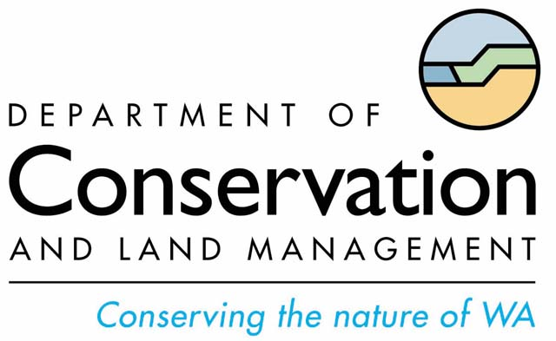 |  | 

FOREWORD

Interim Recovery Plans (IRPs) are developed within the framework laid down in Department of Conservation and Land Management (the Department) Policy Statements Nos. 44 and 50.

IRPs outline the recovery actions that are required to urgently address those threatening processes most affecting the ongoing survival of threatened taxa or ecological communities, and begin the recovery process.

The Department is committed to ensuring that Critically Endangered, and where appropriate and feasible, other threatened ecological communities are conserved through the preparation and implementation of Recovery Plans or Interim Recovery Plans and by ensuring that conservation action commences as soon as possible and always within one year of endorsement of that rank by the Minister.

This Interim Recovery Plan will operate from July 2002 to June 2007 but will remain in force until withdrawn or replaced. It is intended that, if the ecological community is still ranked Critically Endangered, this IRP will be reviewed after five years and the need for a full Recovery Plan assessed.

This IRP was approved by the Director of Nature Conservation on 24 September 2002. The provision of funds identified in this Interim Recovery Plan is dependent on budgetary and other constraints affecting the Department, as well as the need to address other priorities.

Information in this IRP was accurate at July 2002.

SUMMARY

Name: Lesueur-Coomallo Floristic Community D1

Description: This community comprises a species-rich low heath, on moderately to well-drained lateritic gravels on lower slopes and low rises, dominated by Allocasuarina microstachya with A. ramosissima, A. humilis, Baeckea grandiflora, Borya nitida, Calytrix flavescens, Calothamnus sanguineous, Conostylis androstemma, Cryptandra pungens, Dryandra armata, Gastrolobium polystachyum, Hakea auriculata, H. incrassata, H. aff. erinacea, Hibbertia hypericoides, Hypocalymma xanthopetalum, Melaleuca trichophylla, Petrophile chrysantha, Schoenus subflavus and Xanthorrhoea drummondii.

IBRA Bioregion: Geraldton Sandplains

Department of Conservation and Land Management: Midwest Region

Department of Conservation and Land Management District: Moora

Recovery Team: Moora District Threatened Flora Recovery Team

Current status: This community was assessed by the Threatened Ecological Communities’ Scientific Committee on the 28 July 2000 as Critically Endangered; this status was endorsed by the Minister for the Environment and Heritage on 6 November 2001.

Critical habitat: The area of occupancy of the known occurrence corresponding to moderately to well-drained lateritic gravels on lower slopes and low rises of the Banovich Uplands.

IRP Objective(s): To maintain the overall health of the community and reduce the level of threat (by negotiating with the landholder to protect the remnant or acquiring the land parcel for the conservation estate) to prevent the community becoming extinct.

Criteria for success:
1. Maintenance of the diversity and composition of the native species in the community.
2. A conservation covenant, management agreement or acquisition of the whole land parcel or the occurrence with a buffer.
3. Improvement in terms of reduction of threatening processes as defined in this document.

Criterion for failure:
Loss or modification of the threatened ecological community.

Summary of recovery actions for the Lesueur-Coomallo Floristic Community D1.

1. Seek to acquire the land parcel for the conservation estate | 8. Liaise with owner and surrounding landholders to manage their properties in ways sympathetic to the community
2. Locate further occurrences | 9. Monitor Phytophthora spp. disease and assess the need for disease treatment
3. Monitor the boundary of the community | 10. Design and implement weed management program
4. Obtain biological and ecological information of the components of the community | 11. Implement replanting and rehabilitation where necessary
5. Design and implement a flora monitoring program | 12. Prepare and implement appropriate fire management plans
6. Preserve genetic material of the community | 13. Nominate the TEC under the Commonwealth EPBC Act (1996)
7. Investigate the feasibility of translocating the TEC; if feasible design a translocation program

1 BACKGROUND

History, defining characteristics of ecological community, and conservation significance
The Lesueur-Coomallo area has long been known to be ''an area of outstanding flora conservation values, complex geological features and unusually rugged terrain in the otherwise subdued landforms of the northern kwongan region'' (Burbidge and van Leeuwen 1990). It ranks as one of the three most important areas for flora conservation in southwest Western Australia (Burbidge et al. 1990).

Griffin et al. (1983) identified the Lesueur-Coomallo area as floristically distinctive and diverse compared to other areas of the northern kwongan region. Within the Lesueur-Coomallo area, Griffin and Hopkins (1990) identified 11 distinct floristic sub-types which are geographically identifiable and can be related to specific geological substrates and soil erosional processes. They concluded that gravel heath was a minor component of the area (Griffin and Hopkins 1990).

Martinick and Associates (1989) produced a detailed vegetation map of much of the Lesueur-Coomallo area. They mapped 64 floristic communities, distinguished on the basis of soils, landforms and indicator species, and observed that gravel heath floristic type D (Allocasuarina microstachya Heath D1) only occurred on one site in the Lesueur-Coomallo region.

Being small and the only known occurrence, this community is particularly valuable, and is under threat from plant disease, indirect effects of mining, inappropriate fire regime and weed invasion.

Description of Occurrences
Lesueur-Coomallo Floristic Community D1 is only known from one 0.1 ha occurrence on private freehold land immediately adjacent (south) to Lesueur National Park in the Shire of Dandaragan.

Critical Habitat
Critical habitat is habitat identified as being critical to the survival of a listed threatened species or listed threatened ecological community. Habitat is defined as the biophysical medium or media (a) occupied (continuously, periodically or occasionally) by an organism or group of organisms; or (b) once occupied (continuously, periodically or occasionally) by an organism, or group of organisms, and into which organisms of that kind that the potential to be reintroduced (sections 207A and 528 of Commonwealth Environment Protection and Biodiversity Conservation Act 1999 (EPBC Act)).

The critical habitat for the Lesueur-Coomallo Floristic Community D1:
- the area of occupancy of the known occurrence
- moderately to well-drained lateritic gravels
- lower slopes and low rises of the Banovich Uplands.

Biological and ecological characteristics
The floristic composition of the heath community is assumed to correspond to the soil/substrate types and depths. Very little is known of the biology and ecology of the community and its components – particularly in response to fire and disease, and research on such matters is a priority in this IRP.

Threatening processes

Mining
Currently there is a proposal to mine coal by open cut mining techniques being assessed by the Environmental Protection Authority (in accordance with the Environmental Protection Act 1986) for this land parcel. The threatened ecological community (TEC) lies approximately 100 metres east of the proposed mining area. If mining were to go ahead, the introduction and spread of disease, altered hydrology, dust and road widening are concerns for the conservation of the TEC (A. Burbidge, personal communication).

- Mining activities are likely to change surface water flows in an area substantially larger than the mining area and are likely to affect ground water flows. The soil profiles in the Lesueur-Coomallo area are known to contain substantial amounts of salt. Mining may also promote acid mine drainage which would be likely to have negative impacts on the native vegetation.

- Dust from mining activities may disperse beyond the mine site and settle on the native vegetation. This may cause damage to the leaf surfaces and restrict evapotranspiration. The dust may also contain nutrients that will alter the nutrient status of the native vegetation - well adapted to low nutrient soils and adversely affected by nutrient inputs - or may contain minerals that may have detrimental effects on the plant.

- To accommodate mining equipment and vehicles, road building may remove some of the TEC. It may also increase water run-off and dust.

Disease
Dieback disease caused by the Phytophthora spp. plant pathogens is a serious threat as there are a high number of susceptible species in and surrounding the TEC (G. Keighery, personal communication). Phytophthora citricola occurs in Lesueur National Park (Mills 1992) to the north of the land parcel, while three other species of Phytophthora, including the virulent P. cinnamomi, are known from within 30 km of the Park (A. Burbidge, personal communication). These plant pathogens, which cause the roots to rot and results in death from drought stress, are commonly introduced and spread in infected soil, mud and gravel carried on the wheels and underside of vehicles; and mud on walking shoes/boots. There are currently no hygiene measures for this land parcel.

Other disease-causing pathogens such as Armillaria luteobubulina and the canker-causing fungus Botryosphaeria ribis are known from the northern kwongan and have the potential to cause significant problems in the native vegetation. Botryosphaeria ribis has been found in cankers of Banksia attenuata and Banksia menziesii on the gravel road that runs adjacent (east) to the land parcel (Shearer and Batini 1990). This road is likely to be the main access road to the mine site.

Clearing
Clearing for agriculture in the Shire of Dandaragan has been extensive but there is approximately 49% of vegetation remaining (D. Shepherd, personal communication). Although more than 20% of the original vegetation remains, any proposals to clear the TEC and/or the surrounding vegetation would be subject to assessment in accordance with the Memorandum of Understanding for the protection of remnant vegetation on private land in the agricultural region of Western Australia (Government of Western Australia 1997).

Weed invasion
Weeds can have significant impacts on a community through competition with the native species, prevention of regeneration and alteration of fire regimes (Hobbs and Mooney 1993). Disturbances such as fires, grazing and death through disease can predispose areas to weed invasion if weed propagules are present. At present there is no weed invasion in the TEC, but if mining does go ahead, there is an increased risk of introduction.

Altered fire regimes
Increased frequency of fire can change the species composition by increasing the number of weeds and by preventing some species from completing growth and reproductive cycles: Petrophile chrysantha and Hakea erinacea have been identified as vulnerable species affected by frequent fire (Department of CALM 1990). The risk of fire is increased by fuel build-up, and human activity in the increasingly popular Lesueur National Park increases the risk of more frequent fires.

Guide for decision-makers
Section 1 provides details of current and possible future threats. Developments in the immediate vicinity of the occurrences require assessment. No developments should be approved unless the proponents can demonstrate that they will have no significant impact on the ecological community.

Current status
The ‘Lesueur-Coomallo Floristic Community D1’ community meets the following criteria for Critically Endangered (CR) ecological communities:

B) Current distribution is limited, and
(i) geographic range and/or number of discrete occurrences, and/or area occupied is highly restricted and the community is currently subject to known threatening processes which are likely to result in total destruction throughout its range in the immediate future (within approximately 10 years)
(ii) there are very few occurrences, each of which is small and/or isolated and extremely vulnerable to known threatening processes.

Recovery strategy
To conduct appropriate research into the ecological characteristics of the community to develop further understanding about the management actions required to maintain or improve its condition.

2 RECOVERY AIM AND CRITERIA
- To seek appropriate management of the TEC.
- To improve its status by protecting and maintaining the only known occurrence, and reducing the level of threat as defined in this document.
- To locate more occurrences and promote their protection, maintenance and recovery.

Criteria for success
- Maintenance of the diversity and composition of the native species in the community.
- A conservation covenant, management agreement or acquisition of the whole land parcel or the occurrence with a buffer.
- Improvement in terms of reduction of threatening processes as defined in this document.

Criterion for failure
- Loss or modification of the TEC.

RECOVERY ACTIONs

3.1 Existing Recovery Actions
The Moora District Threatened Flora Recovery Team (MTFRT) is the recovery team for this TEC and will continue to report annually to the Department's Corporate Executive.

The Department has already written to the Environmental Protection Authority opposing the mining proposal on the land parcel in accordance with the Environmental Protection Act 1986.

3.2 Recommended Recovery Actions
The following recovery actions are roughly in order of descending priority; however this should not constrain addressing any of the priorities if funding is available for ′lower′ priorities and other opportunities arise.

3.2.1 Seek to acquire the land parcel for the conservation estate
To secure the long-term recovery of this community, the Department will liaise with the landowner and seek to acquire the land parcel and add it to Lesueur National Park. Alternatively, the Department will seek to acquire the occurrence with a buffer and corridor that directly links to the park.

Responsibility: WA Threatened Species and Communities Unit (WATSCU), Moora District and Land Administration Section
Estimated cost: WATSCU, Moora District and Land Administration Section to negotiate costs on a market/valuation basis
Completion date: On-going.

3.2.2 Locate further occurrences
It is possible that other occurrences occur on private land. The best quality colour aerial photographs (stereoscopic pairs) may assist in selecting likely sites, as would geological and soil maps. Newspaper articles and other publicity campaigns may also aid in locating further occurrences.

Responsibility: MTFRT
Estimated cost: $3,000 p/a
Completion date: Year 2.

3.2.3 Monitor the boundary of the community
The boundary of the occurrences should be monitored regularly and can be determined from current aerial photographs and annual ground-truthing. This information should be added to the TEC database as recommended in English and Blyth (1999).

Responsibility: WATSCU and Moora District through the MTFRT for initial monitoring; the MTFRT for subsequent years
Estimated cost: $600 for the initial monitoring ($550 per year for subsequent monitoring)
Completion date: Ongoing.

3.2.4 Design and implement a flora monitoring program
Data collected will include plant species diversity, species richness and weed levels. The occurrence should be monitored regularly to provide information on condition. The program will include installing a baseline permanent quadrat and establishing photopoints and photoplots (Elzinga et al. 2001). This information will be added to the TEC database.

Responsibility: WATSCU and Moora District through the MTFRT
Estimated cost: $500 for the design, $1000 p/a for the implementation
Completion date: Year 1 for the design, ongoing for the implementation.

3.2.5 Obtain biological and ecological information of the components of the community
Research designed to increase an understanding of the biology of the species comprising the community will provide a scientific base for management in the wild. Research will include:

- Study of the soil seed bank dynamics and the role of various factors (disturbance, competition, rainfall and grazing) in recruitment and seedling survival.
- Seed germination requirements.
- Quantification of level of seed predation or removal of seed.
- Determination of reproductive strategies, phenology and seasonal growth.
- Factors determining level of flower and fruit abortion.
- Investigation of population genetic structure, levels of genetic diversity and minimum viable population size.
- Effects of weeds on recruitment and establishment.
- Response to herbicide treatments.
- Response to fire.
- Response to infection (in particular Phytophthora spp.) particularly at different stages of their life-cycles.

Responsibility: Moora District through the MTFRT in liaison with Science Division
Cost: $20,000 p/a
Completion date: Ongoing.

3.2.6 Preserve genetic material of the community
It is necessary to store germplasm as a genetic resource, ready for use in translocations and as an ex situ genetic ‘blueprint’ of plant components of the TEC. The germplasm stored will only comprise seed material. All species should be collected.

If it is not possible to collect adequate quantities of viable seed from each taxon in the TEC, then the material will be taken from surrounding areas to preserve local provenance. If not possible, other methods of germplasm storage will be investigated, such as living collections grown from cutting material.

Responsibility: WATSCU and Moora District through the MTFRT in liaison with the Threatened Flora Seed Centre
Estimated cost: $3000 per species
Completion date: Ongoing.

3.2.7 Investigate the feasibility of translocating the TEC; if feasible, design a translocation program
In the event that the TEC is likely to be cleared, investigate the feasibility of translocating the TEC into another site – either an extinct occurrence or with very similar non-biological conditions – and, if feasible, design a translocation plan.

Responsibility: WATSCU and Moora District through the MTFRT in liaison with the Threatened Flora Seed Centre and Science Division
Estimated cost: $5000 to investigate feasibility; $8000 to design plan
Completion date: Year 5.

3.2.8 Liaise with owner and surrounding landholders to manage their properties in ways sympathetic to the community
Liaise with the owner and surrounding landholders to manage their properties without compromising the conservation values of the TEC, particularly in regard to fire management, disease, weeds and feral animals such as rabbits.

Responsibility: WATSCU and Moora District via the MTFRT
Cost: $2000 p/a
Completion date: Ongoing.

3.2.9 Monitor Phytophthora spp. disease and assess the need for disease treatment
Phytophthora spp. infestations are known in the adjacent Lesueur National Park. Infestations have already been mapped and will be monitored at least every five years in summer with flagging marking the front replaced regularly. Similar measures should be taken with this land parcel identifying infestations within a three kilometre radius. Maintenance of any fire-fighting access tracks in the vicinity of the TEC will be kept to a minimum and conducted in seasons where the risks associated with soil movement are reduced, i.e. summer.

Responsibility: Moora District through the MTFRT
Estimated cost: $1000 per time
Completion date: Every five years.

3.2.10 Prepare and implement appropriate fire management plans
A fire management plan should be developed with landowners and the relevant authorities. The plan should deal with minimising wildfires; the need for, design, position and upgrading of firebreaks/fire-fighting access tracks; fire management (including the need for and design of prescribed fire) and fire suppression. The plan should include an annual fire monitoring and reporting schedule.

Responsibility: Moora District through the MTFRT
Estimated cost: $7,000 for preparation of plan
Completion date: Plan to be completed in Year 1: implementation ongoing.

3.2.11 Design and implement weed management program
If it is determined that weeds are present in the TEC, or in the event of any weed invasion, a weed control strategy is required that takes into account the nature of the community and the need for continuing maintenance. The weed management program should involve (adapted from Panetta and Hopkins 1991):

- Identifying and mapping the weed species
- Investigating the effects of herbicide on the native species
- Eradicating weeds with the selection of the appropriate herbicide
- The control of invasive weeds by hand or spot spraying as soon as the weeds emerge.

Responsibility: Moora District through the MTFRT
Estimated cost: $2000 for the design
Completion date: Ongoing.

3.2.12 Implement replanting and rehabilitation where necessary
Seek to replant and rehabilitate occurrences that have suffered disturbance – due to weed control as part of recovery action 3.2.11, fire or other disturbance. The appropriate species can be identified from plot data held in Martinick and Associates (1989) or from flora monitoring (recovery action 3.2.4). These should then be propagated from material collected within the TEC (recovery action 3.2.6) or from surrounding areas to preserve local provenance.

Responsibility: Moora District through the MTFRT
Estimated cost: MTFRT to determine costs
Completion date: Ongoing.

3.2.13 Nominate the TEC under the Commonwealth EPBC Act (1996).
To further secure the TEC, the TEC should be nominated to the Commonwealth for listing under the Environment Protection and Biodiversity Conservation Act 1999 (EPBC Act)).

Responsibility: WATSCU with support from the Moora District and the Midwest Region.
Estimated cost: $150
Completion date: Year 1.

4 Term of Plan
This IRP will operate from August 2002 for 5 years but will remain in force until withdrawn or replaced.

5 ACKNOWLEDGMENTS
The following people provided valuable advice and assistance in the preparation of this Interim Recovery Plan:

Mr John Blyth Acting Manager, WATSCU, Department of Conservation and Land Management
Mr Angas Hopkins Principal Research Scientist, Department of Conservation and Land Management
Information Management Branch for mapping the Lesueur-Coomallo units.

6 REFERENCES

Burbidge, A. A. and van Leeuwen, S. (1990). The Hill River Project and the proposed conservation reserve at Lesueur. A report to the Environmental Protection Authority from the Department of Conservation and Land Management. Occasional Paper 1/90. Department of Conservation and Land Management.

Burbidge, A. A., Hopper, S. D. and van Leeuwen, S. (1990). Nature Conservation, Landscape and Recreation values of the Lesueur Area. A report to the Environmental Protection Authority from the Department of Conservation and Land Management. Bulletin 424, Environmental Protection Authority, Perth.

Department of Conservation and Land Management (1990). Moora District Dieback Protection Plan, 1990-1994.

Elzinga, C.L., Salzer, D.W., Willoughby, J.W. and Gibbs, J.P. (2001). Monitoring Plant and Animal Populations. Blackwell Science Inc: USA.

English, V. and Blyth, J. (1999). Development and application of procedures to identify and conserve threatened ecological communities in the South-west Botanical Province of Western Australia. Pacific Conservation Biology 5: 124-138.

Government of Western Australia (1997). Memorandum of Understanding between the Commissioner of Soil and Land Conservation, Environmental Protection Authority, Department of Environmental Protection, Agriculture Western Australia, Department of Conservation and Land Management, Water and Rivers Commission for the protection of remnant vegetation on private land in the agricultural region of Western Australia. Western Australian Department of Agriculture, Perth.

Griffin, E. A. and Hopkins, A. J. M. (1990). Vegetation. In: Burbidge, A. A., Hopper, S. D. and van Leeuwen, S. (eds.). Nature Conservation, Landscape and Recreation values of the Lesueur Area, pp. 25-38. A report to the Environmental Protection Authority from the Department of Conservation and Land Management. Bulletin 424, Environmental Protection Authority, Perth.

Griffin, E. A., Hopkins, A. J. M and Hnatiuk, R. J. (1983). Regional variation in Mediterranean-type shrublands near Eneabba, south-western Australia. Vegetatio 52, 103-127.

Hobbs, R. J. and Mooney, H. A. (1993). Restoration ecology and invasions. In Saunders, D. A., Hobbs, R. J. and Ehrlich, P. R. (eds). Nature Conservation 3: Reconstruction of Fragmented Ecosystems, pp 127-133. Surrey Beatty and Sons: NSW.

Martinick, W. G. & Associates Pty Ltd. (1989). Hill River Project Biological Studies: Vegetation of the Project Area in a Regional Context. Unpublished Report.

Mills, C. H. (1992). The Northern Sandplains Dieback Working Party. In: Freeman, M. J., Hart, R. and Ryall, M. (eds.). Dieback – What if the Future? The Northern Sandplains Dieback Working Party: Perth.

Panetta, F. D. and Hopkins, A. J. M. (1991). Weeds in Corridors: Invasion and Management. In Saunders, D.A. and Hobbs, R.J. (eds.) Nature Conservation 2: The Role of Corridors, pp. 341-51, Surrey Beatty & Sons: NSW.

Shearer, B. F. and Batini, F. E. (1990). Phytophthora and other fungal plant diseases. In: Burbidge, A. A. and van Leeuwen, S. (eds.). The Hill River Project and the proposed conservation reserve at Lesueur. pp43-48. A report to the Environmental Protection Authority from the Department of Conservation and Land Management. Occasional Paper 1/90. Department of Conservation and Land Management.

Summary of costs for each Recovery Action

Recovery action | Year 1 | Year 2 | Year 3 | Year 4 | Year 5
Seek to acquire the land parcel for the conservation estate | Market /valuation basis
Locate further occurrences | $3000 | $3000 | - | - | -
Monitor the boundary of the community | $600 | $550 | $550 | $550 | $550
Obtain biological and ecological information of the components of the community | $20000 | $20000 | $20000 | $20000 | $20000
Design and implement a flora monitoring program | $1500 | $1000 | $1000 | $1000 | $1000
Preserve genetic material of the community | $3000 per species
Investigate the feasibility of translocating the TEC; design a translocation program | - | - | - | - | $13000
Liaise with owner and surrounding landholders to manage their properties in ways sympathetic to the community | $2000 | $2000 | $2000 | $2000 | $2000
Monitor Phytophthora spp. disease and assess the need for disease treatment | $1000 | - | - | - | $1000
Design and implement weed management program | $2000 | * | * | * | *
Implement replanting and rehabilitation where necessary | * | * | * | * | *
Prepare and implement appropriate fire management plans | $7000 | * | * | * | *
Nominate the TEC under the Commonwealth EPBC Act (1996) | $150

* Body responsible for the action to determine costs

Dr Andrew Burbidge – Deputy Director Biodiversity Conservation, Department of Conservation and Land Management, P.O. Box 51, Wanneroo 6946.
Mr Greg Keighery - Principal Research Scientist, Department of Conservation and Land Management, P.O. Box 51, Wanneroo 6946.
Mr Damian Shepherd, Research Officer, Agriculture WA, 3 Baron-Hay Court, South Perth.

