INTERIM RECOVERY PLAN NO. 47

Acacia rostellifera low forest with scattered Eucalyptus camaldulensis on Greenough River Alluvial Flats

Interim Recovery Plan
1999-2002

by
Sheila Hamilton-Brown and John Blyth

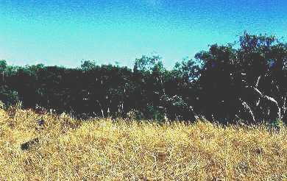
Photograph: Sheila Hamilton-Brown

May 1999

Department of Conservation and Land Management
Western Australian Threatened Species and Communities Unit
PO Box 51, Wanneroo, WA 6946

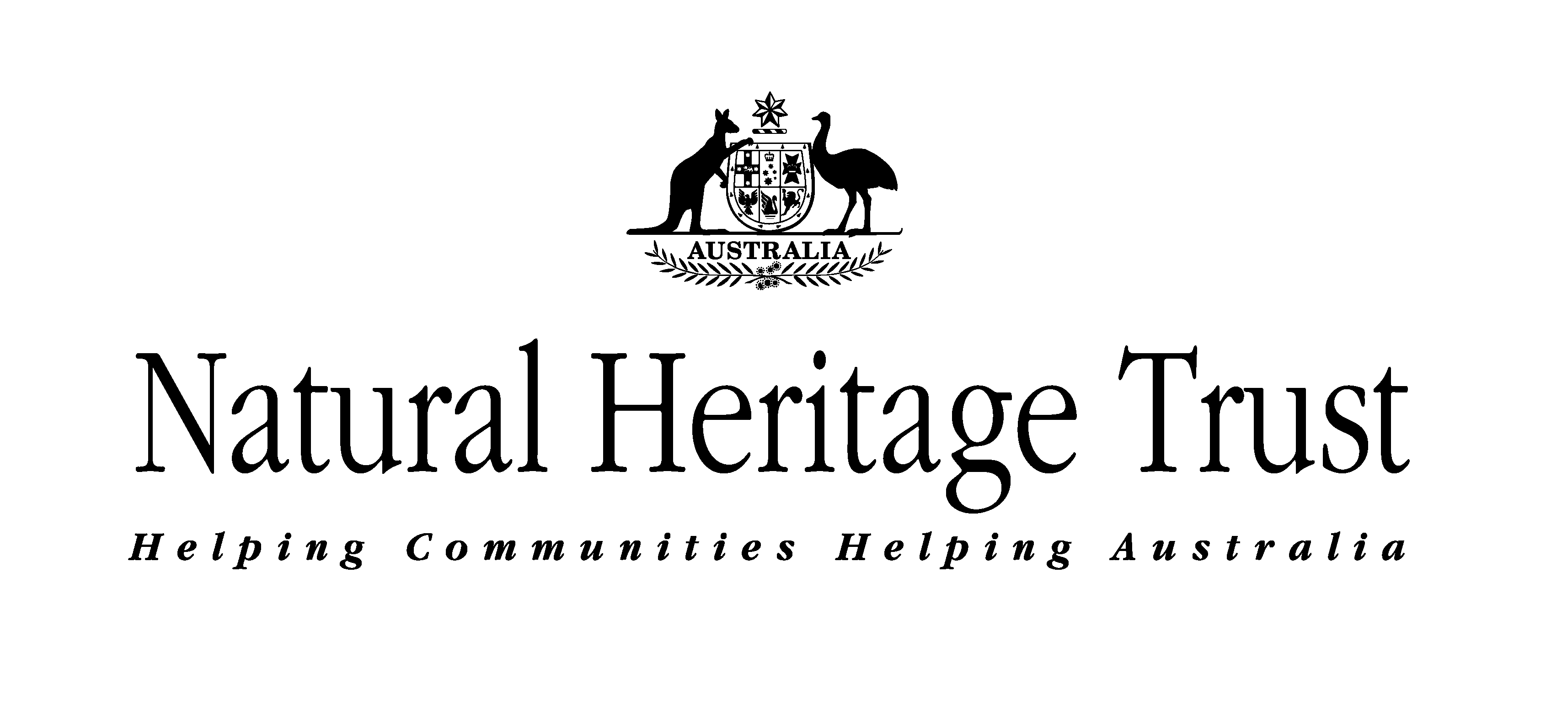 | Department of Conservation and Land Management
FOREWORD

Interim Recovery Plans (IRPs) are developed within the framework laid down in Department of Conservation and Land Management (CALM) Policy Statements Nos 44 and 50

IRPs outline the recovery actions that are required to urgently address those threatening processes most affecting the ongoing survival of threatened taxa or ecological communities, and begin the recovery process.

CALM is committed to ensuring that Critically Endangered ecological communities are conserved through the preparation and implementation of Recovery Plans or Interim Recovery Plans and by ensuring that conservation action commences as soon as possible and always within one year of endorsement of that rank by CALM's Director of Nature Conservation.

This Interim Recovery Plan will operate from 26 November 1999 but will remain in force until withdrawn or replaced. It is intended that, unless the ecological community is no longer threatened with total destruction, this IRP will be replaced by a full Recovery Plan after three years.

The provision of funds identified in this Interim Recovery Plan is dependent on budgetary and other constraints affecting CALM, as well as the need to address other priorities.

Information in this IRP was accurate at 31 May 1999.

SUMMARY
Name: Acacia rostellifera low forest with scattered Eucalyptus camaldulensis on Greenough River Alluvial Flats.

Description: 2 sub-communities:
Front Flats - Acacia rostellifera and Melaleuca sp. thickets with scattered Eucalyptus camaldulensis over an understorey that includes Drosera bulbosa, Hypoxis glabella var. leptantha, Wurmbea densiflora, Wurmbea tubulosa, Marsilea drummondii, and Amphibromus nervosus.
Back Flats - Acacia rostellifera thickets with scattered Eucalyptus camaldulensis, Eucalyptus loxophleba and Banksia sp. scrub over an understorey that includes Hypoxis glabella var. leptantha, Panicum decompositum, Rhodanthe chlorocephala, Schoenus verbena, Wurmbea monantha and Amphibromus nervosus.

CALM Region(s): Midwest Region

CALM District(s): Geraldton

Shire(s): Greenough

Recovery Team: A priority in this Interim Recovery Plan.

Current status: Assessed 1 September 1998 as Critically Endangered. Endorsed 6 November 1999.

IRP Objective(s): The restoration or rehabilitation of the known occurrences.

Criteria for success: Successful location, restoration or rehabilitation of one or more occurrences of the community.

Criteria for failure: Loss of area or further modification of the community.

Recovery Actions:

Summary of Recovery Actions for Greenough Alluvial Flats community

Form a Recovery Team
Locate more occurrences
Survey the physical characteristics of all known occurrences
Design and implement weed control strategy
Design and apply appropriate fire management plans
Identify further the original plant species of the community
Investigate the feasibility of restoration of the occurrences and design and implement a program of restoration
Acquire one or more occurrences for the conservation estate

1. BACKGROUND

History, defining characteristics of ecological community, and conservation significance

Lieutenant Grey – who named the Greenough River - came across the fertile alluvial soils of the Greenough Flats in 1837 and sent glowing reports about its suitability as a major grain-growing area. A. C. Gregory surveyed the area in 1851 and described the Greenough Flats - the alluvial plain of the Greenough River between the dunes and hills south of Geraldton - as divided by a limestone hill into two portions: the ‘Front Flats’ that were approximately 35,000 ha and the larger ‘Back Flats’ that were about 100,000 ha. Agricultural and social activities have since transformed the landscape of Greenough Flats after settlement in the 1850s and it is believed to have been more or less completely cleared by the end of the century (Beard and Parker 1976; O’Connor 1997).

When Beard attempted to map (1:250,000) the vegetation of the Greenough alluvial flats in 1976, he could not find a trace of the original structure of the plant community of either the ‘Front’ or ‘Back Flats’. By using his knowledge of other nearby alluvial flats, the occasional scattered plants remaining on the Greenough Flats and anecdotal information from local inhabitants, he attempted to describe the original plant community type. He mapped it as a very open woodland of Eucalyptus camaldulensis over dense stands of Acacia rostellifera with Melaleuca rhaphiophylla, Melaleuca lanceolata and Eucalyptus obtusiflora as associated species on the ‘Front Flats’; and patches of Eucalyptus loxophleba and Banksia scrub on the ‘Back Flats’ (Beard and Parker 1976).

To date, only three small occurrences are known – two on the Front Flats and one on the Back Flats. In a Shire that is more than 86% cleared (F. Armstrong, personal communication) and with the community almost completely destroyed, the ecological as well as historical significance of any remnant of this plant community is self-evident.

Extent and location of occurrences

All known occurrences are privately owned plots, located in the Shire of Greenough, surrounded by cleared agricultural land. Two of these (one each of Front and Back Flats) are located not more than 50 m from the Greenough River whilst the other is approximately in the middle of the Front Flats (Table 1).

Table 1: Summary of occurrence information and threats

Occurrence Number and location | Land Status | Estimated area of occurrence (ha) | Condition | Threats
1. (Front), Shire of Greenough | Private land | 1 | Highly modified | weeds, fire and chemical drift
2. (Front), Shire of Greenough | Private land | 0.2 | Completely modified | weeds, fire and chemical drift
3. (Back), Shire of Greenough | Private land | 1 | Highly modified | weeds, fire and chemical drift

Biological and ecological characteristics

It was thought that the flats were originally lagoons cut off by the sea and then flooded by the river (Bain 1975). Not much is known about the ecological characteristics of the alluvial plain as very little remnant vegetation exists today. The plant community was thought to originally cover the flats, but in pre-European times, it has been suggested that the fire regime of the indigenous Australians had opened up the woodland and the flats were covered with native grasses (M. O’Connor, personal communication).

Historical data from the Royal Botanic Gardens of Melbourne have records of the understorey plants Senna glutinosa subsp. chatelainiana, Stylidium elongatum, Thelymitra antennifera, Thelymitra crinita, Thelymitra macrophylla and Thelymitra pauciflora subsp. pauciflora collected from the Greenough Flats between 1860-80, but the exact location on the flats is unknown (C. Coles, personal communication).

Front Flats

Beard et al. (1976) mapped the Front Flats as very open woodlands of Eucalyptus camaldulensis over dense stands of Acacia rostellifera with Melaleuca rhaphiophylla, Melaleuca lanceolata and Eucalyptus obtusiflora on loamy soils. Occurrence 1 (highly modified) has Eucalyptus camaldulensis over Acacia rostellifera but other associated species have yet to be identified. Occurrence 2 (completely modified) contains the bulbous and grazing tolerant understorey species Drosera bulbosa, Hypoxis glabella var. leptantha, Wurmbea densiflora, Marsilea drummondii, Wurmbea tubulosa (T. Macfarlane, personal communication), the grass Amphibromus nervosus (G. Keighery, personal communication) and a few Acacia rostellifera shrubs.

Back Flats

The Back Flats were structurally very open woodlands of Eucalyptus camaldulensis over dense stands of Acacia rostellifera with patches of Eucalyptus loxophleba and Banksia scrub on sandy clay loam soils (Beard and Parker 1976). Associated understorey plant species collected from the Back Flats include Hypoxis glabella var. leptantha, Panicum decompositum, Rhodanthe chlorocephala, Schoenus verbena, Wurmbea monantha and Amphibromus nervosus (G. Keighery, personal communication). Occurrence 3 on the back flats is highly modified.

Threatening processes

The major threatening processes to the known occurrences are weed invasion, chemical drift, including artificial fertilizers that favour weeds over most native plants, and inappropriate fire regimes.

Current status

The ‘Acacia rostellifera low forest with scattered Eucalyptus camaldulensis on Greenough River Alluvial Flats’ community meets the following criteria for Critically Endangered (CR) ecological communities:

A) The estimated geographic range, and/or total area occupied, and/or number of discrete occurrences since European settlement have been reduced by at least 90%:
i) Geographic range, and/or total area occupied and/or number of discrete occurrences are continuing to decline such that total destruction of the community is imminent (within approximately 5 years).

B) Current distribution is limited:
i) Geographic range and/or number of discrete occurrences, and/or area occupied is highly restricted and the community is currently subject to known threatening processes that are likely to result in total destruction throughout its range in the immediate future (within approximately 5 years).
ii) There are very few occurrences, each of which is small and/or isolated and extremely vulnerable to known threatening processes.

C) The ecological community exists only as highly modified occurrences that may be capable of being rehabilitated if such work begins in the immediate future (within approximately 5 years).

Recovery strategy

To design, in close liaison with landholders, recovery actions for the two known highly modified occurrences, and promote and assist their rehabilitation.

To conduct appropriate research into the ecology of the community to develop further understanding about the management actions required to maintain or improve its condition.

2. RECOVERY AIM AND CRITERIA

Objective

- To improve the status of the plant community of the Greenough Flats by rehabilitating/restoring the two known occurrences that are not completely modified.
- To locate more occurrences and promote their rehabilitation and recovery.

Criteria for success

- Improvement in the condition of the two known extant occurrences of the community measured by a reduction of weed invasion and an increased occurrence (by natural regeneration or reintroduction) of native species.
- The finding of more extant occurrences of the community.

Criterion for failure

- A decline in the conservation status of the community as measured by the condition of known occurrences, and an inability to find other occurrences.

RECOVERY ACTIONS

As all the occurrences occur on land not managed by CALM, land managers will be notified of the importance of the community and their cooperation sought to ensure that on-farm activities do not affect the occurrences. As well, permission and cooperation will be sought from the appropriate land managers prior to any recovery actions being taken.

1. Form a Recovery Team

The Recovery Team will be the main body responsible for overseeing any Recovery Actions. Members of the Recovery team should include an individual from each of the following: the landholders or their representatives, CALM Western Australian Threatened Species and Communities Unit (WATSCU), CALM Midwest Region, CALMScience, Agriculture WA and a local naturalists group. The Recovery Team will report annually to CALM’s Corporate Executive.

Action: Form a Recovery Team
Responsibility: CALM (WATSCU)
Estimated cost: $5,000 per year

2. Locate more occurrences

Field survey is required to try to locate more occurrences of the community. The best quality colour aerial photographs (stereo pairs) may assist in selecting likely sites. An appropriate starting point would be the areas adjacent to the vegetated limestone hills and the coastal area.

About 34% of the remaining 14% of native vegetation in the Greenough Shire is on private land and the local community is unaware of the basic make-up of the Greenough flats as described above (M. O’Connor, personal communication). It is likely that these remnants may contain more occurrences of this community and it is essential that public awareness of it is raised (via newspaper articles, radio programs and field days).

Action: Locate more occurrences
Responsibility: CALM (WATSCU)
Estimated cost: $3,000

Survey the physical characteristics of all known occurrences

To ascertain the exact amount of the Greenough Flats community left, the position, size, boundaries and condition of all known occurrences must be determined.

Action: Survey the physical characteristics of all known occurrences
Responsibility: CALM (WATSCU)
Estimated cost: $1,000

4. Design and implement weed control strategy

As all occurrences are adjacent to cleared farm land and are severely weed infested, a weed control strategy is required that takes into account the modified nature of the community, the probably complex nature of regenerating native plant species and the need for continuing maintenance. The weed control program will involve:

- The selection of an appropriate herbicide after determining which weeds and native species are present.
- The control of invasive weeds by hand or spot spraying as soon as the weeds emerge.

Action: Design and implement a weed control strategy
Responsibility: Landholder and CALM Geraldton District via Recovery Team
Estimated cost: Recovery Team to determine costs.

5. Design and apply appropriate fire management plans

The probability of fire affecting the occurrences is high, therefore, a fire management plan should be developed with landholders and the relevant authorities.

Action: Design and apply appropriate fire management plans
Responsibility: Landholder and CALM Geraldton District via Recovery Team
Estimated cost: Recovery Team to determine costs

6. Identify further the original plant species of the community

The original plant composition of the Greenough flats needs to be clarified. The first step should be to thoroughly survey current occurrences, remnant vegetation on similar landforms in the Shire (to be carried out in spring; that is, peak flowering period). In addition, access to archival material in Kew Gardens should be sought to see if any specimens were collected from the area.

Action: Identify further the original plant species of the community
Responsibility: Landholder and CALM Geraldton District via Recovery Team
Estimated cost: Recovery Team to determine costs

7. Investigate the feasibility of restoration of the occurrences and design and implement a program of re-introduction of component species

Investigate the feasibility of re-introducing the component plant species into the occurrences taking into consideration the change in physical and chemical conditions that may have occurred, and design a translocation plan. If approved, such a plan would include monitoring the success of the program.

Action: Investigate the feasibility of restoration of the occurrences and design and implement a program of re-introduction
Responsibility: Recovery Team
Estimated cost: Recovery Team to determine costs

Acquire one or more occurrences for the conservation estate

To secure the long-term recovery of this community, CALM should liaise with landholders and seek funds to acquire appropriate occurrences.

Action: Acquire one or more occurrences for the conservation estate
Responsibility: CALM
Estimated cost: CALM to negotiate costs.

4 TERM OF PLAN

This Interim Recovery Plan (IRP) will operate from 26 November 1999 but will remain in force until withdrawn or replaced. It is intended that, unless the ecological community is no longer threatened with total destruction, this IRP will be replaced by a full Recovery Plan after three years.

5 ACKNOWLEDGMENTS
Cathryn Coles, Stan Gratt, Len Hamersley, Greg Keighery and Terry Macfarlane provided useful information and comments on this IRP.

6 REFERENCES

Bain, M. A. (1975). Ancient Landmarks, A Social and Economic History of the Victoria districts of Western Australia 1839-1894. University of Western Australia Press: Nedlands.

Beard, J. S. and Parker, A. Z. (1976). Vegetation Survey of Western Australia. The Vegetation of the Dongara Area, Western Australia. 1:250,000 series. Vegmap Publications, Perth.

O’Connor, M. (1997). The historical ecology of Greenough Flats, Western Australia, since 1839: an investigation into the persistence of agriculture in the landscape. Unpublished PhD Thesis proposal for Curtin University.

7 GLOSSARY

Re-introduction: An attempt to establish a population in a site where it formerly occurred, but now is believed to be extinct.

Summary of costs for each Recovery Action

 | Year 1 |  | Year 2 |  | Year 3
Recovery action | NHT* | Other | NHT* | Other | NHT* | Other
1. Form a Recovery Team |  | $5000* |  | $5000* |  | $5000*
2. Locate more occurrences | $1000 |  | $1000 |  | $1000
3. Survey the physical characteristics of all known occurrences | $1000
4. Design and implement weed control strategy |  | *** |  | *** |  | ***
5. Design and apply appropriate fire management plans |  | *** |  | *** |  | ***
6. Identify further the original plant species of the community |  | *** |  | *** |  | ***
7. Investigate the feasibility of restoration of the occurrences and design and implement a program of re-introduction |  | *** |  | *** |  | ***
8. Acquire one or more occurrences for the conservation estate |  | *** |  | *** |  | ***
*Funds the Natural Heritage Trust has already contributed
** In-kind contribution
*** Recovery Team to calculate costs

Fred Armstrong – Agriculture Western Australia. Box 110, Geraldton 6531.
Michael O’Connor – Curtin University of Technology. Kent Street, Bentley 6024.
Cathryn Coles – Royal Botanic Gardens. Birdwood Avenue, South Yarra 3141.
Terry Macfarlane – Department of Conservation and Land Management. Brain Street, Manjimup 6258.
Greg Keighery – Department of Conservation and Land Management. PO Box 51, Wanneroo 6946.

