Map 6. 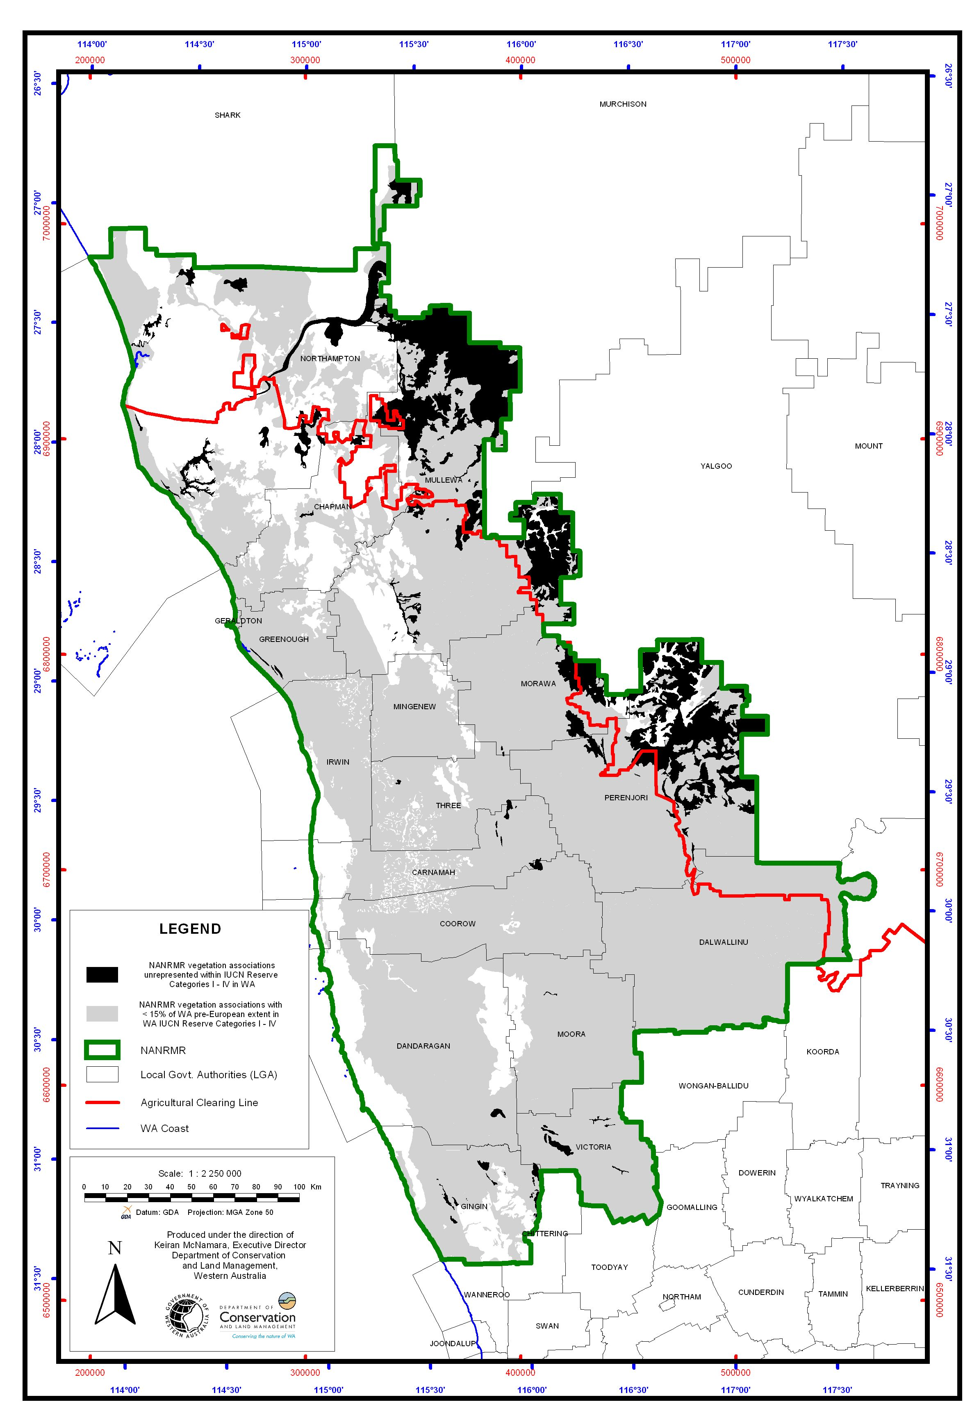Vegetation associations within NAR that are either unrepresented in the State’s IUCN I-IV reserves or have <15% of their State pre-European extent in these reserves. See Tables 8 and 9.

