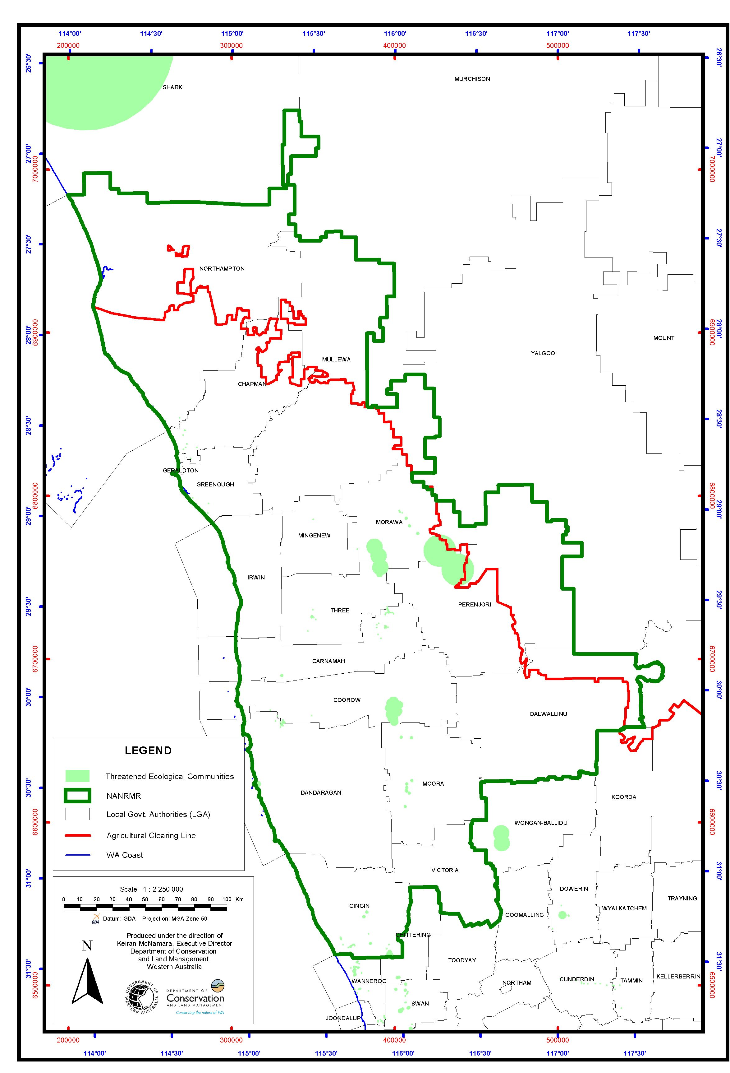
Map 8. The Threatened Ecological Communities (TECs) within or near the NAR boundary. The TEC boundaries are buffered.

