INTERIM RECOVERY PLAN NO. 73

Plant assemblages of the Koolanooka System

Interim Recovery Plan

2000-2003

by

Sheila Hamilton-Brown

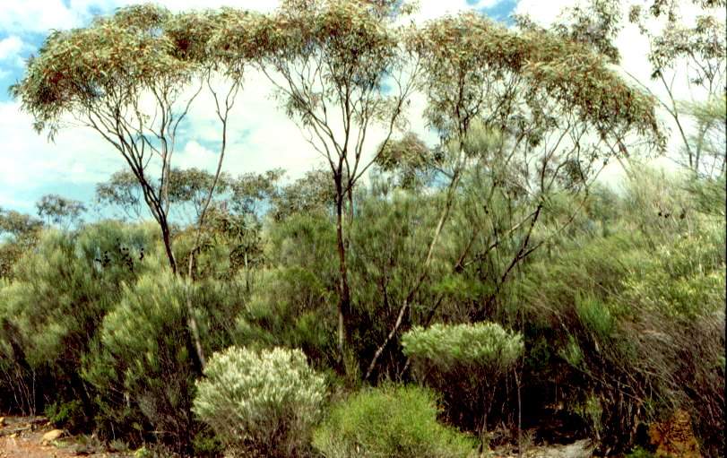

Photograph: Sheila Hamilton-Brown

December 2000

Department of Conservation and Land Management
Western Australian Threatened Species and Communities Unit
PO Box 51, Wanneroo, WA 6946

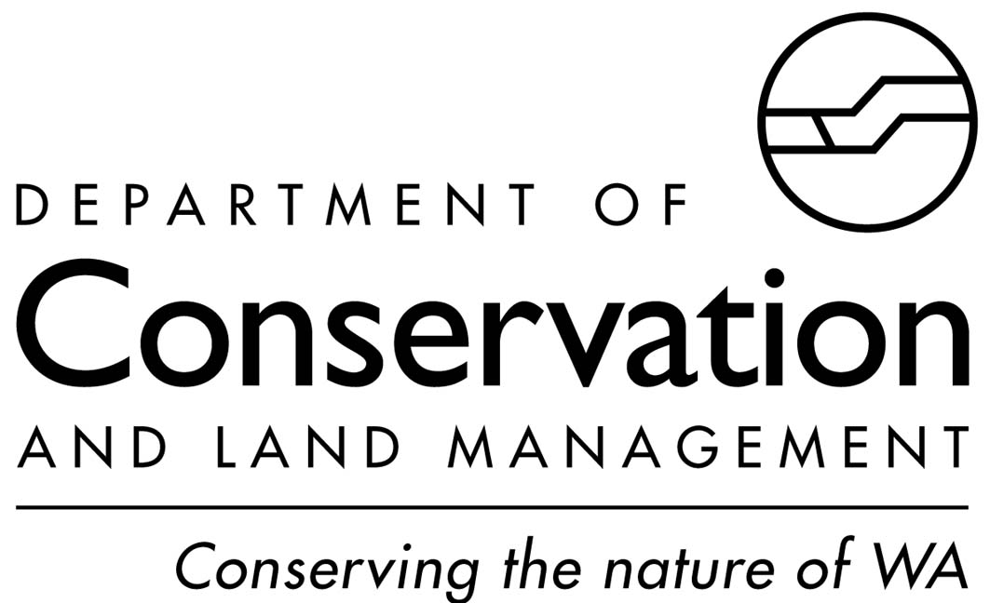 |  | 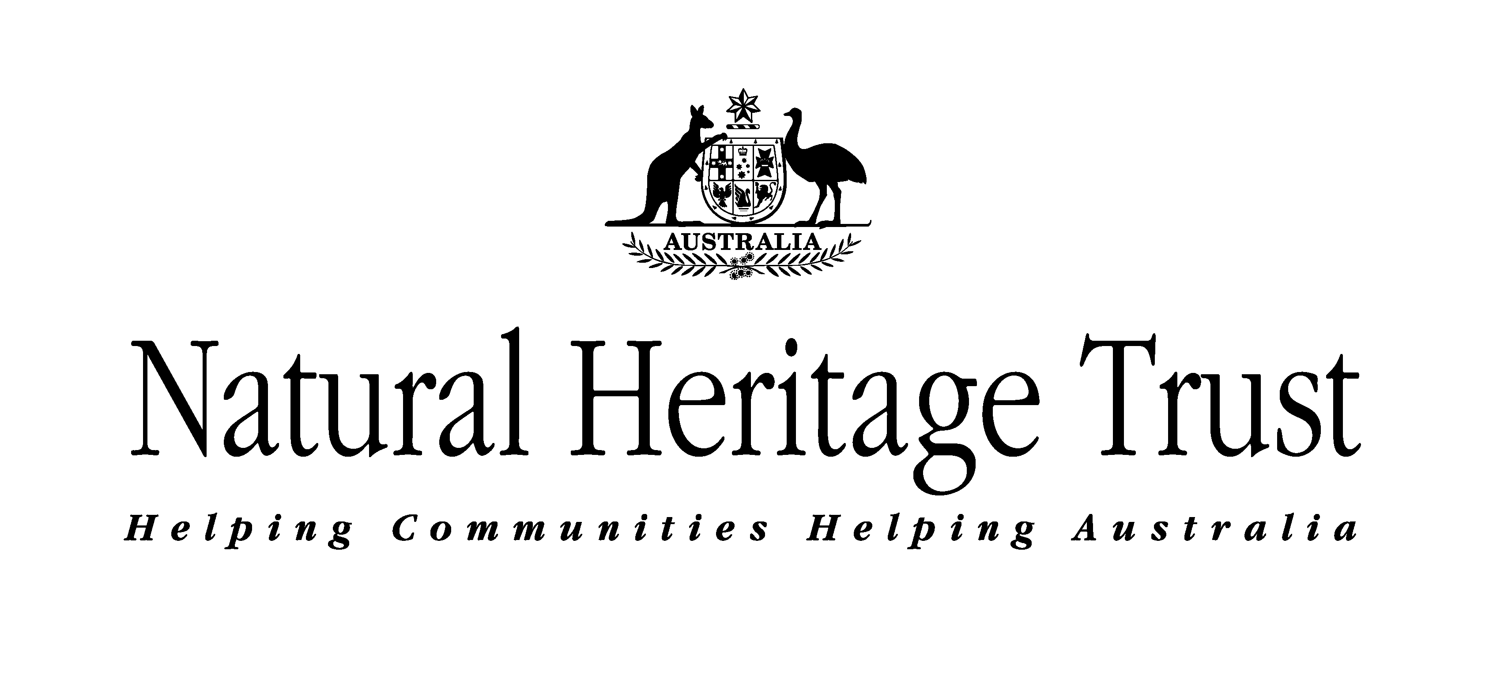

FOREWORD

Interim Recovery Plans (IRPs) are developed within the framework laid down in Department of Conservation and Land Management (CALM) Policy Statements Nos 44 and 50.

IRPs outline the recovery actions that are required to urgently address those threatening processes most affecting the ongoing survival of threatened taxa or ecological communities, and begin the recovery process.

CALM is committed to ensuring that Critically Endangered, and where appropriate and feasible, other threatened ecological communities are conserved through the preparation and implementation of Recovery Plans or Interim Recovery Plans. CALM will also ensure that conservation action commences as soon as possible and always within three years of endorsement of Vulnerable rank by CALM's Director of Nature Conservation.

This Interim Recovery Plan will operate from 4 December 2000 but will remain in force until withdrawn or replaced.

The provision of funds identified in this Interim Recovery Plan is dependent on budgetary and other constraints affecting CALM, as well as the need to address other priorities.

Information in this IRP was accurate at 4 December 2000.

SUMMARY
Name: Plant assemblages of the Koolanooka System.

Description: Plant assemblages of the Koolanooka System (Beard 1976) cover the Archaean metamorphic rocks of the Koolanooka Hills, the surrounding footslopes, and the fork-shaped range to the south-east, referred to in this document as the Perenjori Hills. The plant assemblage comprises Eucalyptus ebbanoensis subsp. ebbanoensis mallee and Acacia sp. scrub with scattered Allocasuarina huegeliana over red loam and ironstone on the upper slopes and summits; Allocasuarina campestris scrub over red loam on hill slopes; shrubs and emergent mallees on shallow red loam over massive ironstone on steep rocky slopes; Eucalyptus loxophleba woodland over scrub on the footslopes; and mixed Acacia sp. scrub on granite.

IBRA Bioregion: Geraldton Sandplains

CALM Region: Midwest Region

CALM District: Geraldton

Shire: Morawa

Recovery Team: Geraldton District Threatened Flora Recovery Team

Current status: Assessed by the TEC Scientific Advisory Committee on 29 October 1999 as Vulnerable. The ranking was endorsed by CALM's Director of Nature Conservation on 24 November 1999.

IRP Objective(s): To maintain the overall health of the community and reduce the level of threat to ensure the community does not move to the Endangered category.

Critical Habitat: The area of occupancy of the occurrences corresponding to the group of Archaean metamorphic rock including banded ironstone as expressed in the Koolanooka Hills, its footslopes and the Perenjori Hills.

Criteria for success: Maintenance of the diversity and composition of the native species in the community and of the full range of its occurrences.

Criteria for failure: An increased level of modification of occurrences of the community as measured by a decline in the diversity and composition of the native species.

Summary of Recovery Actions
- Form a Recovery Team
- Map the components of the community
- Fence occurrences where appropriate
- Monitor the extent and boundaries of the community
- Design and implement a program for flora monitoring
- Liaise with current owners, land managers and other interested groups
- Encourage and assist landowners to utilise incentives and mechanisms for conserving the community
- Design and implement weed control strategy
- Design and apply appropriate fire management plans
- Acquire occurrences for the conservation estate

1 BACKGROUND

History, defining characteristics of ecological community, and conservation significance
The Koolanooka Hills, its footslopes and the fork-shaped range to the south-east, referred to in this document as the Perenjori Hills, are formed of Archaean metamorphic rock including banded ironstone and are highly ferruginous (Baxter and Lipple 1985). They have a particular series of plant communities recurring in a catenary sequence or mosaic pattern linked to topographic, pedological and/or geological features. This catenary sequence or ‘System’ has a distinctive geology, topography and vegetation, different from that of any other comparable system. The Koolanooka Hills, its footslopes and the Perenjori Hills comprise the Koolanooka System (Beard 1976).

The plant community on the Koolanooka and Perenjori hills comprises Eucalyptus ebbanoensis subsp. ebbanoensis mallee and Acacia sp. scrub with scattered Allocasuarina huegeliana over red loam and ironstone on the upper slopes and summits, Allocasuarina campestris scrub over red loam on hill slopes; mixed shrubs and emergent mallees on shallow red loam over massive ironstone on steep rocky slopes. A mixed Acacia ramulosa, A. quadrimarginea, A. tetragonophylla and Hakea preissii scrub on a granitic outcrop occurs on the north-east flank of the Koolanooka Hills; and a Eucalyptus loxophleba woodland over scrub on its footslopes (Beard 1976). During the preparation of this Recovery Plan, eleven 10 m x 10 m quadrats (seven on the Koolanooka Hills and four on the Perenjori Hills) were established, during which Eucalyptus salubris woodland over scrub was found in the gullies. A list of taxa that occur in these quadrats and from other collections from the Koolanooka Hills (Western Australian Herbarium 2000) is given in Appendix 1.

The Koolanooka System contains a number of plant taxa that are included in CALM’s Priority Flora List: Acacia acanthoclada subsp. glaucescens (P3), A. tuberculata (P2), Grevillea stenostachya (P3) and Millotia dimorpha (P1) (CALM 1999).

Description of occurrences
The Koolanooka Hills are located approximately 18 km south-east of Morawa, in the Shire of Morawa, and the Perenjori Hills approximately 13 km north-east of Perenjori, in the Shire of Perenjori. No vegetation has been cleared on the lower-lying areas between hills, therefore there are two occurrences. Both occurrences have been, are currently or are potentially threatened by mining activities, grazing, weed invasion and inappropriate fire regimes (Table 1).

Table 1: Summary of occurrence information and threats

Occurrence | Land Status | Estimated area (ha) | Condition | Threats
1  Koolanooka Hills | Private land, Leasehold and Shire reserve | 3 496.3 | Slightly modified | Mining activities, grazing, clearing, weed invasion and inappropriate fire regime
2  Perenjori Hills | Private land | 1 947.7 | Moderately modified | Mining activities, grazing, clearing, weed invasion and inappropriate fire regime

Koolanooka Hills

An iron ore mine was located in the northern portion of the Koolanooka hills (Occurrence 1). Rehabilitation has been in progress for a number of years with seed collected mostly from the hill range immediately north of Koolanooka (Pintharuka hills) (J. Brooker, personal communication). Of the original 1 665 ha plant community on the mining lease, it is estimated that 20% remained untouched.

Immediately east of the minesite is a highly modified 23 ha recreation reserve vested in the Shire of Morawa. Of the remaining land, 2 783 ha is Crown land leased by the Department of Land Administration (DOLA) to a number of landholders; 380 ha is freehold land. None of this occurrence has been fenced to prevent grazing.

Perenjori Hills

Exploration tracks are prominent throughout the northern half of the Perenjori Hills (Occurrence 2). There has been very little regeneration of the plant assemblages on the grid lines even though exploration ceased in the 1980s. Most of this northern section has been fenced, but the landholders have recently introduced sheep into the remnant to graze for a fortnight a year and have plans to increase the frequency of grazing. The rest of this occurrence remains unfenced and therefore, unprotected from grazing.

Critical Habitat

Critical habitat is habitat identified as being critical to the survival of a listed threatened species or listed threatened ecological community. Habitat is defined as the biophysical medium or media (a) occupied (continuously, periodically or occasionally) by an organism or group of organisms; or (b) once occupied (continuously, periodically or occasionally) by an organism, or group of organisms, and into which organisms of that kind that the potential to be reintroduced. (sections 207A and 528 of Commonwealth Environment Protection and Biodiversity Conservation Act 1999 (EPBC Act)).

The critical habitat for the plant assemblage of the Koolanooka System comprises the area of occupancy of the known occurrences as expressed in the hill ranges formed of Archaean metamorphic rocks including banded ironstone (Beard 1976) and encompasses:

- Red loam and ironstone on the upper slopes and summits for the Eucalyptus ebbanoensis subsp. ebbanoensis mallee and Acacia sp. scrub with scattered Allocasuarina huegeliana association.
- Red loam on hill slopes for the Allocasuarina campestris scrub association.
- Shallow red loam over massive ironstone on steep rocky slopes for the mixed shrubs and emergent mallees association.
- Granitic outcrop for the mixed Acacia ramulosa, A. quadrimarginea, A. tetragonophylla and Hakea preissii scrub association.

Biological and ecological characteristics

Important factors affecting community composition and structure are aspect, soil/substrate types and depths, fire history and moisture regimes. There has been no detailed study of any of these aspects of the community’s ecological needs.

Threatening processes

Eighty-nine per cent of the plant assemblages of the Koolanooka System remain - much of the loss is from the footslopes of the Koolanooka Hills and the southern portion of the Perenjori Hills. None of the community is in conservation reserve. Potential and current threatening processes affecting individual occurrences are summarised in Table 2 and detailed below:

Mining

Plants that are reliant on the ironstone substrate are unlikely to regenerate once the ironstone is removed from the soil profile. Regeneration techniques such as returning the topsoil and controlling weeds may be useful in reducing native species loss. However, unless all species reliant on ironstone are identified and afforded special treatment, regeneration may not be extensive enough to return the community to anything approaching its original state. The northern portion of the Koolanooka Hills has been extensively mined for iron ore, and there are prospecting leases throughout the whole occurrence. Future mining proposals, however, would be subject to assessment by the Environmental Protection Authority in accordance with the Environmental Protection Act 1986.

Clearing

Clearing for agriculture in the Shire of Morawa has been extensive with more than 80% cleared (P. Whale, personal communication). Any new proposals to clear one hectare or more of any portion of the community on private land would be subject to assessment in accordance with the Memorandum of Understanding for the protection of remnant vegetation on private land in the agricultural region of Western Australia (Government of Western Australia 1997).

Grazing

The northern portion of Perenjori hills has been fenced, although the landholders have recently commenced sheep grazing for a fortnight a year, and have plans to increase the frequency of grazing. The remaining areas of both occurrences are unfenced with grazing by sheep and cattle widespread. Much of the remaining footslopes have been heavily grazed and trampled by sheep and cattle, which has caused alterations to the species composition of both occurrences by the selective grazing of edible species, the introduction of weeds and nutrients, trampling and general disturbance.

Weed invasion

Weeds can have significant impacts on a community through competition with the native species, prevention of regeneration and alteration to fire regimes (Hobbs and Mooney 1993). Combined disturbances such as fires and grazing can predispose areas to weed invasion if weed propagules are present. Both occurrences of this community are adjacent to agricultural areas that act as weed sources, and are vulnerable to weed invasion following any disturbance.

Altered fire regimes

Fire can cause alterations to the species composition by increasing the number of weeds. As well, an increase in the frequency of fire can prevent species from completing growth and reproductive cycles. In December 1999, a lightning strike fire burned ~ 50 ha of the central portion of the hills, but an assessment of the regeneration has not occurred as the landholders have planned to graze the site. Assessing the recovery from fire is a priority in this IRP.

Guide for decision-makers

Section 1 provides details of current and possible future threats. Developments in the immediate vicinity of the occurrences require assessment. No developments should be approved unless the proponents can demonstrate that they will have no significant impact on the ecological community.

Current status
The ‘Plant assemblages of the Koolanooka System’ community meets the following criteria for Vulnerable (VU):

B) The ecological community can be modified or destroyed and would be vulnerable to threatening processes, is restricted in area and/or range and/or is only found at a few locations.

Recovery strategy
To devise, in close liaison with landowners, recovery actions for both occurrences, and promote and assist their conservation.

To conduct appropriate research into the ecology of the community to develop further understanding about the management actions required to maintain or improve its condition.

2 RECOVERY AIM AND CRITERIA

Aim
- To improve the long term security of the plant community by protecting and maintaining the known occurrences, and reducing the level of threat so that the community will not move into a higher category of threat.

Criteria for success
- Improvement in the condition of known occurrences of the community measured by a reduction in grazing pressure, weed invasion and inappropriate fire regime by encouraging landholders to fence occurrences, reduce grazing where necessary, implement weed control strategies and fire management plans.

- No further loss of area covered by the community.

Criterion for failure
- Significant clearing of the community and/or sustained or increased level of modification of occurrences of the community as measured by a decline in the diversity and composition of the native species and increase in weed diversity or extent.

RECOVERY ACTIONS

Land managers will be notified of the importance of the community and, if not already protected, their cooperation sought to ensure that on-farm activities do not affect the occurrences. As well, permission and cooperation will be sought from the appropriate land managers prior to any recovery actions being taken.

3.1 Existing Recovery Action
The Geraldton District Threatened Flora Recovery Team (GTFRT) is the recovery team for this ecological community and is responsible for overseeing Recovery Actions. Its membership has been recently expanded to include a CALM WATSCU member with expertise in ecological community conservation. The Recovery Team will continue to report annually to CALM’s Corporate Executive.

3.2 Essential Recovery Actions

3.2.1 Map the components of the community
A vegetation map (with species lists) of the Koolanooka System will be produced using aerial photography and ground survey. This information will be added to the CALM’s Threatened Ecological Communities (TEC) database as recommended in English and Blyth (1999).

Action: Map the components of the community
Responsibility: GTFRT
Estimated cost: $6,000 for one year

3.2.2 Fence occurrences where appropriate
The Recovery Team will seek to fence the remaining portion of the occurrences to ensure stock is excluded and vehicle access can be limited to management needs only. For those portions that are already fenced, the Recovery Team will seek funds to assist in the maintenance and repair of the fences.

Action: Fence occurrences where appropriate
Responsibility: GTFRT in liaison with landowners
Estimated cost: GTFRT to determine costs and seek funds through other sources

3.2.3 Monitor the extent and boundaries of the community
The extent and condition of known occurrences will be determined and monitored. The boundary of the occurrences will be monitored regularly and can be defined from aerial photographs and annual ground-truthing. This information will be added to the TEC database.

Action: Monitor the extent and boundaries of the community
Responsibility: GTFRT
Estimated cost: $2,500 for the establishment of baseline information, $550 for subsequent monitoring

3.2.4 Design and implement a program for flora monitoring

Data collected will include plant species diversity, species richness and weed levels. Occurrences will be monitored regularly to provide information on condition. The program already has some baseline data from quadrats established in October 2000 and would include establishing additional permanent quadrats on the site burnt in December 1999, as well as taking photographs from the same area. This information will be added to the TEC database.

Action: Design and implement a program for flora monitoring
Responsibility: GTFRT
Estimated cost: GTFRT to determine costs and seek funds through other sources

3.2.5 Liaise with current owners, land managers and other interested groups

The involvement of land managers, landowners and local community groups in the protection and recovery of the community is essential to the recovery process.

Action: Liaise with current owners, land managers, and other interested groups
Responsibility: GTFRT
Estimated cost: $1,000 for the first year (+ 10% increment for subsequent years).

3.2.6 Encourage and assist landowners to utilise incentives and mechanisms for conserving the community

Incentives for protection include the CALM’s Land for Wildlife scheme, covenanting schemes, the Remnant Vegetation Protection Scheme and other funds that may be available to ensure long term protection of remnant vegetation.

Action: Encourage and assist landowners to utilise the available incentives and mechanisms for conserving the community
Responsibility: GTFRT
Estimated cost: $Nil

3.2.7 Design and implement weed control strategy
As both occurrences are surrounded by agricultural land and have some degree of weed infestation, a weed control strategy is required that takes into account the nature of the community and the need for continuing maintenance. The weed control program should include:

- Determining which weeds and native species are present (recovery action 3.2.4).
- The selection of the appropriate herbicide and establishing priorities for treatment.
- The control of invasive weeds by hand or spot spraying as soon as the weeds emerge.
- Rehabilitation through reintroduction of local native species where such species are no longer capable of regenerating following weed control.

Action: Design and implement weed control strategy
Responsibility: GTFRT
Estimated cost: GTFRT to determine costs and seek funds through other sources

3.2.8 Design and apply fire management plans
A fire management plan should be developed with landowners and the relevant authorities. The plan should deal with issues such as knowledge of the recovery of the community and its component species from fire (derived from information in 3.2.4); minimising wildfires; the need for, design and position of firebreaks/fire-fighting access tracks; and fire management including the need for and design of prescribed fire and fire suppression. The plan should include an annual fire monitoring and reporting schedule.

Action: Design and apply appropriate fire management plans
Responsibility: GTFRT
Estimated cost: GTFRT to determine costs and seek funds through other sources

3.2.9 Seek to acquire occurrences for the conservation estate
To secure the long-term recovery of this community, CALM will seek funds for purchase of freehold land, and negotiate with landowners and DOLA to acquire leasehold land and seek a change in purpose and vesting of other publicly-owned land containing occurrences if and when they become available. Such areas should then be declared Class A reserves for the purpose of ‘Conservation of Flora and Fauna’ and vested in the Conservation Commission.

Action: Seek to acquire occurrences for conservation
Responsibility: CALM (Land Acquisitions Section)
Estimated cost: CALM to negotiate costs on a market/valuation basis.

4 Term of Plan
This Interim Recovery Plan (IRP) will operate from 4 December 2000 for three years but will remain in force until withdrawn or replaced.

ACKNOWLEDGMENTS
The following people provided valuable advice and assistance in the preparation of this Interim Recovery Plan:

John and Lorraine Bestry Landholders, Morawa
Rod and Katrina Butler Landholders, Perenjori
Alanna Chant Flora Conservation Officer, CALM Midwest Region, Geraldton
Robert Gomer CALM Volunteer
Don McGlew Landholder, Morawa
Greg Burrows and the Central West College Land Management 2000 class

6 REFERENCES

Baxter, J. L. and Lipple, S. L. (1985). Perenjori, Western Australia. 1:250,000 Geological Series – Explanatory Notes. Geological Survey of Western Australia, Perth.

Beard, J. S. (1976). Vegetation Survey of Western Australia. The Vegetation of the Perenjori Area, Western Australia. 1:250,000 series. Vegmap Publications, Perth.

Conservation and Land Management (1999). Declared Rare and Priority Flora List for Western Australia. Department of Conservation and Land Management, Perth.

Western Australian Herbarium (2000). FloraBase - Information on the Western Australian Flora. Department of Conservation and Land Management, Western Australia. http://www.calm.wa.gov.au/science/.

Government of Western Australia (1997). Memorandum of Understanding between the Commissioner of Soil and Land Conservation, Environmental Protection Authority, Department of Environmental Protection, Agriculture Western Australia, Department of Conservation and Land Management, Water and Rivers Commission for the protection of remnant vegetation on private land in the agricultural region of Western Australia. Western Australian Department of Agriculture, Perth.

Hobbs, R. J. and Mooney, H. A. (1993). Restoration ecology and invasions. In Nature Conservation 3: Reconstruction of Fragmented Ecosystems. pp 127-133, Saunders, D. A., Hobbs, R. J. and Ehrlich, P. R. (eds). Surrey Beatty and Sons: NSW.

Appendix 1: List of species found in each occurrence of the Koolanooka System (Note: the species list for occurrence 2 has not been completed)

 | Occurrence
Species | 1 | 2
Acacia acanthoclada subsp. glaucescens | +
Acacia acuminata | + | +
Acacia assimilis subsp. assimilis | + | +
Acacia coolgardiensis subsp. coolgardiensis | +
Acacia daviesioides | +
Acacia erinacea | + | +
Acacia exocarpoides | +
Acacia kochii | +
Acacia neurophylla subsp. neurophylla | +
Acacia nigripilosa subsp. nigripilosa | +
Acacia quadrimarginea | +
Acacia ramulosa | + | +
Acacia stereophylla var. stereophylla | +
Acacia tetragonophylla | + | +
Acacia tratmaniana |  | +
Acacia tuberculata | +
Allocasuarina campestris | + | +
Allocasuarina huegeliana | + | +
Blennospora drummondii | +
Borya sphaerocephala | + | +
Brachysema aphyllum | +
Brunonia australis | +
Caladenia incensa | +
Calotis multicaulis | +
Calycopeplus paucifolius | +
Cephalipterum drummondii | +
Cyanicula amplexans | +
Daviesia benthamii subsp. benthamii | +
Daviesia hakeoides subsp. hakeoides | +
Dianella revoluta | + | +
Dichopogon capillipes | +
Dodonaea inaequifolia | + | +
Eremophila clarkei | + | +
Eucalyptus ebbanoensis subsp. ebbanoensis | + | +
Eucalyptus loxophleba | + | +
Eucalyptus oldfieldii | +
Eucalyptus salmonophloia |  | +
Eucalyptus salubris | + | +
Grevillea extorris | +
Grevillea stenostachya | +
Hakea recurva | + | +
Labichea teretifolia subsp. teretifolia | + | +
Lepidium oxytrichum | +
Melaleuca cordata | +
Melaleuca fulgens subsp. steedmanii | +
Melaleuca nematophylla | + | +
Melaleuca radula | + | +
Millotia dimorpha | +
Olearia humilis | +
Pimelea avonensis | + | +
Pimelea microcephala subsp. microcephala | +
Podolepis canescens | +
Ptilotus obovatus | +
Rhodanthe polycephala | +
Ricinocarpos muricatus | + | +
Senna artemisioides | + | +
Sida calyxhymenia | +
Silene nocturna | +
Sisymbrium runcinatum | +
Stylidium confluens | + | +
Stylidium repens | + | +
Thysanotus patersonii | + | +
Velleia cycnopotamica | +
Velleia rosea | +
Vulpia myuros | +
Waitzia nitida | + | +
Xanthosia bungei | +

Summary of costs for each Recovery Action

 | Year 1 | Year 2 | Year 3
Recovery action
Existing
Form a Recovery Team | $Nil | $Nil | $Nil
Essential/Desirable
Map the components of the community | $6,500 | $Nil | $Nil
Fence occurrences where appropriate | * | * | *
Monitor the extent and boundaries of the community | $2,500 | $550 | $550
Design and implement a program for flora monitoring | * | * | *
Liaise with current owners, land managers and other interested groups | $1,000 | $1,100 | 1,220
Encourage and assist landowners to utilise incentives and mechanisms for conserving the community | $Nil | $Nil | $Nil
Design and implement weed control strategy | * | * | *
Design and apply appropriate fire management plans | * | * | *
Acquire occurrences for the conservation estate | CALM to negotiate based on market value
* Geraldton District Threatened Flora Recovery Team to calculate costs

Jenna Brooker - Environmental Consultant, Geraldton
John Paul – Agriculture WA, Three Springs

