INTERIM RECOVERY PLAN NO. 141

HINGED DRAGON ORCHID

(CALADENIA DRAKEOIDES)

INTERIM RECOVERY PLAN

2003-2008

Andrew Brown, Emma Holland and Kim Kershaw
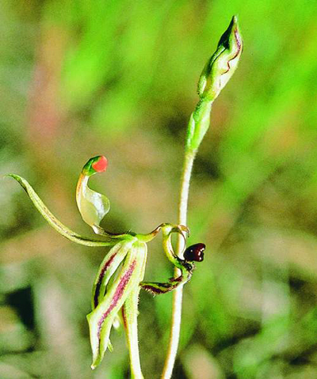
Photo A.P. Brown
July 2003

Department of Conservation and Land Management
Western Australian Threatened Species and Communities Unit
PO Box 51, Wanneroo, WA 6946.


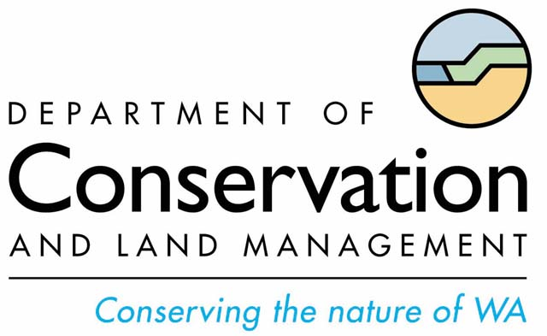
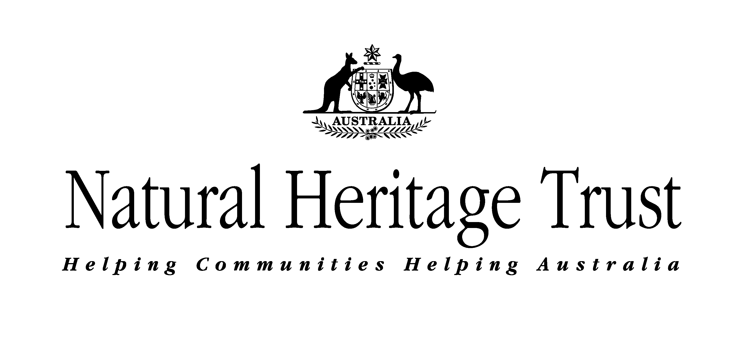

FOREWORD

Interim Recovery Plans (IRPs) are developed within the framework laid down in Department of Conservation and Land Management (the Department) Policy Statements Nos. 44 and 50.

IRPs outline the recovery actions that are required to urgently address those threatening processes most affecting the ongoing survival of threatened taxa or ecological communities, and begin the recovery process.

The Department is committed to ensuring that Critically Endangered taxa are conserved through the preparation and implementation of Recovery Plans or Interim Recovery Plans and by ensuring that conservation action commences as soon as possible and always within one year of endorsement of that rank by the Minister.

This Interim Recovery Plan, which replaces IRP 29 (Drakonorchis drakeoides ms) will operate from July 2003 to June 2008 but will remain in force until withdrawn or replaced. It is intended that, if the taxon is still ranked Critically Endangered, this IRP will be reviewed after five years and the need for a full Recovery Plan will be assessed.

This IRP was approved by the Director of Nature Conservation on 21 July, 2003. The provision of funds identified in this Interim Recovery Plan is dependent on budgetary and other constraints affecting the Department, as well as the need to address other priorities.

Information in this IRP was accurate at July 2003.

SUMMARY

Scientific Name: Caladenia drakeoides | Common Name: Hinged Dragon Orchid
Family: Orchidaceae | Flowering Period: August - October
DCLM Regions: Midwest, Wheatbelt | DCLM District: Moora, Merredin
Shires: Coorow, Wongan-Ballidu, Dalwallinu, Moora, Goomalling | Recovery Teams: Merredin and Moora District Threatened Flora Recovery Teams (MDTFRT)

Illustrations and/or further information: Brown, A., Thomson-Dans, C. and Marchant, N. (Eds). (1998). Western Australia’s Threatened Flora. Department of Conservation and Land Management, Western Australia; Hoffman, N. & Brown, A. (1992) Orchids of South West Australia. 2nd Edition. University of Western Australia Press, Nedlands; Hopper, S. D., van Leeuwen, S., Brown, A.P. & Patrick, S. J. (1990) Western Australia’s Endangered Flora. Department of Conservation and Land Management, Western Australia; Patrick S. J., Brown A. P. & Rose D. (draft) Declared Rare and Poorly Known Flora in the Moora District. Department of Conservation and Land Management, Western Australia.

Current status: Caladenia drakeoides was declared as Rare Flora in September 1986 as Drakonorchis drakeoides ms (it has now been placed back in Caladenia) and ranked as Critically Endangered in November 1998. It currently meets World Conservation Union Red List Category ‘CR’ under criteria B2ab(ii,iii,iv,v) due to its small area of occupancy, the populations being severely fragmented and an observed decline in area of occupancy, quality of habitat, number of subpopulations and number of mature individuals. The species is currently known from nine populations in the Moora District, eight populations in the Merredin District and one population in the Katanning District. The main threats are inappropriate fire regimes, rising saline water tables, grazing, degraded habitat, weeds, poor recruitment and limited genetic diversity.

Distribution and habitat: Caladenia drakeoides is confined to seasonally moist rises above salt lakes between Coorow, Beacon and Lake King. Habitat is tall to medium shrubland dominated by Melaleuca and Acacia species over low shrubs and annuals. Soils are variable but consist mainly of grey sandy loam.

Critical habitat: The critical habitat for Caladenia drakeoides comprises the area of occupancy of known populations; similar habitat within 200 metres of known populations; corridors of remnant vegetation that link populations; additional nearby occurrences of similar habitat that are not known to contain the species but may have done so in the past and may be suitable for translocations; and local catchment areas for the surface and ground waters that provide habitat for the species.

Habitat critical to the survival of the subspecies, and important populations: Given that this species is listed as Critically Endangered it is considered that all known habitat containing wild and translocated populations is habitat critical.

Benefits to other species/ecological communities: Recovery actions implemented to improve the quality or security of the habitat of Caladenia drakeoides will also improve the status of remnant vegetation in which it is located.

International Obligations: This plan is fully consistent with the aims and recommendations of the Convention on Biological Diversity, ratified by Australia in June 1993, and will assist in implementing Australia’s responsibilities under that Convention. However, as Caladenia drakeoides is not listed under any international agreement, the implementation of other international environmental responsibilities is not affected by this plan.

Role and interests of indigenous people: There are no known indigenous communities interested or involved in the management of areas affected by this plan. Therefore no role has been identified for indigenous communities in the recovery of this species.

Social and economic impacts: The implementation of this recovery plan is unlikely to cause significant adverse social and economic impacts. However, as many populations occur on private land the protection of them may potentially affect farming activities. Many of these populations have now been fenced to reduce the impact on what may have otherwise been large areas that could not have been farmed.

Evaluation of the Plan’s Performance: The Department of Conservation and Land Management, in conjunction with the Recovery Team will evaluate the performance of this IRP. The plan is to be reviewed within five years.

Existing Recovery Actions: The following recovery actions have been or are currently being implemented.
- Populations 1, 7 and 14 and subpopulation 2b (private property) have been fenced to exclude sheep.
- All owners of private property populations have been notified of the presence of the species.
- The Moora and Merredin District Threatened Flora Recovery Teams are overseeing the implementation of recovery actions prescribed in this IRP, and are reporting annually to DCLM’s Corporate Executive.
- Regular monitoring of populations is being undertaken by DCLM Moora and Merredin District staff.

IRP Objective: The objective of this Interim Recovery Plan is to abate identified threats and maintain and/or enhance in situ populations to ensure the long-term preservation of the taxon in the wild.

Recovery criteria
Criteria for success: The number of individuals within populations and/or the number of populations have increased by 10% or more.
Criteria for failure: The number of individuals within populations and/or the number of populations have decreased by 10% or more.

- Coordinate recovery actions. | - Collect and store seed.
- Install DRF markers. | - Develop and implement a translocation proposal.
- Monitor populations. | - Conduct further surveys.
- Fencing. | - Develop and implement a fire management strategy.
- Goat control. | - Obtain biological and ecological information.
- Weed control. | - Promote community awareness
- Rehabilitate habitat of subpopulations 2a, 2b, 5a and population 11. | - Review the need for a full Recovery Plan

1. BACKGROUND

History

Caladenia drakeoides was first collected near Meckering in the 1960s by the late J. Tonkinson. It was then not seen again until 1984 when R. Bates (an orchidologist visiting from South Australia) found a small population near Goomalling. Subsequent surveys have located a further 17 mostly small populations with a combined total of approximately 1058 plants. During a survey for the orchid in the Merredin and Moora Districts between 1996-and 2001 no plants were found at eight populations. In recent years there has been a dramatic decline in plant numbers in many other populations. When originally gazetted as rare flora it was listed as Drakonorchis drakeoides ms but has since been placed in Caladenia (Hopper & Brown 2001).

Description

Caladenia drakeoides is an inconspicuous, erect, 20-30 cm tall tuberous herb. Usually single, or rarely two flowered, it differs from other Caladenia species in its small hanging petals and sepals (13-17 mm by 2.5-4 mm), its small hinged labellum (5-7 mm long) with two lateral slight swellings (not antenna-like as in the related C. barbarossa), and its hump like shoulder calli. The latter are 1.5-2 mm wide, golden brown with small dark red spots, with a cranial depression and two lateral anterior slight swellings. A full taxonomic description of C. drakeoides, is provided by S. D. Hopper and A.P. Brown in Nuytsia Vol. 14 1/2 2001. On rare occasions C. drakeoides hybridizes with Caladenia exilis and Caladenia longicauda, and these have been named x Caladenia ornata and x Caladenia enigma respectively.

Distribution and habitat

Caladenia drakeoides is confined to seasonally moist rises above salt lakes between Coorow, Beacon and Goomalling. Habitat is tall to medium shrubland dominated by Melaleuca and Acacia species over low shrubs and annuals. Soils are variable but consist mainly of grey sandy loam.

Biology and ecology

Caladenia drakeoides has an insect-like labellum which emits a pheromone similar to that of a female thynnid wasp. Male thynnid wasps attempt copulation with the labellum and in the process remove or deposit pollen. Like other orchids, C. drakeoides produces thousands of tiny seeds that contain little testa. These seeds rely on a symbiotic association with soil fungi for germination.

Threats

Caladenia drakeoides was declared as Rare Flora in September 1986 as Drakonorchis drakeoides ms and ranked as Critically Endangered in November 1998. It currently meets World Conservation Union Red List Category ‘CR’ under criteria B2a,b,(ii,iii,iv,v) due to its small area of occupancy, the populations being severely fragmented and an observed decline in area of occupancy, quality of habitat, number of subpopulations and number of mature individuals. This is due to the extremely restricted habitat of the species in a narrow ecotone on the edges of salt lakes, the wide scale clearing for agriculture in the northern and western wheatbelt and rising water tables which have caused an increase in salinity and water logging. In addition to these, current continuing threats include inappropriate fire regimes, erosion, degraded habitat, weeds, poor recruitment, grazing and trampling by sheep and goats and road maintenance. Details of continuing threats are as follows.

- Salinisation, waterlogging and erosion are contributing to habitat degradation in populations 2, 3, 4, 5, 6, 7, 10 and 11. The rising saline water table is the greatest single threat to the species.

- Weeds are invading the habitat of populations 1, 3, 5b, 6, 7, 9 and 10. Inappropriate fire regimes may also promote weed growth and could exacerbate the problem if not controlled.

- Grazing and trampling by sheep has been observed in the area of populations 3, 5, 6 and 9.

- Goats are a threat to the habitat of population 12 due to heavy grazing and trampling of plants.

- Road maintenance may accidentally destroy Caladenia drakeoides plants and habitat.

- Poor recruitment is a continuing threat to the species. All populations are declining with little natural recruitment observed.

Summary of population information and threats

Pop. No. & Location | Land Status | Year/No. plants | Condition | Threats
1. ENE of Gunyidi | Private | 1988 1000+  1998 50 | Moderate | Weeds, increasing salinity
2a. ENE of Gunyidi | Private | 1988 100+  1998 0 | Moderate | Rising salinity, erosion
2b. ENE of Gunyidi | Private | 1996 100+  1998 50 | Poor | Rising salinity, erosion
3. ENE of Gunyidi | Nature Reserve, Class A | 1988 3  1996 0 | Moderate | Rising salinity, weeds, grazing
4a. ESE of Pithara | Private | 1988 20+  1998 10 | Good | Grazing, rising salinity
4b. ESE of Pithara | Private | 1991 100+  1998 127 | Good | Grazing, rising salinity
5a. N of Ballidu | Private | 1988 15+  1996 0 | Moderate | Rising salinity, grazing, rabbits
5b. N of Ballidu | Private | 1988 15+  1998 47 | Moderate | Rising salinity, grazing, weeds, rabbits
6. SW of Kondut | Private | 1988 30+  1998 0 | Poor | Rising salinity, weeds, grazing by sheep, vehicles
7. W of Miling | Private | 1987 5  1996 0 | Moderate | Rubbish dumping, weeds, increasing salinity
8. ENE of Dalwallinu | Shire road reserve | 1991 18  1998 16 | Moderate | Grazing, weeds
9. NW of Goomalling | Private | 1984 2  1996 0 | Poor | Rabbits, sheep, erosion, weeds
10. WSW of Ballidu | Private | 1990 4  1996 0 | Moderate | Rising salinity, weeds, grazing
11. ENE of Gunyidi | Private | 1996 167  1999 75 | Moderate | Rising salinity, erosion, grazing
12. SW of Coorow | Nature Reserve, Class C | 1992 100+  1996 333+ | Moderate | Rising salinity, rabbits, goats
13a. N of Beacon | Private | 1992 8  1998 5 | Not recently surveyed | Rising salinity, weeds
13b. N of Beacon | Shire road reserve | 1992 10  1992 5 | Not recently surveyed | Rising salinity, weeds
14. SE of Coorow | Private | 1996 200+  1996 20 | Good | None apparent
15. W of Lake Moore | Private | 1999 47 | Poor | Rising salinity, weeds
16. W of Lake King | Nature Reserve | 2002 0 | Poor | Rising salinity, degraded habitat
17. E of Coorow | Private | 1999 200 | Moderate | Rising salinity, weeds
18a. E of Coorow | Private | 2001 100 | Moderate | Rising salinity, weeds
18b. E of Coorow | Private | 2001 30 | Moderate | Rising salinity, weeds

Critical habitat

Critical habitat is habitat identified as being critical to the survival of a listed threatened species or listed threatened ecological community. Habitat is defined as the biophysical medium or media occupied (continuously, periodically or occasionally) by an organism or group of organisms or once occupied (continuously, periodically or occasionally) by an organism, or group of organisms, and into which organisms of that kind have the potential to be reintroduced. (Environment Protection and Biodiversity Conservation Act 1999 (EPBC Act)).

The critical habitat for Caladenia drakeoides comprises:
- the area of occupancy of the known populations,
- areas of similar habitat ie. Winter-moist rises above salt lakes and saline flats, within 200 metres of known populations (these provide potential habitat for natural recruitment),
- corridors of remnant vegetation that link populations (these are necessary to allow pollinators to move between populations),
- the local catchment which provides the correct water table for the species (the species occurs adjacent to lakes and saline flats and is dependent on maintenance of local surface hydrology),
- additional occurrences of similar habitat that do not currently contain the species (these represents possible future translocation sites).

Habitat critical to the survival of the species, and important populations

Given that this species is listed as Critically Endangered it is considered that all known habitat is habitat critical. In addition, all populations, including translocated populations, are considered important to the survival of the species.

Benefits to other species/ecological communities

Recovery actions implemented to improve the quality or security of the habitat of Caladenia drakeoides populations will improve the status of the remnant vegetation in which the populations are located.

International Obligations

This plan is fully consistent with the aims and recommendations of the Convention on Biological Diversity, ratified by Australia in June 1993, and will assist in implementing Australia’s responsibilities under that Convention. However, as Caladenia drakeoides is not listed under any international agreement, the implementation of other international environmental responsibilities is not affected by this plan.

Role and interests of indigenous people

There are no known indigenous communities interested or involved in the management of areas affected by this plan. Therefore no role has been identified for indigenous communities in the recovery of this species.

Social and economic impacts

The implementation of this recovery plan is unlikely to cause significant adverse social and economic impacts. However, as many populations occur on private land the protection of them may potentially affect farming activities. Many of these populations have now been fenced to reduce the impact on what may have otherwise been large areas that could not have been farmed.

Evaluation of the Plans Performance

The Department of Conservation and Land Management, in conjunction with the Moora, Merredin and Katanning District Threatened Flora Recovery Teams will evaluate the performance of this Interim Recovery Plan. The plan is to be reviewed within five years. Any changes to management / recovery actions will be documented accordingly.

Guide for decision-makers

Section 1 provides details of current and possible future threats. Developments in the immediate vicinity of the population or within the defined critical habitat of Caladenia drakeoides require assessment. No developments should be approved unless the proponents can demonstrate that they will not have a significant impact on the species, or its habitat or potential habitat, or the local surface and ground water hydrology.

2. RECOVERY OBJECTIVE AND CRITERIA

Objectives

The objective of this Interim Recovery Plan is to abate identified threats and maintain or enhance in situ populations to ensure the long-term preservation of the species in the wild.

Criteria for success: The number of individuals within populations and/or the number of populations have increased by 10% or more.
Criteria for failure: The number of individuals within populations and/or the number of populations have decreased by 10% or more.

3. RECOVERY ACTIONS

Existing recovery actions

Populations 1, 7 and 14 and subpopulation 2b (all private property) have been fenced to exclude sheep.

Owners of private property populations have been notified of the presence of the species.

Staff from the Botanic Gardens and Parks Authority have collected seed from several populations.

An information sheet, which includes a description of the plant, its habitat type, threats and management actions has been produced.

The Moora, Merredin and Katanning District Threatened Flora Recovery teams oversee the implementation of recovery actions prescribed in this IRP, and report annually to DCLM’s Corporate Executive.

Future recovery actions

Where populations occur on lands other than those managed by DCLM, permission has been or will be sought from the appropriate land managers prior to recovery actions being undertaken.

1. Coordination

The Katanning District Threatened Flora Recovery Team (KDTFRT), Merredin District Threatened Flora Recovery Team (MeDTFRT) and Moora District Threatened Flora Recovery Team (MoDTFRT) will continue to coordinate recovery actions for Caladenia drakeoides and other Declared Rare Flora in the districts. They will include information on progress in their annual report to DCLM’s Corporate Executive and funding bodies.

Action: Coordinate recovery actions
Responsibility: Relevant recovery teams (Katanning, Narrogin & Moora Districts) in conjunction with DCLM staff.
Cost: $1,800 per year.

2. Declared Rare Flora Markers

Four Declared Rare Flora (DRF) markers are required at population 12 (Capamauro Nature Reserve).

Action: Install DRF markers
Responsibility: DCLM (Moora District) through the MoDTFRT
Cost: $100 in year 1.

3. Monitoring

Monitoring of factors such as goat activity, rising salinity, weed encroachment, population stability (expanding or declining), pollination activity, seed production, recruitment, and longevity is essential.

Action: Monitor populations
Responsibility: DCLM (Moora, Katanning and Merredin Districts) through the relevant recovery teams
Cost: $2,000 pa.

4. Fencing

The habitat of subpopulations 4a, 5b and population 11 are currently being grazed by sheep. These will be fenced to exclude stock.

Action: Erect fencing
Responsibility: DCLM (Moora and Merredin Districts) through the relevant recovery teams, landowners
Cost: $2,500 in years 1 and 2.

5. Goat control

Goat control is needed in Capamauro Nature Reserve (population 12) to prevent further degradation of the habitat. This should be done in conjunction with a goat control program for the nearby Watheroo National Park and Pinjarrega Nature Reserve.

Action: Implement goat control
Responsibility: DCLM (Moora District) through the MoDTFRT
Cost: $4,500 in years 1 & 3.

6. Weed control

Weeds are a major threat to the habitat of populations 1, 5b, 6, 7, 9 and 10 (private), population 3 (nature reserve) and population 8 (Shire road reserve) is badly infested by weeds. The following should be taken into consideration when undertaking weed control.

- Experience and research to date in similar situations has shown that the use of selective herbicides to control grasses may result in infestation by broad leaf weeds. As there are currently no herbicides available for broad leaf weeds that can be used in a non-selective way and it is unknown how herbicides will affect orchids, care must be taken when implementing weed control.
- Broad spectrum, non-residual herbicides, e.g. glyphosate, can be used for spot control of weeds utilising techniques such as direct application or the use of temporary spray shields. Generally these techniques have been under utilised in respect to threatened flora and practical methods of application in the field require further development.
- Hand removal of native weeds immediately around plants of Caladenia drakeoides plants may have to be undertaken due to the risk of damage from herbicides at such close quarters. Care must be taken as hand weeding has the potential to increase weed levels (at least temporarily) as a result of soil disturbance.
- Within the five-year scope of an IRP weed control will be a short-term protective measure. Long term conservation of populations of CR flora will require further habitat rehabilitation including the replacement of weeds with appropriate native species.

Action: Implement weed control
Responsibility: DCLM (Moora, Katanning and Merredin Districts) through the relevant recovery teams
Cost: $2,500 pa.

7. Habitat rehabilitation

The reintroduction of native shrubs and trees is required to rehabilitate the degraded habitat of subpopulations 2a, 2b, 5a and population 11.

Action: Rehabilitate habitat of subpopulations 2a, 2b, 5a and population 11
Responsibility: DCLM (Moora and Merredin Districts) through the relevant recovery teams
Cost: $3,500 in years 1, 2 and 3.

8. Seed collection

Preservation of germplasm is essential to guard against extinction if wild populations are lost. Seed collections can also be used to propagate plants for the establishment of a living collection at the Botanic Garden and Parks Authority (BGPA) and for future translocations back into the wild (see 13).

Action: Collect and store seed
Responsibility: DCLM (TFSC, Merredin, Katanning & Moora Districts), Kings Park and Botanic Garden (KPBG) through the relevant recovery teams
Cost: $4,000 in year 1 and 2.

9. Translocation

Although translocations are generally undertaken under full Recovery Plans, the threats to all known wild populations of Caladenia drakeoides requires the implementation of a translocation proposal within the time frame of this IRP. A translocation proposal prepared by DCLM and BGPA will be coordinated by the relevant recovery teams. Information on the translocation of threatened animals and plants in the wild is provided in DCLM’s Policy Statement No. 29 Translocation of Threatened Flora and Fauna.

Action: Develop and implement a translocation proposal
Responsibility: The Department (Science Division, Katanning, Merredin and Moora Districts) through KPBG and relevant recovery teams
Estimated Cost: $13,300 in the third year and $6,200 in subsequent years.

10. Surveys

Surveys supervised by DCLM staff, and with the assistance of the West Australian Native Orchid Study and Conservation Group, wildflower societies and naturalist clubs, will be conducted for Caladenia drakeoides during its flowering period (Late August- early October).

Action: Conduct further surveys
Responsibility: DCLM (Moora and Merredin Districts) through the relevant recovery teams
Cost: $4,000 pa.

11. Fire management strategy

It is likely that Caladenia drakeoides is not harmed by fire between November and May when the plant is dormant but fires during the growing, flowering and seeding phase (June-October) may be detrimental to the long term survival of the species.

Action: Develop and implement a fire management strategy
Responsibility: DCLM (Moora, Katanning and Merredin Districts) through the relevant recovery teams, relevant authorities and landowners
Cost: $1000 in the first year and 700 in subsequent years.

12. Biology and ecology

Better knowledge of the biology and ecology of Caladenia drakeoides will provide a scientific basis for management of wild populations. An understanding of the following is necessary for effective management:

- The pollination biology of the species, and the requirements of pollinators.
- The phenology and seasonal growth of the species.
- The distribution of seed and the requirements for germination.
- The longevity of plants, and time taken to reach maturity.
- The population genetic structure, levels of genetic diversity and minimum viable population size.
- The impact of salinity on Caladenia drakeoides and its habitat.
- The effects of weeds on recruitment and establishment.

Action: Obtain biological and ecological information
Responsibility: DCLM (Science Division, Moora, Katanning & Merredin districts) through the relevant recovery teams
Cost: $18,000 per year.

13. Community awareness

The importance of biodiversity conservation and the protection of Caladenia drakeoides will be promoted to the public. This will be achieved through an information campaign using the local print and electronic media and by setting up poster displays. This is especially important as most populations of the species are small and all are highly threatened, and increased awareness may result both improved protection and the discovery of others.

An information sheet, which includes a description of the plant, its habitat type, threats and management actions has been produced. The preparation of a poster illustrating all Critically Endangered flora species in the District is recommended. Formal links with local naturalist groups and interested individuals will be encouraged.

Action: Promote community awareness
Responsibility: DCLM (Moora and Merredin Districts, Corporate Relations) through the relevant recovery teams
Cost: $500 in the first year and $1,500 in the second year.

Recovery Plan

If the taxon is still ranked as Critically Endangered at the end of the fourth year of the five-year term of this Interim Recovery Plan, the need for a full Recovery Plan or a review of this IRP will be assessed and a plan prepared if necessary.

Action: Review this IRP and the need for a full Recovery Plan
Responsibility: The Department (WATSCU, Moora, Merredin & Katanning Districts) through the relevant recovery teams
Cost: $22,200 in the fifth year (if required).

4. TERM OF PLAN

This Interim Recovery Plan will operate from June 2003 to May 2008 but will remain in force until withdrawn or replaced. If the taxon is still ranked Critically Endangered after five years, the need to review this IRP or to replace it with a full Recovery Plan will be determined.

5. ACKNOWLEDGMENTS

The following people have provided assistance and advice in the preparation of this Interim Recovery Plan:

Claire Welbon Former Conservation Officer, Merredin District, DCLM
Rebecca Wolstenholm Former Conservation Officer, Moora District, DCLM
Nick Woolfrey Former Conservation Officer, Merredin District, DCLM

We would like to thank the staff of the W.A. Herbarium for providing access to Herbarium databases and specimen information, and DCLM's Wildlife Branch for their assistance.

6. REFERENCES

Brown, A., Thomson-Dans, C. and Marchant, N. (Eds). (1998). Western Australia’s Threatened Flora. Department of Conservation and Land Management, Western Australia.
DCLM (1992) Policy Statement No. 44 Wildlife Management Programs. Department of Conservation and Land Management, Perth.
DCLM (1994) Policy Statement No. 50 Setting Priorities for the Conservation of Western Australia’s Threatened Flora and Fauna. Department of Conservation and Land Management, Perth.
DCLM (1995) Policy Statement No. 29 Translocation of Threatened Flora and Fauna. Department of Conservation and Land Management, Perth.
Hoffman, N. & Brown, A. (1992) Orchids of South West Australia. 2nd Edition. University of Western Australia Press, Nedlands.
Hopper, S., van Leeuwen, S., Brown, A. & Patrick, S. (1990) Western Australia’s Endangered Flora. Department of Conservation and Land Management, Western Australia.
Patrick S. J., Brown A. P. & Rose D. (draft) Declared Rare and Poorly Known Flora in the Moora District. Department of Conservation and Land Management, Western Australia.
World Conservation Union (1994). IUCN red list categories prepared by the IUCN Species Survival Commission, as approved by the 40th meeting of the IUCN Council. Gland. Switzerland.

7. TAXONOMIC DESCRIPTION (S.D. Hopper and A. P. Brown, Nuytsia 14: Nom. 1/2 2002)

Caladenia drakeoides differs from other species of Caladenia in its small petals and sepals (to 13-17 mm by 2.5-4 mm) that are scarcely splayed out from the ovary; its labellum on a loosely hinged claw, 5-7 mm long; its small labellum lamina held below the top of the ovary - the abdomen 5-7 mm by 3-4 mm, scarcely curved and shallowly channelled towards the tail, hirsute only on the margins and should calli, the head globular, 1.5-2 mm wide, golden brown with small dark red spots, with a cranial depression and two lateral anterior slight swellings (not antenna-like as in C. barbarossa) and the shoulder calli hump-like, less than 1 mm tall; and its confinements to the margins of salt lakes.

