INTERIM RECOVERY PLAN NO 103

PYTHARA GREVILLEA

(GREVILLEA PYTHARA)

INTERIM RECOVERY PLAN

2001-2004

Robyn Phillimore, Diana Papenfus, Felicity Bunny & Andrew Brown

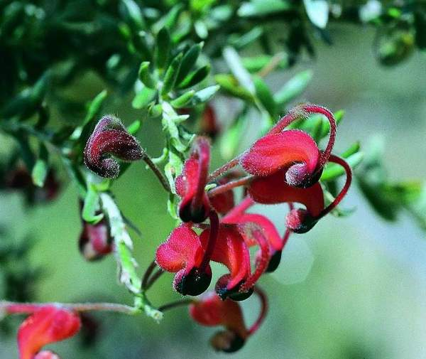

Photograph: A. Brown
July 2001

Department of Conservation and Land Management
Western Australian Threatened Species and Communities Unit (WATSCU)
PO Box 51, Wanneroo, WA 6946

  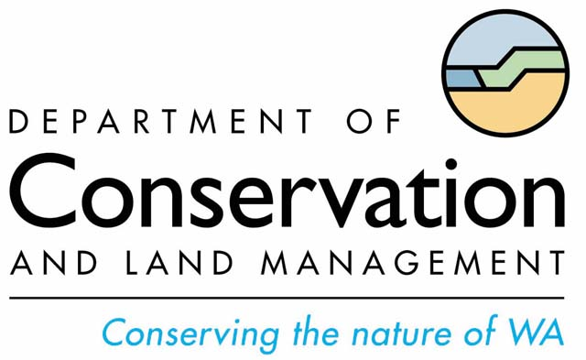 |  | 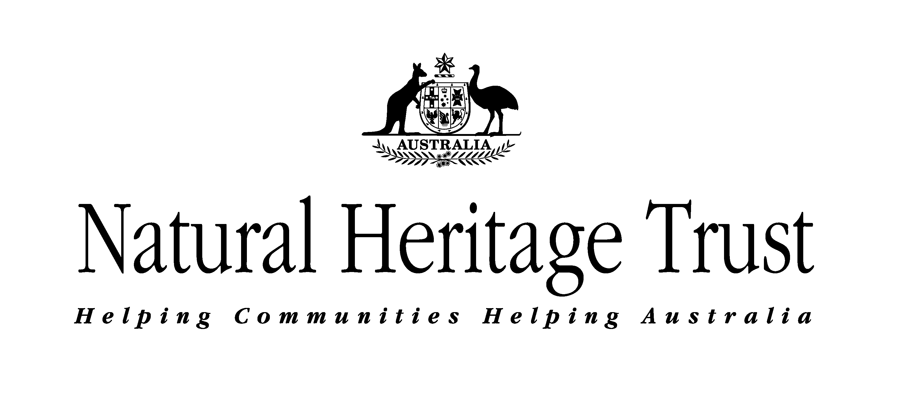

FOREWORD

Interim Recovery Plans (IRPs) are developed within the framework laid down in Department of Conservation and Land Management (the Department) Policy Statements Nos. 44 and 50.

IRPs outline the recovery actions that are required to urgently address those threatening processes most affecting the ongoing survival of threatened taxa or ecological communities, and begin the recovery process.

The Department is committed to ensuring that Critically Endangered taxa are conserved through the preparation and implementation of Recovery Plans or Interim Recovery Plans and by ensuring that conservation action commences as soon as possible and always within one year of endorsement of that rank by the Minister.

This Interim Recovery Plan will operate from July 2001 to June 2004 but will remain in force until withdrawn or replaced. It is intended that, if the taxon is still ranked Critically Endangered, this IRP will be replaced by a full Recovery Plan after three years.

This IRP was approved by the Deputy Director, Biodiversity Conservation on 23, March, 2002. The provision of funds identified in this Interim Recovery Plan is dependent on budgetary and other constraints affecting the Department, as well as the need to address other priorities.

Information in this IRP was accurate at July 2001.

SUMMARY

Scientific Name: Grevillea pythara | Common Name: Pythara Grevillea
Family: Proteaceae | Flowering Period: August to December and sporadically at other times of year
Departmental Region: Wheatbelt | Departmental District: Merredin
Shire: Dalwallinu | Recovery Team: Merredin District Threatened Flora Recovery Team

Illustrations and/or further information: Brown, A., Thomson-Dans, C. and Marchant, N. (Eds). (1998) Western Australia’s Threatened Flora. Department of Conservation and Land Management, Western Australia; Olde, P.M. and Marriott, N.R. (1993) New species and taxonomic changes in Grevillea (Proteaceae: Grevilleoideae) from south-west Western Australia. Nuytsia 9(2), 237-304; Olde, P.M. and Marriott, N.R. (1995) The Grevillea Book 2: 124. Kangaroo Press, Kenthurst NSW.

Current status: Grevillea pythara was declared as Rare Flora in August 1994 and ranked as Critically Endangered (CR) in September 1995. The species currently meets World Conservation Union (IUCN 2000) Red List Category ‘CR’ under criteria B1a+2ab(iii); C2a(ii) due to it being known from one location only, and a continuing decline in quality of habitat. Threats are lack of habitat, continuing road maintenance, poor genetic diversity, weeds, inappropriate fire, salinity, chemical drift and grazing.

Critical habitat: The critical habitat for Grevillea pythara comprises the habitat of the known population, similar habitat within 200 metres of the known population, and corridors of remnant vegetation that link the population with other nearby areas of apparently suitable habitat that do not currently contain the species.

Habitat requirements: Grevillea pythara is endemic to the Dalwallinu area of Western Australia where it grows in brown gravelly and sandy-loam soils in a narrow weedy, heavily disturbed road reserve with other remnant native species including Dampiera spp., Actinostrobus sp., Keraudrenia sp., Gastrolobium sp. and Conospermum stoechadis.

Existing Recovery Actions: The following recovery actions have been or are currently being implemented -
- Land managers and adjacent landowners have been notified of Grevillea pythara and its location.
- Declared Rare Flora markers have been installed at the population.
- Dashboard stickers and posters have been produced and distributed.
- An A4 sized poster has been produced for Grevillea pythara, which provides a description of the species, and information about threats and recovery actions.
- Staff from the Department's Merredin District, in cooperation with the Shire of Dalwallinu and the adjacent private property owner, relocated a gate in June/July 1997 to an area where its use would have not have an impact on Grevillea pythara.
- All subpopulations have been fenced with ringlock.
- Departmental staff are actively involved in rehabilitating the habitat of Grevillea pythara. Approximately 1000 seeds were collected from local native trees and shrubs and propagated for planting. In 2000, Departmental staff and local volunteers planted out 186 Actinostrobus seedlings.
- The Department's Science Division and Merredin District staff undertook weed control in 1997, 1998 and 2000. Grassy weeds were controlled using fusilade and broadleaf weeds were controlled by hand weeding.
- A PhD project titled ‘Population dynamics with life histories of rare and common Grevillea species in Western Australia’ by Paul Armstrong, has been completed.
- The Botanic Garden and Parks Authority has received material from 11 clones but as propagation has been difficult only two plants have survived.
- The Merredin District Threatened Flora Recovery Team is overseeing the implementation of this IRP and will include information on progress in its annual report to the Department's Corporate Executive and funding bodies.
- Staff from the Department's Merredin District office regularly monitor the population.

IRP Objective: The objective of this IRP is to abate identified threats and maintain or enhance in situ populations to ensure the long-term preservation of the species in the wild.

Recovery criteria
Criteria for success: The number of individuals within populations and/or the number of populations have increased.
Criteria for failure: The number of individuals within populations and/or the number of populations have decreased.

Recovery actions
- Coordinate recovery actions. | - Develop and implement a fire management strategy.
- Undertake weed control using proven, best practice methods. | - Monitor population.
- Conduct habitat rehabilitation. | - Conduct further surveys.
- Propagate plants for translocation. | - Liaise with relevant land managers.
- Develop and implement a translocation proposal. | - Promote awareness.
- Obtain biological and ecological information. | - Write a full Recovery Plan.
- Collect germplasm material.
1. BACKGROUND

History

Jan Wellburn, the daughter of an adjacent landowner, discovered Grevillea pythara in 1988. Unable to identify it using available botanical keys, Ms Wellburn sent a sample to the Department of Conservation and Land Management in 1990, where it was recognised as a new species. The species was formally named pythara after the family farm. Road reserves within five kilometres, and Nature, Water and Shire Reserves within 10 km have been surveyed for more populations of the species without success.

Grevillea pythara is currently known from a single roadside population, which comprises around 300 stems over a distance of 500 m. Due to its suckering nature the population may represent several clones, rather than individual plants. The extremely localised nature of the population makes the species vulnerable to any localised event, which could bring about the extinction of the species in the wild. The road reserve on which the population is located is badly degraded and severely weed infested. The species is also vulnerable to grazing, road maintenance and fire.

Description

Grevillea pythara is a low, spreading shrub to 30 cm tall. The leaves, which are 7 to 16 mm long and 1.5 to 4 mm wide, narrow, greyish-green and covered with long, soft, fine hairs, have downward-curving margins and a pointed tip. The erect capitulum of 4 to 8 flowers is stalkless and is held at the ends of the branchlets. Individual flowers have a stalk 4 to 8 mm long. The floral whorl, about 1 cm long and 5 mm wide, is predominantly red with black bordering the dilated section of the dorsal sepals below the limb. The anthers are yellow. The sparsely hairy style is red and curved and 20 to 22 mm long. Fruits have not been seen (Brown et al. 1998). G. pythara has no close relatives (Olde and Marriott 1995).

Distribution and habitat

Grevillea pythara is endemic to the Dalwallinu area in Western Australia where it grows in brown gravelly, sandy loam on a weedy, disturbed road reserve with remnant native species including Dampiera spp., Actinostrobus sp., Keraudrenia sp., Gastrolobium sp. and Conospermum stoechadis.

Critical habitat

Critical habitat is habitat identified as being critical to the survival of a listed threatened species or listed threatened ecological community. Habitat is defined as the biophysical medium or media occupied (continuously, periodically or occasionally) by an organism or group of organisms or once occupied (continuously, periodically or occasionally) by an organism, or group of organisms, and into which organisms of that kind that the potential to be reintroduced (Environment Protection and Biodiversity Conservation Act 1999 (EPBC Act)).

The critical habitat for Grevillea pythara comprises:
- the area of occupancy of the known population,
- areas of similar habitat within 200 metres of the known population (these provide potential habitat for natural recruitment),
- the local catchment that provides the correct water table for the species (the species occurs adjacent to samphire flats and is dependent on maintenance of local surface hydrology),
- additional occurrences of similar habitat within 20 km of the population that do not currently contain the species (these represent possible translocation sites).

Biology and ecology

Grevillea pythara is thought to reproduce vegetatively by suckering from underground stems. No fruits or swollen ovaries have been observed on the flowers and cytological studies on pollen indicate a viability of less than 1%, which is typically 100% for Grevillea pollen (personal communication Paul Armstrong 2001). Armstrong suggested the population may have originated from one plant that has spread, either naturally due to suckering from underground stems, or unnaturally due to road maintenance which has caused stem fragmentation. The latter scenario is more probable as the road reserve contour does not appear natural or of long standing. The plant may even have been imported to the site in soil used in road construction works.

Grevillea pythara may be a sterile hybrid, however, there appear to be no closely related taxa. It is possible that G. singuliflora or G. glossdenia are remotely related (Olde and Marriott 1993). However, as these species occur 3 000 km distant, the similarities are more likely to be a process of evolutionary convergence than common ancestry Age estimates of the population have been undertaken, based on current plant expansion rates. These indicated the population is between 190 and 1330 years old (personal communication P. Armstrong 2001).

The response of Grevillea pythara to fire is unknown. The species does, however, seem to respond well to disturbance with healthy, new stems visible on plants which have been disturbed during grading. Older, senescing stems are found on long undisturbed plants (personal communication K. Bettink).

In cultivation, Grevillea pythara, although susceptible to root disease, is generally a long-lived plant. It requires a well-drained, sunny position in acidic to neutral sandy or gravelly loam with adequate subsoil moisture. The species was first cultivated in 1992. According to Olde and Marriott (1995), cuttings strike readily from firm, young growth taken in spring.

Threats

Grevillea pythara was declared as Rare Flora in August 1994 and ranked as Critically Endangered (CR) in September 1995. The species currently meets World Conservation Union (IUCN 2000) Red List Category ‘CR’ under criteria B1a+2ab(iii); C2a(ii) due to it being known only from one location, and there being a continuing decline in quality of habitat. Threats are lack of habitat, continuing road maintenance, poor genetic diversity, weeds, inappropriate fire, salinity, chemical drift and grazing.

- Poor genetic diversity is likely as it appears that all known plants originated from one or a few clones. Genetic diversity is needed for a species to adapt to changes in its environment. Low genetic diversity would lower this capacity.

- Continuing road maintenance threatens Grevillea pythara and its habitat. Threats include grading road reserves, road widening, spraying of chemicals, constructing drainage channels and mowing roadside vegetation. These events often encourage weed invasion, as well as directly damaging plants.

- Weeds are a major threat. Weeds suppress early plant growth by competing for soil moisture, nutrients and light. They also exacerbate grazing pressure and increase the fire hazard due to the easy ignition of high fuel loads, which are produced annually by many grass weed species.

- Inappropriate fire may affect the long-term viability of the population. Although the species is likely to resprout from rootstock, overly frequent fire is likely to kill plants. Further research is required and this will be addressed in management action 4.

- Salinisation of groundwater as a result of altered hydrology is a severe and increasing problem in the wheatbelt. As the population is located just 100 m from a samphire flat, a rising water table may result in an expansion of the saline area and ultimately threaten the population. The water table will be monitored under Recovery Action 6.

- Degraded habitat: The species occurs on a degraded road reserve where there is little associated native vegetation. Native fauna, soil fungi and bacteria, upon which the taxon is dependent for its long term survival, may be locally impoverished or no longer present at the site.

- Competition from a local native species, Dampiera lavandulacea, is a threat to Subpopulations 1b and 1c, as it is growing over many adult plants of Grevillea pythara.

- Chemical drift from herbicide and fertiliser applications in adjacent farmland has the potential to impact on Grevillea pythara.

- Grazing by rabbits (Oryctolagus cuniculus) may directly threaten Grevillea pythara. Disturbance of soil by rabbit warren construction, increased nutrient levels from their droppings and the introduction of weeds may also impact on the habitat of the species. There are currently several large rabbit burrows at the very eastern end of the population but these are away from G. pythara plants. Several G. pythara plants are also outside of the fence line at Subpopulation 1b and are susceptible to grazing by sheep. This will be monitored under Recovery Action 9.

Summary of population information and threats
Pop. No. & Location | Land Status | Year/No. plants | Condition | Threats
1a. SW of Dalwallinu | Shire Road Reserve | 1995 *50  2001 20 (5) | Moderate | Poor genetic diversity, road maintenance, weed invasion, inappropriate fire, salinity, degraded habitat, chemical drift, grazing
1b. SW of Dalwallinu | Shire Road Reserve | 1995 *50  2001 50 (15) | Healthy/ Moderate | Poor genetic diversity, road maintenance, weed invasion, inappropriate fire, salinity, degraded habitat, chemical drift, grazing, competition
1c. SW of Dalwallinu | Shire Road Reserve | 1994 200  2001 200 (50+) | Healthy/ Moderate | Poor genetic diversity, road maintenance, weed invasion, inappropriate fire, salinity, degraded habitat, chemical drift, grazing, competition
*= total for subpopulations a and b combined. Numbers in brackets = number of young stems.

Guide for decision-makers

Section 1 provides details of current and possible future threats. Any on-ground works (firebreaks, roadworks etc) in the immediate vicinity of Grevillea pythara will require assessment. On ground works should not be approved unless the proponents can demonstrate that they will not have an impact on the species, its habitat or potential habitat, or on the local surface hydrology such that drainage in the habitat of the species would be altered.

2. RECOVERY OBJECTIVE AND CRITERIA

Objectives

The objective of this Interim Recovery Plan is to abate identified threats and maintain or enhance the in situ population so as to ensure the long-term preservation of the species in the wild.

Criteria for success: The area of the population has increased and/or further populations are established.
Criteria for failure: The area of the population has decreased.

3. RECOVERY ACTIONS

Existing recovery actions

Land managers and adjacent landowners have been made aware of the threatened nature of the species and its location. Telstra, which has an underground cable situated near the population, has also been notified. The notification details the Declared Rare status of the taxon and associated legal responsibilities.

Declared Rare Flora (DRF) markers have been installed at either end of the population. These alert people working in the area to the presence of threatened flora and therefore help prevent accidental damage during maintenance operations. Awareness of the significance of these markers is being promoted to Shires and their workers through dashboard stickers, posters and the distribution of ‘stubby holders’. These illustrate DRF markers, inform of their purpose and provide a contact telephone number if such a marker is encountered.

An A4 sized poster that provides a description of the species, and information about threats and recovery actions, has been produced for Grevillea pythara. It is hoped that the poster will result in the discovery of new populations.

A farm gate was relocated by Departmental staff in June/July 1997, in cooperation with the Shire of Dalwallinu and the adjacent private property owner. All subpopulations are now fenced with ringlock, and include a buffer of approximately 70 cm. There are two fenced sections (Subpopulation 1 a in one section and Subpopulations 1b and 1c in the other) that are divided by access to private property.

Using a grant from the BankWest Landscope Conservation Visa card, Departmental staff are rehabilitating the habitat of Grevillea pythara. Approximately 1 000 seeds were collected from local native trees and shrubs. These were propagated for planting and, in 2000, 186 Actinostrobus seedlings were planted out by Departmental staff with the help of local volunteers. Herbicide was used on open areas of weeds. Hand weeding near Grevillea pythara plants was also undertaken with the help of local volunteers.

Experimental weed control was undertaken in 1997 and 1998 by staff of the Department's Science Division. Grassy weeds were controlled using fusilade and broadleaf weeds were controlled by hand weeding.

A PhD project titled ‘Population dynamics with life histories of rare and common Grevillea species in Western Australia’ by Paul Armstrong, is close to completion.

Botanic Garden and Parks Authority staff has received material from 11 clones but, as propagation has been difficult, there are currently only two plants of Grevillea pythara in cultivation. Each of these plants is from a separate clone. Although not hugely successful, the best method of propagation appears to be grafting (personal communication A. Shade).

The Merredin District Threatened Flora Recovery Team (MDTFRT) is overseeing the implementation of this IRP and will include information on progress in its annual report to the Department's Corporate Executive and funding bodies.

Staff from the Department's Merredin District office regularly monitor the population.

Future recovery actions

Where populations occur on lands other than those managed by the Department, permission has been or will be sought from the appropriate land managers prior to recovery actions being undertaken.

1. Coordinate recovery actions

The MDTFRT will continue to oversee the implementation of recovery actions for Grevillea pythara and will include information on progress in its annual report to the Department's Corporate Executive and funding bodies.

Action: Coordinate recovery actions
Responsibility: The Department (Merredin District) through the MDTFRT
Cost: $400 per year

2. Undertake weed control using proven, best practice methods

Weeds and a local species, Dampiera lavandulacea, are threats to the population. Weed control will be undertaken with the following points in mind.

- Experience and research to date in similar situations has shown that the use of selective herbicides to control grasses may result in infestation by broad leaf weeds. As there are currently no selective herbicides available for broad leaf weeds that can be used without damaging native plant species and as there are several native grasses present which would be inadvertently killed when spraying for exotic grasses, care must be taken when implementing weed control.
- Broad spectrum, non-residual herbicides, e.g. glyphosate, can be used for spot control of weeds utilising techniques such as direct application or the use of temporary spray shields. Generally these techniques have been under utilised in respect to threatened flora and practical methods of application in the field require further development.
- Hand removal of native weeds will be undertaken around Grevillea pythara plants. Care must be taken as hand weeding has the potential to increase weed levels (at least temporarily) as a result of soil disturbance.
- Within the three-year scope of an IRP weed control will be a short-term protective measure. Long term conservation of populations of CR flora will require further habitat rehabilitation including the replacement of weeds with appropriate native species.

Action: Undertake weed control using proven, best practice methods
Responsibility: The Department (Merredin District, Science Division) through the MDTFRT
Cost: $900 per year

3. Conduct habitat rehabilitation

Restoration of Grevillea pythara habitat by re-introduction of endemic plant species has started and will be continued. In the long term, a link will be established with other nearby road reserve remnants so as to enable gene exchange between native plant species and the reintroduction fauna, fungi and bacteria that may be deficient from the site.

Action: Conduct habitat rehabilitation
Responsibility: The Department (Merredin District) through the MDTFRT
Cost: $2,900 in first and second years

4. Propagate plants for translocation

Due to the Critically Endangered status of Grevillea pythara, the propagation of plants in readiness for translocation is essential. Cuttings will need to be taken and propagated at the Botanic Gardens and Parks Authority (BGPA) for planting in the following year.

Action: Propagate plants for translocation
Responsibility: The Department (Merredin District) and the BGPA through the MDTFRT
Cost: $1,500 in first and second years

5. Develop and implement a translocation proposal

Although translocations are generally undertaken under full Recovery Plans, the many threats to the wild population of this CR species requires the development of an urgent translocation proposal within the time frame of this IRP. This will be coordinated by the MDTFRT. Information on the translocation of threatened animals and plants in the wild is provided in the Department's Policy Statement No. 29 Translocation of Threatened Flora and Fauna. All translocation proposals require endorsement by the Director of Nature Conservation.

Monitoring of the translocation is essential and will be undertaken according to the timetable set out in the Translocation Proposal.

Action: Develop and implement a translocation proposal
Responsibility: The Department (Science Division, Merredin District) through the MDTFRT
Cost: $12,800 in first year and $5,500 in subsequent years

6. Obtain biological and ecological information

Increased knowledge of the biology and ecology of the species will provide a scientific basis for management of Grevillea pythara in the wild. Investigations will include:

- Determination of the levels of seed production and the extent of clonality.
- A study of the effect of disturbance, competition, rainfall and grazing on stem production.
- Determining reproductive strategies, phenology and seasonal growth.
- Investigation of population genetic structures, levels of genetic diversity and minimum viable population size.
- The impact of salinity on Grevillea pythara and its habitat.
- The effect of fire on the species.

Action: Obtain biological and ecological information
Responsibility: The Department (Science Division, Merredin District) through the MDTFRT
Cost: $18,700 per year

7. Collect germplasm material

Preservation of germplasm is essential to guard against extinction if the wild population is lost. If it is not feasible to collect viable seed, other germplasm storage methodologies may need to be used. These can involve living collections from cuttings or storage of tissue culture material.

Action: Collect germplasm material
Responsibility: The Department (Merredin District, TFSC) and the BGPA, through the MDTFRT
Cost: $1,300 in first and second years

8. Develop and implement a fire management strategy

The response of Grevillea pythara to fire is not known. Fire should therefore be prevented from occurring if possible, at least in the short term. A fire management strategy will be developed to determine fire control measures and fire frequency.

Action: Develop and implement a fire management strategy
Responsibility: The Department (Merredin District) through the MDTFRT
Cost: $2,700 in first year and $1,100 in subsequent years

9. Monitor population

Annual monitoring of factors such as habitat degradation, salinity, population stability (expansion or decline), weed invasion, recruitment, longevity and predation is essential.

Action: Monitor population
Responsibility: The Department (Merredin District) through the MDTFRT
Cost: $1,000 per year

10. Conduct further surveys

Further surveys by Departmental staff with assistance from local naturalists and wildflower society members will be conducted during the species’ main flowering period (August to December).

Action: Conduct further surveys
Responsibility: The Department (Merredin District) through the MDTFRT
Cost: $2,400 in first and second years.

11. Liaise with relevant land managers

Staff from the Department's Merredin District will continue to liaise with land managers, adjacent landowners and Telstra to ensure the population is not damaged or destroyed accidentally.

Action: Liaise with relevant land managers
Responsibility: The Department (Merredin District) through the MDTFRT
Cost: $600 per year

12. Promote awareness

The importance of biodiversity conservation and protection of Grevillea pythara will be promoted to the public. Awareness will be encouraged in the community by a publicity campaign through the local print and electronic media and poster displays. Formal links with local naturalist groups and interested individuals will also be encouraged.

Action: Promote awareness
Responsibility: The Department (Merredin District, Strategic Development and Corporate Affairs Division) through the MDTFRT
Cost: $600 per year

13. Write a full Recovery Plan

At the end of the third-year of this IRP, the need for further recovery will be assessed. If Grevillea pythara is still ranked Critically Endangered at that time a full Recovery Plan will be developed that prescribes actions required for the long-term recovery of the species.

Action: Write a full Recovery Plan
Responsibility: The Department (WATSCU, Merredin District) through the MDTFRT
Cost: $20,100 at the end of the third year

4. TERM OF PLAN

This Interim Recovery Plan will operate from July 2001 to June 2004 but will remain in force until withdrawn or replaced. It is intended that, if the taxon is still ranked Critically Endangered, this IRP will be replaced by a full Recovery Plan after three years.

5. ACKNOWLEDGMENTS

The following people have provided assistance and advice in the preparation of this Interim Recovery Plan:

Paul Armstrong PhD student, Murdoch University
Brett Beecham Regional Ecologist, the Department's Wheatbelt Region
Karen Bettink Conservation Officer, the Department's Merredin District
Dave Coates Principal Research Scientist, the Department's Science Division
Amanda Shade Horticulturalist, Botanic Garden and Parks Authority

We would like to thank the staff of the W.A. Herbarium for providing access to Herbarium databases and specimen information, and the Department's Wildlife Branch for their extensive assistance.

6. REFERENCES

Brown, A., Thomson-Dans, C. and Marchant, N. (Eds). (1998) Western Australia’s Threatened Flora. Department of Conservation and Land Management, Western Australia.
Department of Conservation and Land management (1992) Policy Statement No. 44 Wildlife Management Programs. Department of Conservation and Land Management, Western Australia.
Department of Conservation and Land management (1994) Policy Statement No. 50 Setting Priorities for the Conservation of Western Australia’s Threatened Flora and Fauna. Department of Conservation and Land Management, Western Australia.
Department of Conservation and Land management (1995) Policy Statement No. 29 Translocation of Threatened Flora and Fauna. Department of Conservation and Land Management, Western Australia.
Olde, P.M. and Marriott, N.R. (1993) New species and taxonomic changes in Grevillea (Proteaceae: Grevilleoideae) from south-west Western Australia. Nuytsia 9(2), 237-304.
Olde, P.M. and Marriott, N.R. (1995) The Grevillea Book 2: 124. Kangaroo Press, Kenthurst NSW.
Western Australian Herbarium (1998) FloraBase. Department of Conservation and Land Management, Western Australia. http://www.calm.wa.gov.au/science/
World Conservation Union (2000) IUCN red list categories prepared by the IUCN Species Survival Commission, as approved by the 51st meeting of the IUCN Council. Gland, Switzerland.

7. TAXONOMIC DESCRIPTION

Olde, P.M. and Marriott, N.R. (1993) New species and taxonomic changes in Grevillea (Proteaceae: Grevilleoideae) from south-west Western Australia. Nuytsia 9(2), 237-304.

Grevillea pythara is a root/stem-suckering shrub 6 to 30 cm high; branchlets rounded, villous. Leaves 7 to 16 mm long, 1.5 to 4 mm wide, simple, villous, linear to narrowly-elliptic or sometimes obovate, strongly convex, crowded, sessile, slightly discolorous; venation obscure, the midvein sometimes evident on undersurface; margin strongly recurved to revolute, entire, sometimes enclosing undersurface; apex obtuse-mucronate, slightly retrorse. Conflorescence erect, terminal, sessile, 4 to 8 flowered, secund; floral rachis c. 3 mm long, villous; floral bracts 3 mm long, 1 mm wide, subtriangular to linear, villous outside, sometimes persistent to anthesis. Flowers: pedicels 6 to 7 mm long, villous; torus 3.5 to 4 mm across, lateral to very oblique at 80 to 85°; nectary prominent, long U-shaped; perianth 10 mm long, 5 mm wide, red, blue around the dorsal tepal margins in the vicinity of the limb, strongly zygomorphic, ± oblong, ventrally dilated at the base, sparsely tomentose outside, bearded inside below the level of the ovary and above the somewhat chambered dilation, the hairs strongly reflexed and concentrated mainly on the ventral tepals, glabrous to sparsely villous elsewhere; limb 2 mm long, 3.5 m wide, revolute, subglobose to spheroidal, firmly cohering at and beyond anthesis; dorsal tepals flared open below limb before anthesis; anthers misshapen, without pollen; pistil 20 to 22 mm long; stipe 7.5 mm long, adnate to the torus at the base, noticeably thicker than style, sparsely villous with spreading hairs; ovary relatively inconspicuous, densely villous; style red, curved, pubescent; pollen-presenter 2.5 mm long, 1.8 mm wide, lateral, flat, obovate; stigma distally off-centre. Fruits and seeds not seen.
SUMMARY OF RECOVERY ACTIONS AND COSTS (not for publication)

 | Year 1 |  |  | Year 2 |  |  | Year 3
Recovery Action | Department | Other | NHT | Department | Other | NHT | Department | Other | NHT
Coordinate recovery actions | 200 | 100 | 100 | 200 | 100 | 100 | 200 | 100 | 100
Undertake weed control using proven, best practice methods | 200 |  | 700 | 200 |  | 700 | 200 |  | 700
Conduct habitat rehabilitation | 200 |  | 2700 | 200 |  | 2700
Propagate plants for translocation |  | 100 | 1400 |  | 100 | 1400
Develop and implement a translocation proposal | 1600 |  | 11200 | 400 |  | 5100 | 400 |  | 5100
Obtain biological and ecological information | 9400 |  | 9300 | 9400 |  | 9300 | 9400 |  | 9300
Collect germplasm material | 100 | 600 | 600 | 100 | 600 | 600
Develop and implement a fire management strategy | 1100 |  | 1600 | 200 |  | 900 | 200 |  | 900
Monitor population | 400 |  | 600 | 400 |  | 600 | 400 |  | 600
Conduct further surveys | 700 | 500 | 1200 | 700 | 500 | 1200
Liaise with relevant land managers | 100 |  | 500 | 100 |  | 500 | 100 |  | 500
Promote awareness | 500 |  | 100 | 500 |  | 100 | 500 |  | 100
Write a full Recovery Plan |  |  |  |  |  |  | 12000 |  | 8100
Total | 14500 | 1300 | 30000 | 12400 | 1300 | 23200 | 23400 | 100 | 25400
Yearly Total | 45,800 |  |  | 36,900 |  |  | 48,900
NHT = Natural Heritage Trust (future funding to be requested), Other = funds already contributed by NHT, volunteer input and the BGPA in kind contribution.

Total the Department: $50,300

Total Other: $2,700

Total NHT: $78,600

Total costs: $131,600

PhD student, Murdoch University
Karen Bettink, Conservation Officer, CALM Merredin District
Amanda Shade, Horticulturalist, Botanic Garden and Parks Authority

