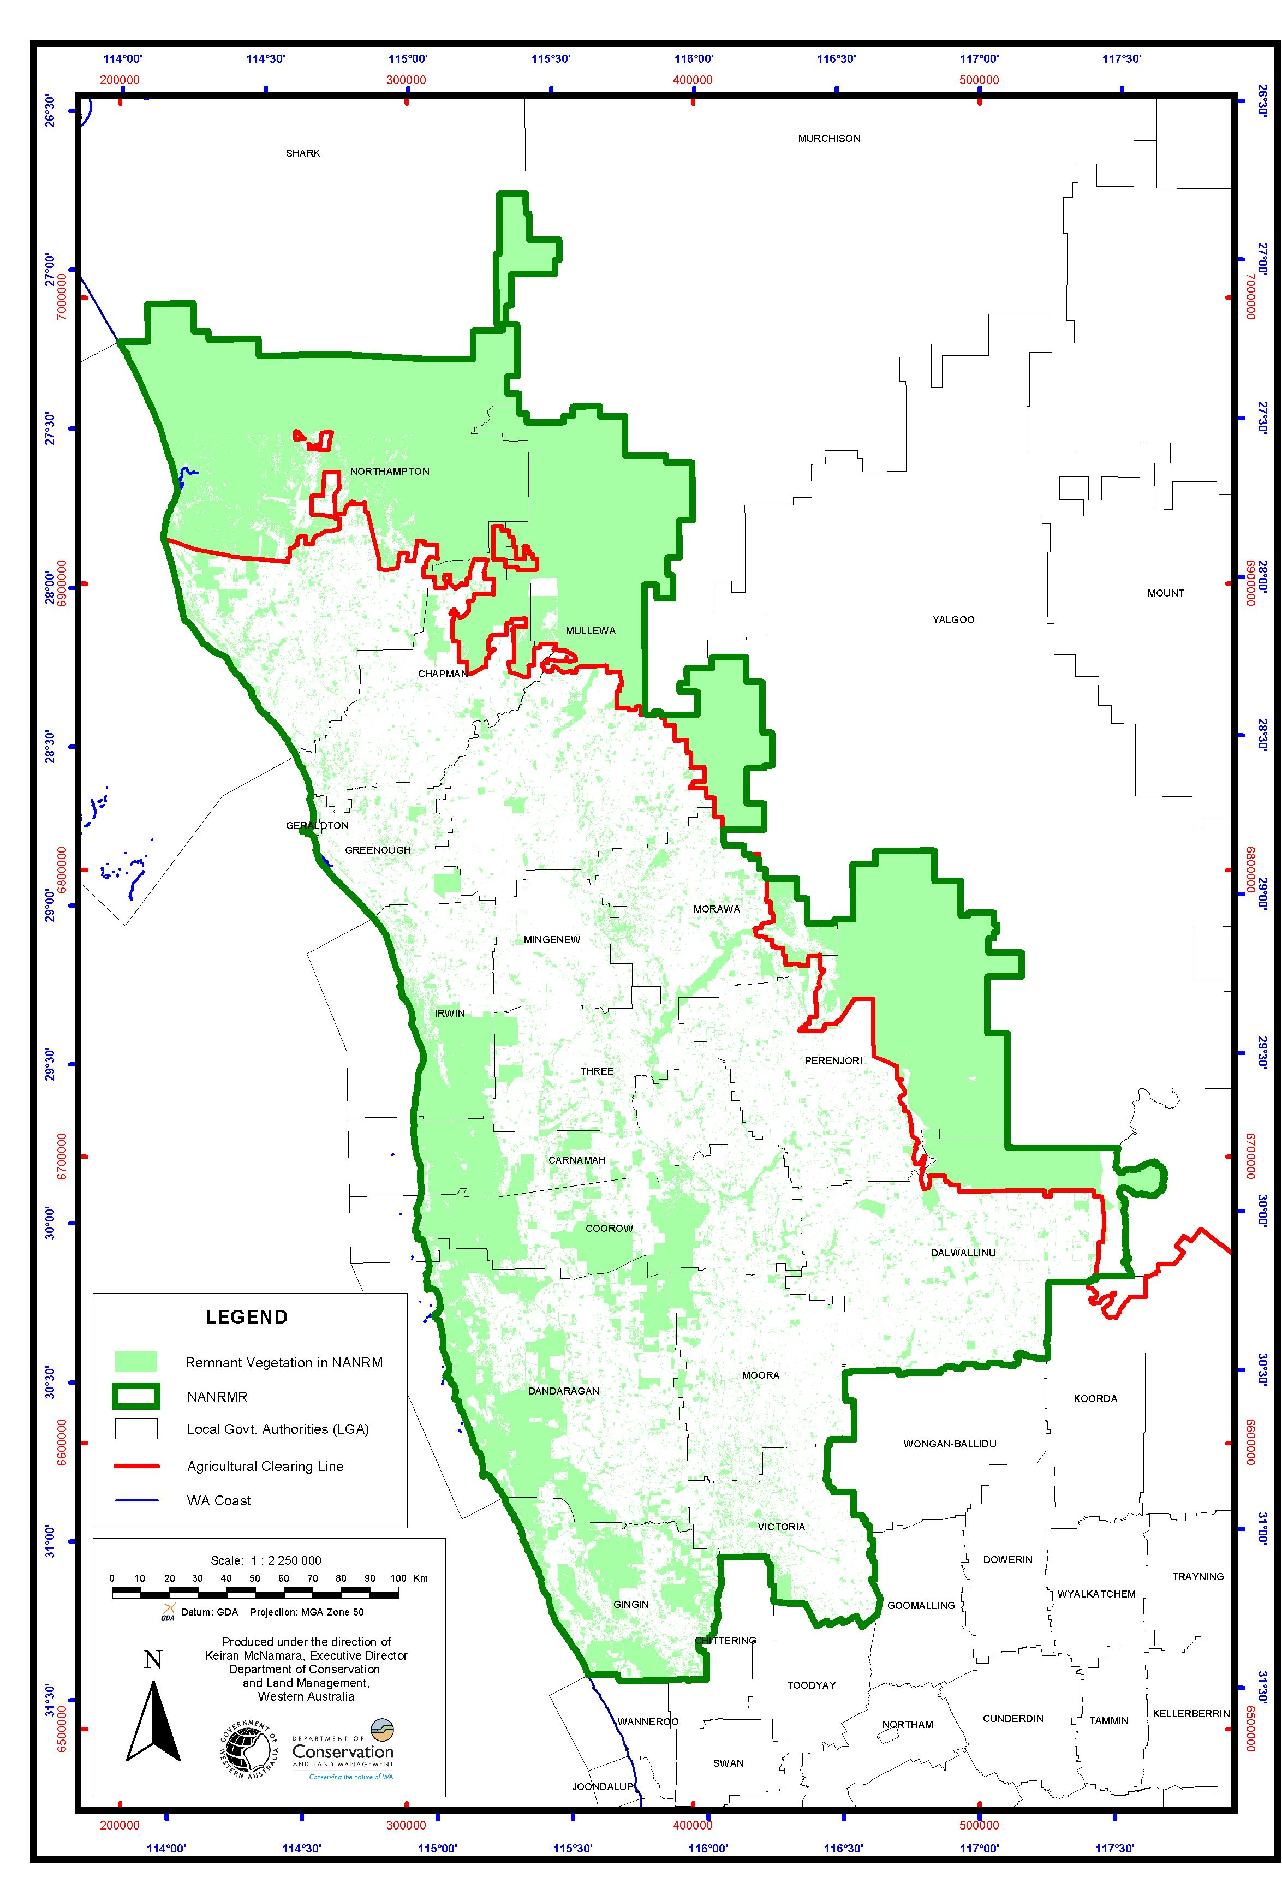

Map 2. The present extent of vegetation of the Northern Agricultural Region.

