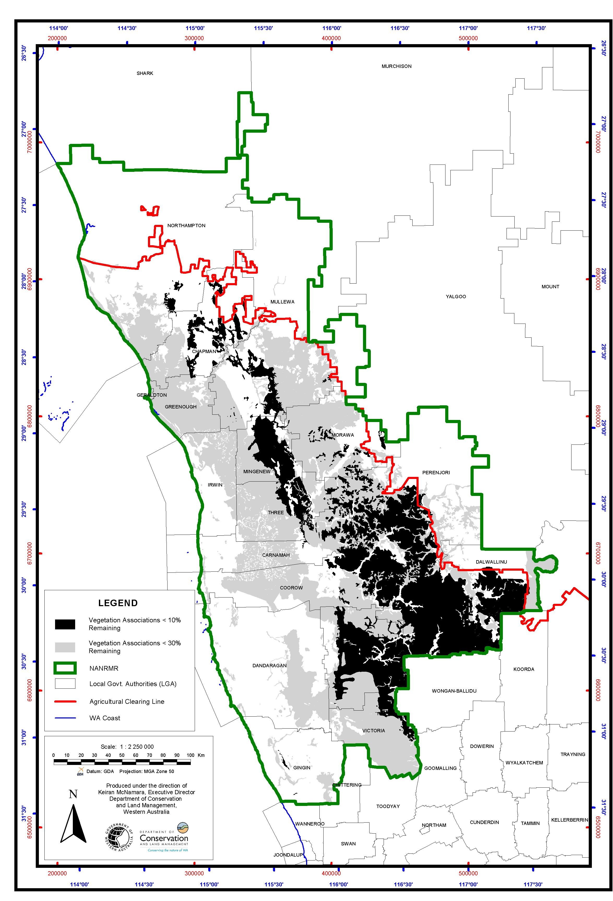
Map 3. Vegetation associations within the Northern Agricultural Region (NAR) with <10% and <30% of their NAR pre-European extent remaining. See Tables 4 and 5.

