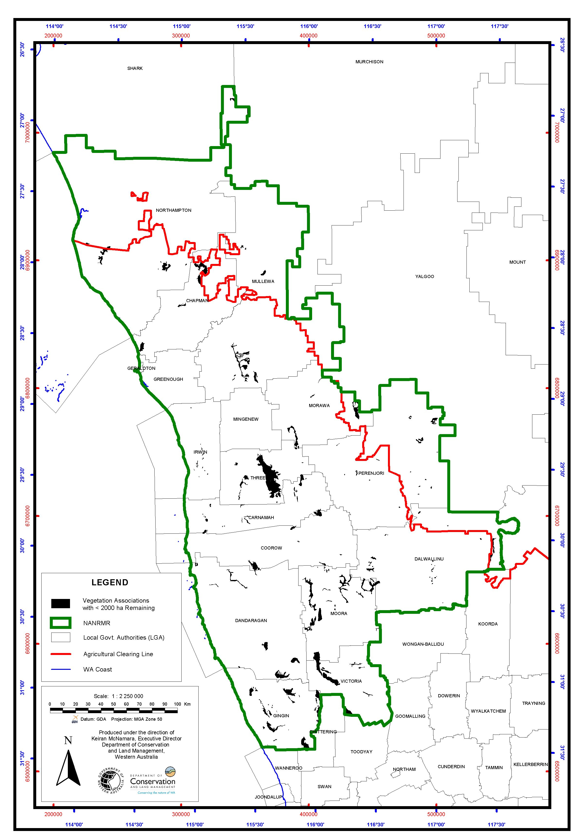Map 4. Vegetation associations of the Northern Agricultural Region. with <2000ha present extent. See also Table 6.

