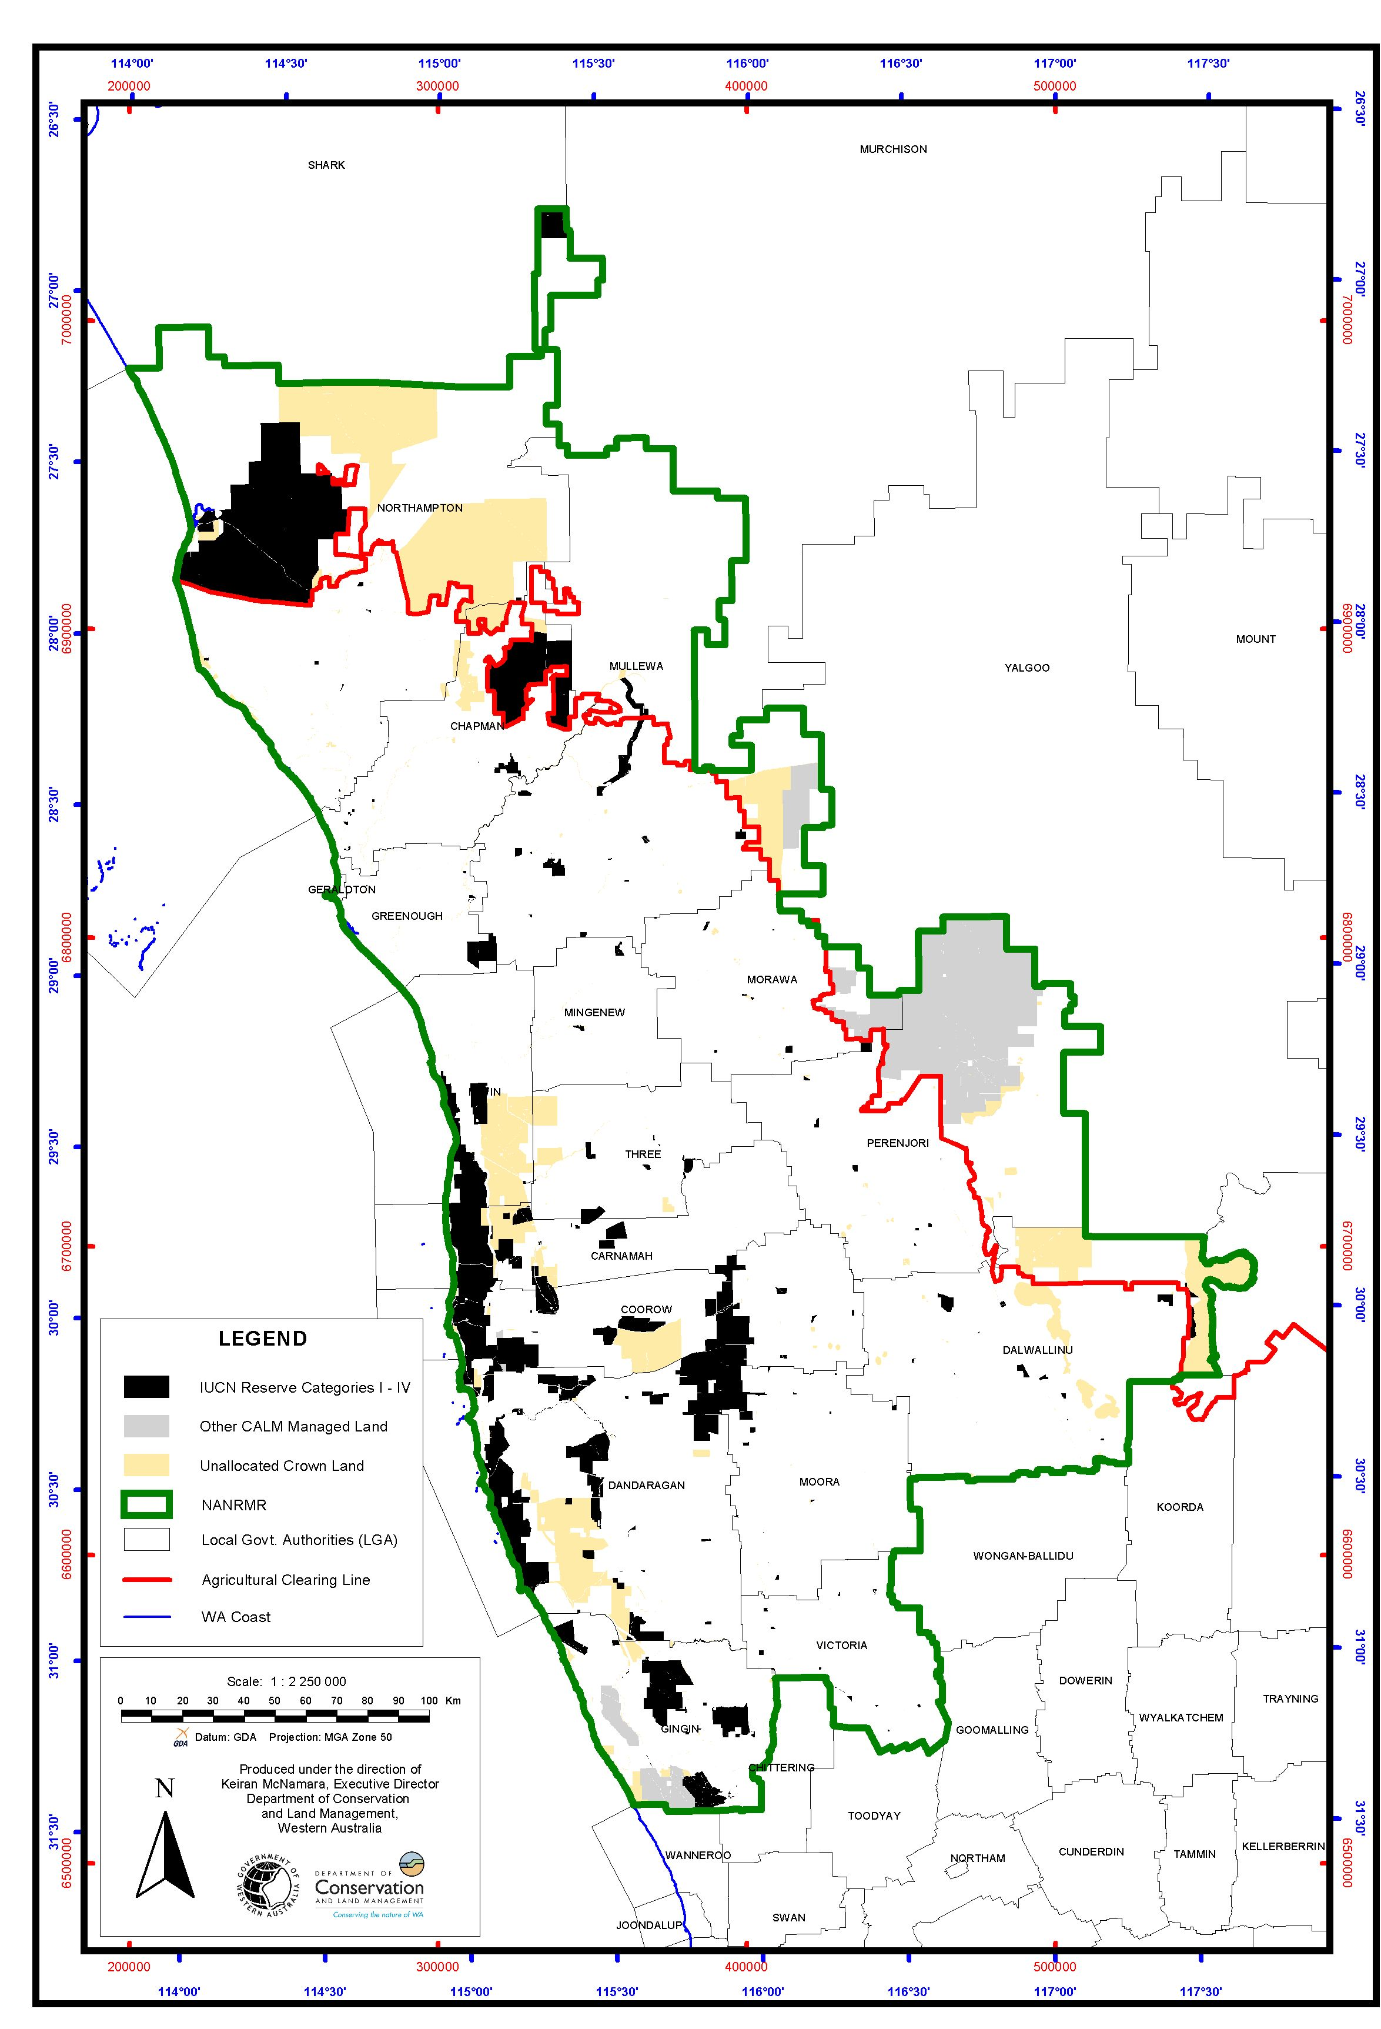
Map 5. IUCN Reserves I-IV, CALM managed land and Unallocated Crown Land of the Northern Agricultural Region.

