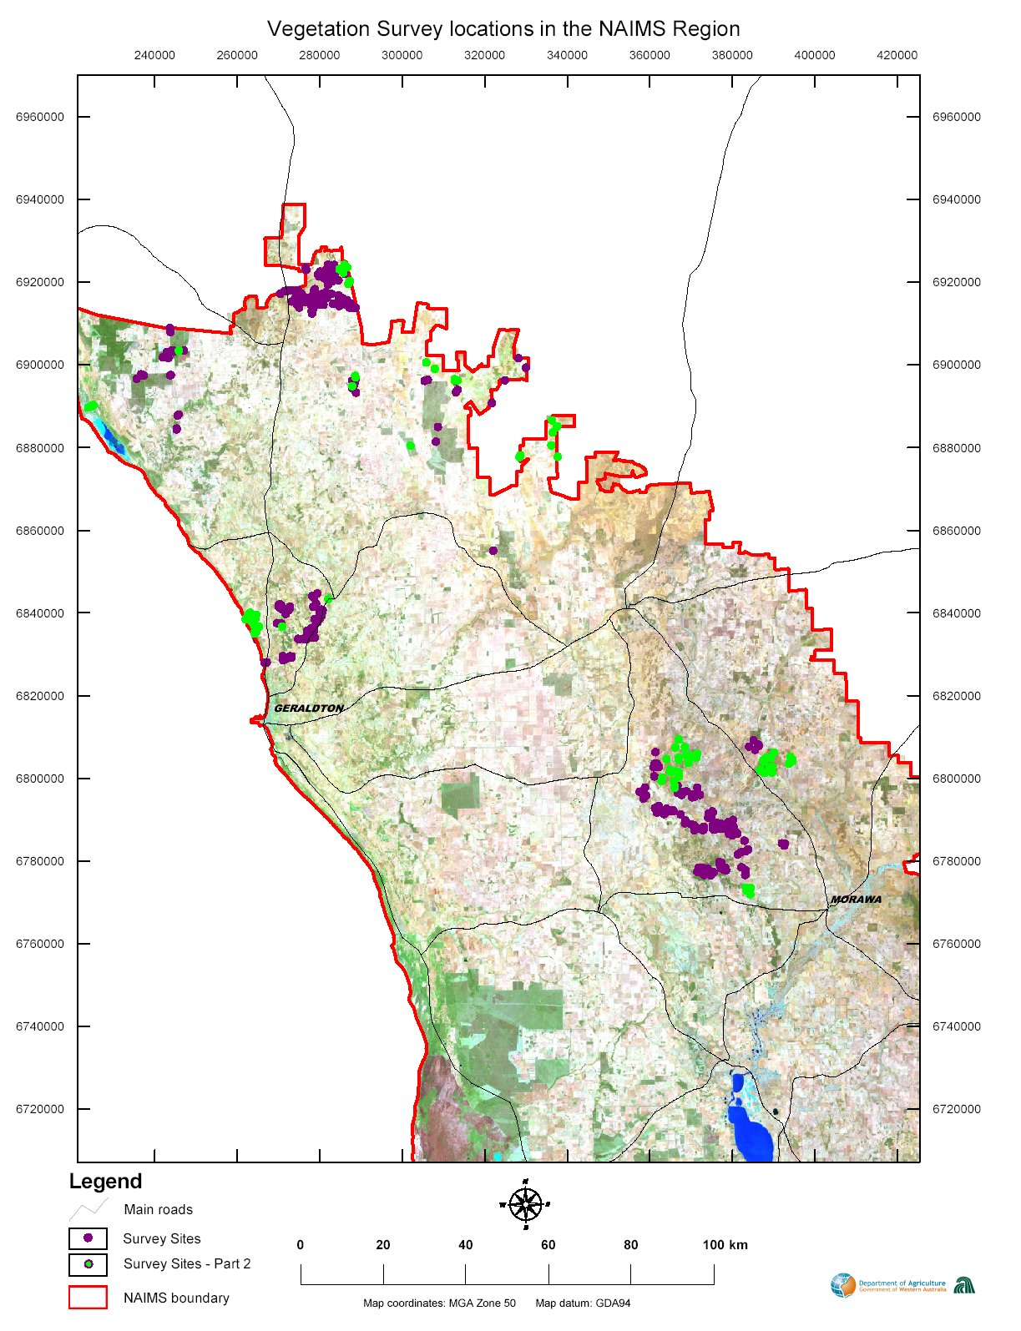

Map 9. The location of remnant vegetation survey sites in the Northern Agricultural Region (NAR). Sites are shown as green and purple dots.

