APPENDIX 1

2009 Quadrat Data

Quatrat GYP001 Date Surveyed 20-10-2009

Location Lake Cobham

Topography and elevation Top of large dune 291.5m +/- 7m

Soils: 5-15cm 12% gypsum 50cm 2.6% gypsum
Below ~1.0m - high levels of gypsum (Regan Grant pers com)

Quadrat orientation: ENE

Photograph reference and orientation: IMG_1534 SE IMG_1535 SW

GPS (WGS 84) NW corner 33° 26’ 12.4” 119° 17’ 33.1”

Diagnosis (Muir 1977): Low Woodland A over Open Low Scrub A over Open Dwarf Scrub C over Low Heath D (scattered grasses)

Condition: Very Good. Minor weed invasion, rabbit activity, old tracks and past disturbance – pits.

Life Form | Species | Height cm | % canopy cover
Tree | Eucalyptus kondininensis | 800 | 20
Shrub | Exocarpos aphyllus | 210 | 2
Shrub | Maireana oppositifolia | 80 | 5
Shrub | Tecticornia pterygosperma subsp. pterygosperma | 55 | 1
Shrub | Atriplex paludosa | 40 | 65
Shrub | Rhagodia crassifolia | 40 | 1
Sub shrub | Disphyma crassifolium | 5 | 2
Grass | Austrostipa juncifolia | 80 | 1.5
 | Adjacent to quadrat
Shrub | Scaevola spinescens | 110
Shrub | Pittosporum angustifolium | 200
Shrub | Lycium australe | 80
Grass | *Bromus rubens | 20
Perennial herb | Lomandra effusa | 30
Perennial herb | Dianella brevicaulis | 25
Annual herb | Trichanthodium skirrophorum | 6

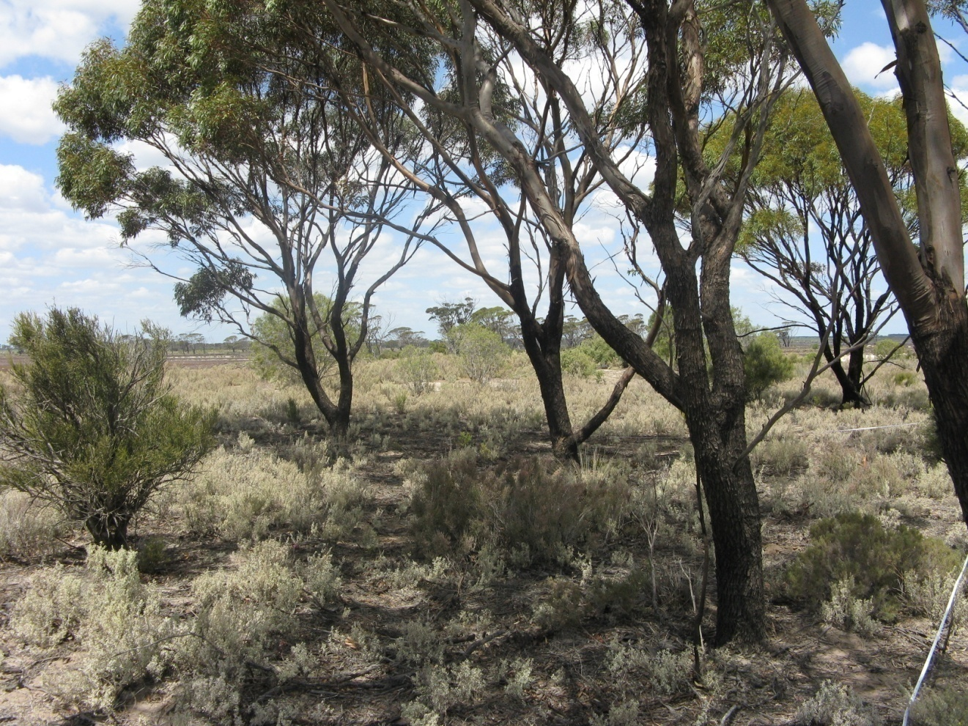
Photograph 1. GYP001 Facing SE
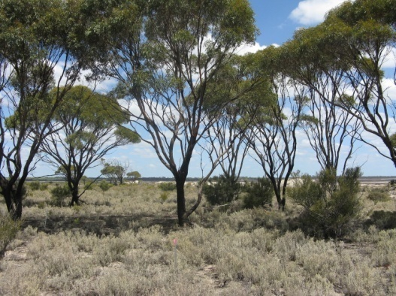
Photograph 2 . GYP001 Facing SW

Quadrat GYP002 Date Surveyed 20-10-2009

Location Lake Cobham

Topography and elevation: Slight ridge - edge of bare lake bed. 286.9 m +/-5 m

Soils: 5-15cm 88% gypsum

Quadrat orientation: NE

Photograph reference and orientation: IMG_1543 NE IMG_1544 NNE

GPS (WGS 84) NW corner 33° 25’ 57.7” 119° 16’ 41.2”

Diagnosis (Muir 1977): Low Heath D

Condition: Excellent. Some weed.

Comments: Frankenia sp. southern gypsum (M.N. Lyons 2864) is a P1 priority species.

Life Form | Species | Height cm | % canopy cover
Shrub | Tecticornia halocnemoides subsp. caudata | 20-30 | 70
Shrub | Tecticornia syncarpa | 20-30
Shrub | Tecticornia pergranulata subsp. pergranulata | 20-30
Shrub | Frankenia sp. southern gypsum (M.N. Lyons 2864 | 10 | 20
Shrub | Frankenia cinerea | 10
Shrub | Frankenia tetrapetala | 10
Grass | Austrodanthonia setacea | 15 | <1
Grass | *Parapholis incurva | 5 | <1

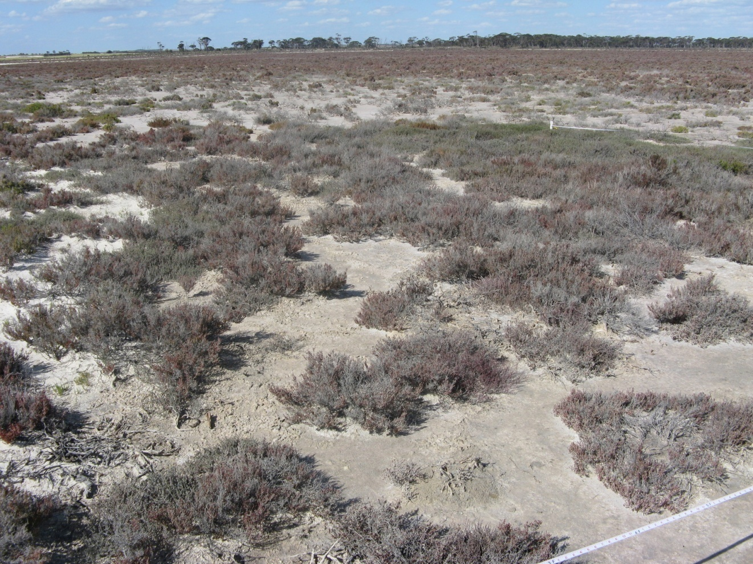
Photograph 3 GYP002
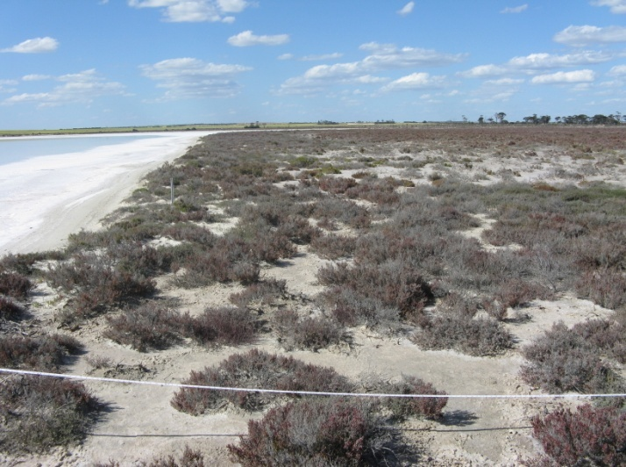
Photograph 4 GYP002
Quadrat GYP003 Date Surveyed 21-10-2009

Location Lake Magenta (North)

Topography and elevation: Large Dune. 293.0 +/- 4.5 m

Soils: 5-15cm 88% gypsum 50cm 92% gypsum

Quadrat orientation: SSW (Top of dune and down slope)

Photograph reference and orientation: IMG_1549 NE IMG_1550 NNE

GPS (WGS 84) NW corner 33° 24′ 51.8″ 119° 12′ 41.5″

Diagnosis (Muir 1977): Dwarf Scrub D (scattered trees to 3.5m and scattered Tecticornia shrubs to 1.0m)

Condition: Excellent. Rabbits, kangaroos. Seedling regeneration.

Life Form | Species | Height cm | % canopy cover
Tree (1 dead) | Eucalyptus spathulata subsp. spathulata | 350 | 5
Shrub | Tecticornia moniliformis | 50 | 20
Shrub | Darwinia sp. Karonie | 50 | 2
Shrub | Lawrencia squamata | 30 | 2
Shrub | Atriplex paludosa | 25 | 1
Shrub | Frankenia tetrapetala | 15 | 1
Shrub | Disphyma crassifolium | 5 | 1
Grass | Austrostipa pycnostachya | 10 | <1
 | Adjacent to quadrat
Shrub | Pittosporum angustifolium | 100
Shrub | Exocarpos aphyllus | 120

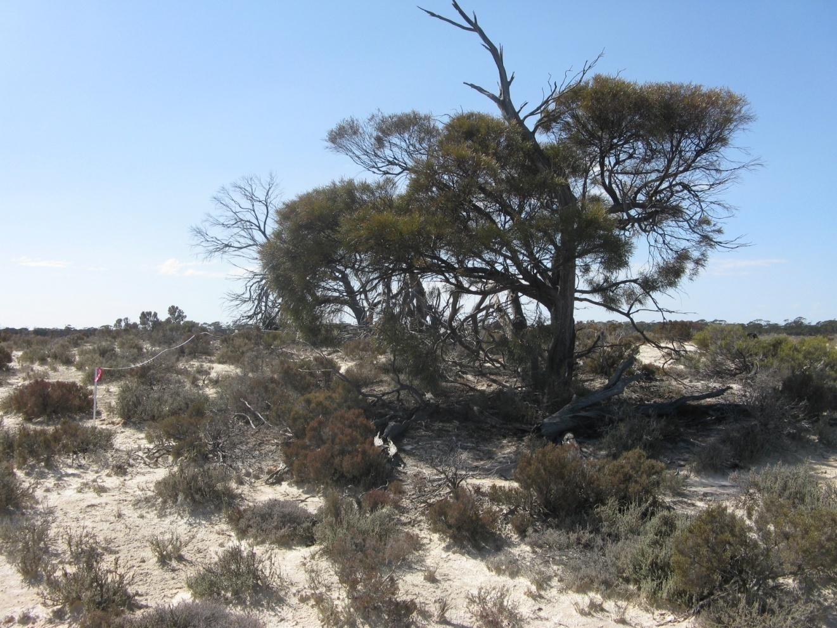
Photograph 5 GYP003
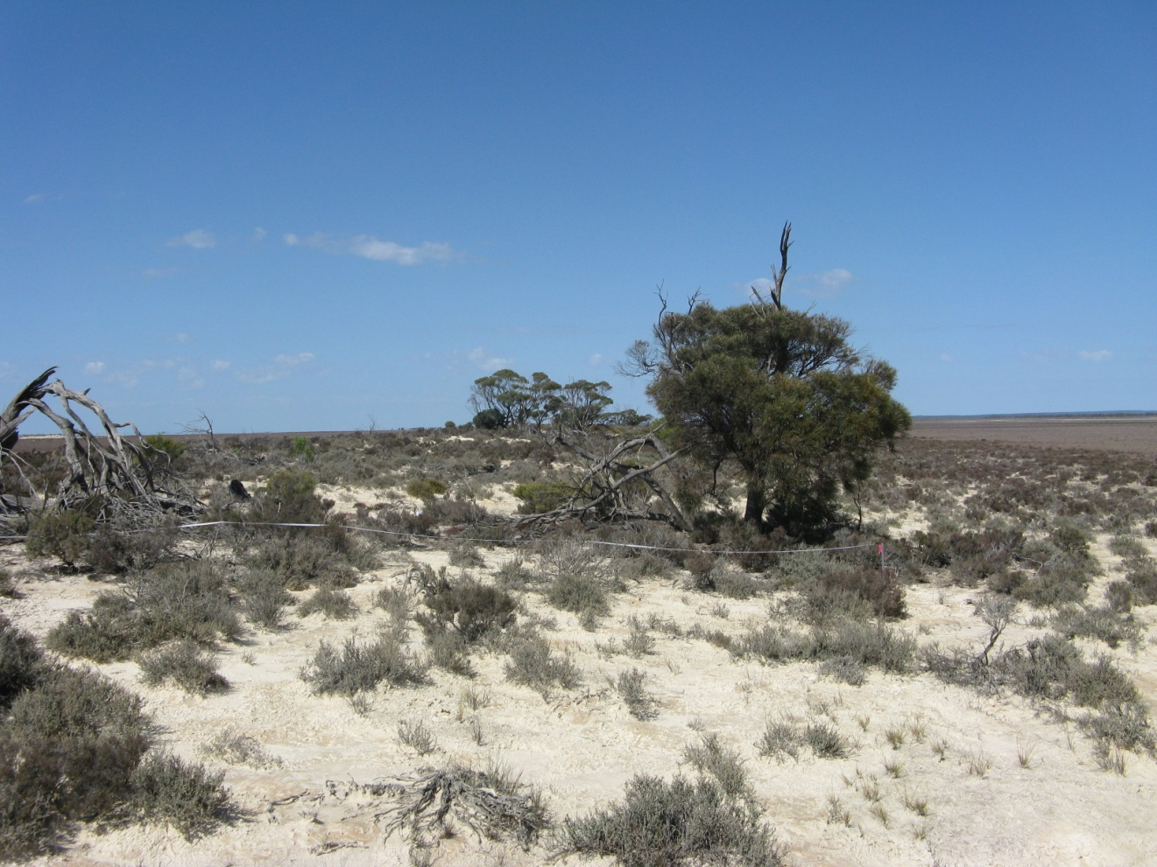
Photograph 6 GYP003

Quadrat GYP004 Date Surveyed 21-10-2009

Location: Lake Magenta (North)

Topography and elevation: Top of large Dune. 286.9 +/- 4.9 m

Soils: 5-15cm 65% gypsum 50cm 91% gypsum

Quadrat orientation: NS

GPS (WGS 84) NW corner 33° 24′ 46.7″ 119° 12′ 46.3″

Photograph reference and orientation: IMG_1556 S E IMG_1557 SE

Diagnosis (Muir 1977): Open Dwarf Scrub C over Dwarf Scrub D (scattered Melaleuca shrubs to 3 m and scattered grasses to 20 cm)

Condition: Excellent. Some weed adjacent to quadrat including Brome grass and wild oats. Rabbits, kangaroos. Regeneration - seedlings.

Life Form | Species | Height cm | % canopy cover
Shrub | Melaleuca hamulosa | 300 | 2
Shrub | Lycium australe | 80 | 1
Shrub | Tecticornia moniliformis | 40-80 | 20
Shrub | Lawrencia squamata | 50 | <1
Shrub | Maireana oppositifolia | 50 | <1
Shrub | Atriplex paludosa | 40 | <1
Shrub | Rhagodia drummondii | 25 | <1
Shrub | Enchylaena tomentosa | 20 | <1
Shrub | Frankenia tetrapetala | 10 | <1
Shrub | Frankenia cinerea | 10 | <1
Shrub | Frankenia sp. southern gypsum (M.N. Lyons 2864) | 3 | <1
Shrub | Disphyma crassifolium | 5 | 2
Grass | Austrostipa elegantissima | 20 | <1
Grass | Austrostipa pycnostachya | 15 | <1
 | Adjacent to quadrat
Shrub | Pittosporum angustifolium | 150
Grass | Austrostipa juncifolia | 20

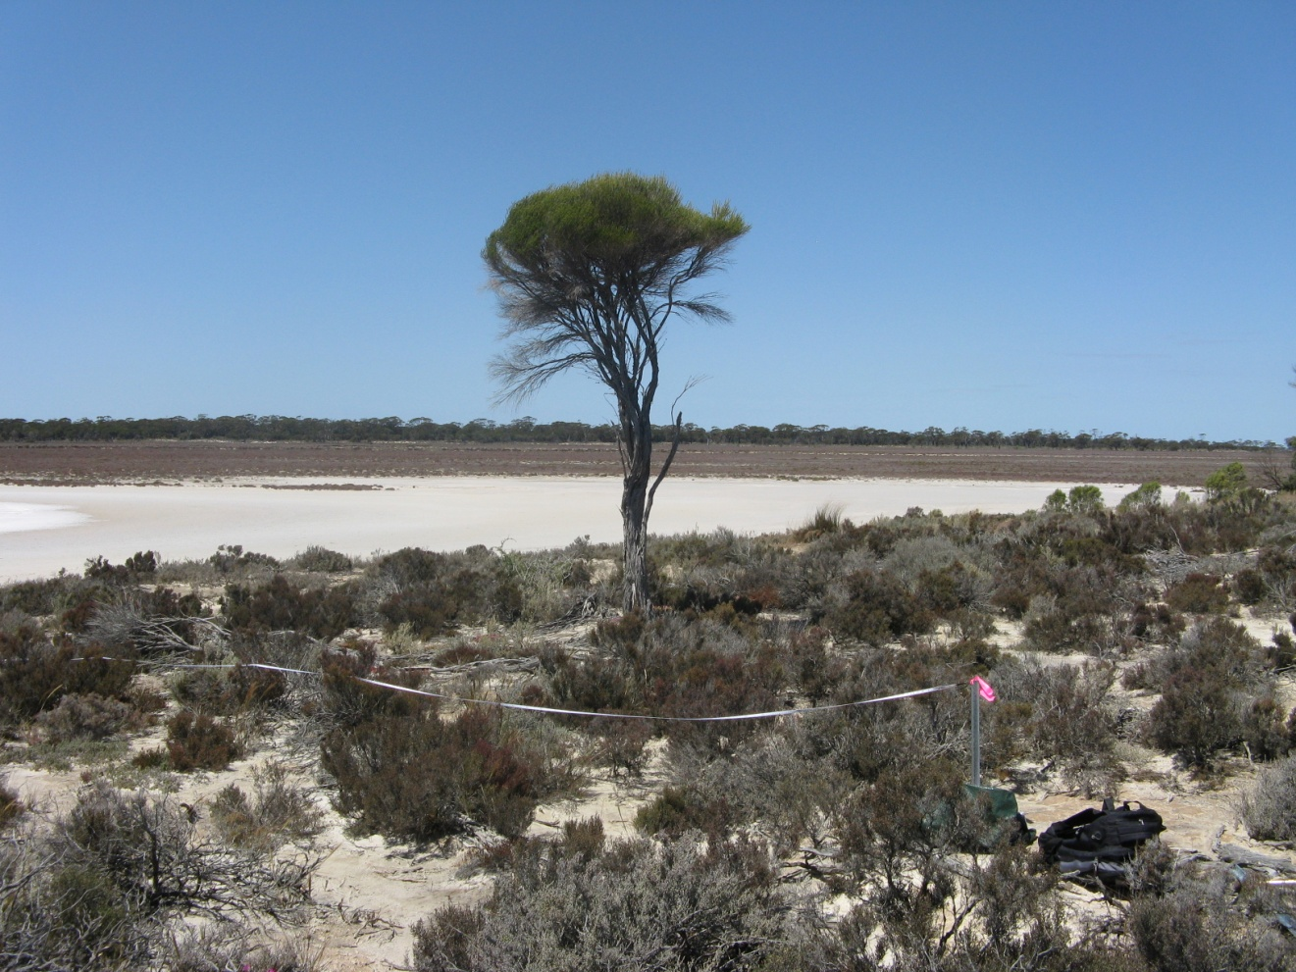
Photograph7 GYP004
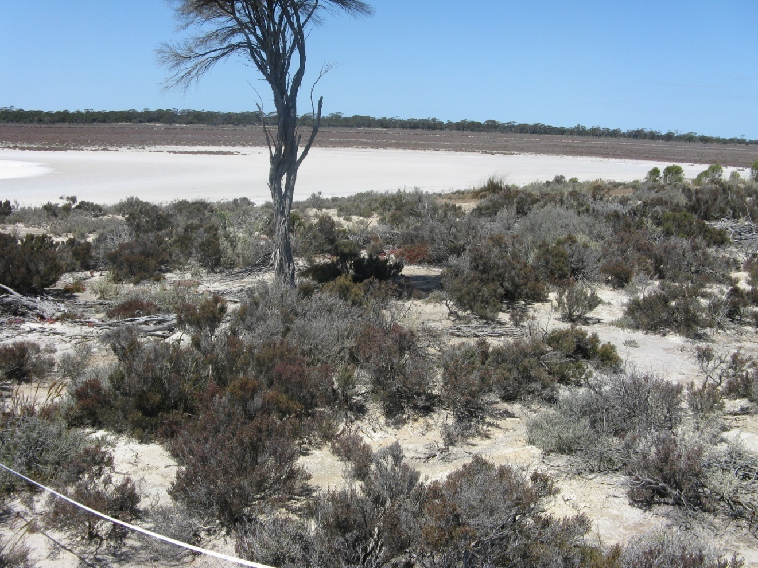
Photograph 8 GYP004
Quadrat GYP005 Date Surveyed 21-10-2009

Location Lake Magenta (north)

Topography: Top and east facing slope of large dune. 291.6 +/- 4.7 m

Soils: 5-15cm 38% gypsum 50cm 77% gypsum

Quadrat orientation: S

Photograph reference and orientation: IMG_1558 SE IMG_1559 S

GPS (WGS 84) NW corner 33° 24′ 41.2″ 119° 12′ 49.3″

Diagnosis (Muir 1977): Low Woodland B over Low Heath D
(scattered shrubs to 3 m)

Condition: Excellent. Some minor weeds, rabbits, kangaroos. Regeneration - seedlings

Life Form | Species | Height cm | % canopy cover
Tree | Eucalyptus aff. quadrans | 400 | 20
Shrub | Pittosporum angustifolium | 300 | <1
Shrub | Exocarpos aphyllus | 60 | 1
Shrub | Tecticornia pterygosperma subsp. pterygosperma | 50 | 20
Shrub | Atriplex paludosa | 50 | 30
Shrub | Rhagodia crassifolia | 50 | 1
Shrub | Lawrencia squamata | 50 | 1
Shrub | Frankenia tetrapetala | 15 | 1
Shrub | Disphyma crassifolium | 5 | 1
 | Adjacent to quadrat
Grass | *Bromus rubens
Grass | *Trifolium arvense
Grass | *Pentaschistis airoides

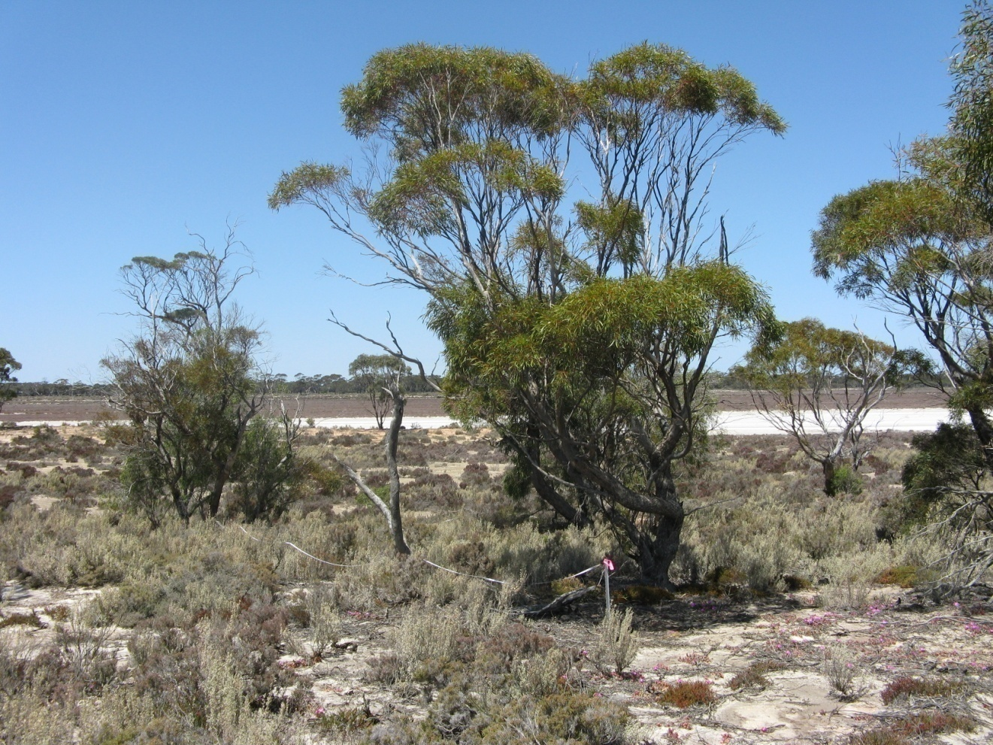
Photograph 9 GYP005
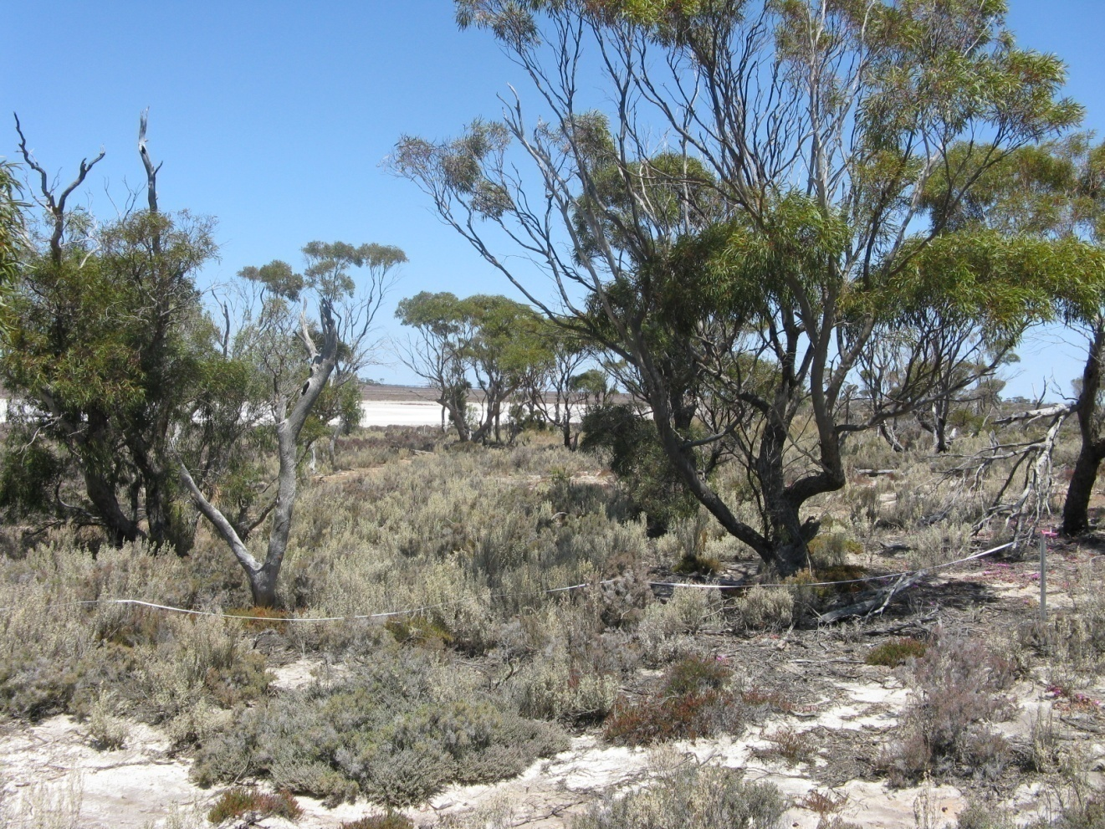
Photograph 10 GYP005
Quadrat GYP006 Date Surveyed: 21-10-2009

Location: Lake Magenta (north)

Topography: Edge of wide dune. Low area in middle. 288.5 +/- 4.3 m

Soils: 5-15cm 2.3% gypsum 50cm 46% gypsum

Quadrat orientation: SSW

Photograph reference and orientation: IMG_1560 S IMG_1562 SSW

GPS (WGS 84) NW corner 33° 24′ 40.9″ 119° 12′ 53.3″

Diagnosis (Muir 1977): Low Woodland A (patchy over area) over Low Scrub A over Dwarf Scrub D (scattered grasses and annual herbs)

Condition: Excellent. Trees dying back

Life Form | Species | Height cm | % canopy cover
Tree | Eucalyptus kondininensis | 1000 | 10
Shrub | Pittosporum angustifolium | 150 | 5
Shrub | Exocarpos aphyllus | 180 | 10
Shrub | Lycium australe | 150 | 2
Shrub | Atriplex paludosa | 50 | 20
Shrub | Lawrencia squamata | 40 | 1
Shrub | Enchylaena tomentosa | 20 | 1
Shrub | Maireana oppositifolia | 40 | 1
Shrub | Tecticornia moniliformis | 40 | 1
Shrub | Maireana erioclada | 25 | 1
Grass | Austrodanthonia setacea | 30 | <1
Grass | Austrostipa trichophylla | 30 | <1
Grass | Austrostipa drummondii | 30 | <1
Grass | *Bromus rubens | 15 | <1
Grass | *Pentaschistis airoides | 10 | <1
Grass | *Rostraria cristata | 10 | <1
Annual herb | Senecio glossanthus | 20 | <1
Annual herb | Crassula exserta | 5 | <1
Annual herb | *Trifolium arvense | 8 | <1
 | Adjacent to quadrat
Shrub | Disphyma crassifolium | 5
Perennial herb | Vittadinia gracilis | 15
Shrub | Melaleuca lanceolata | 180

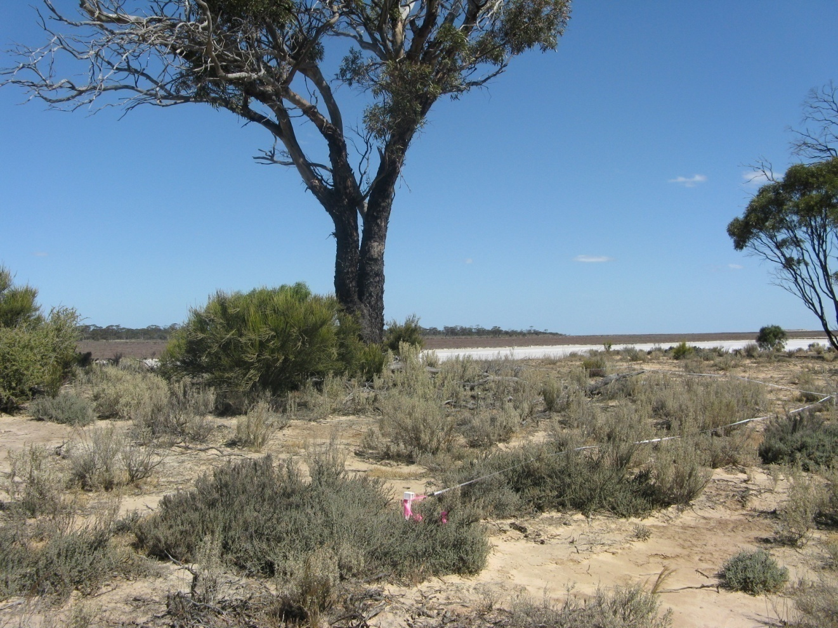
Photograph 11 GYP006
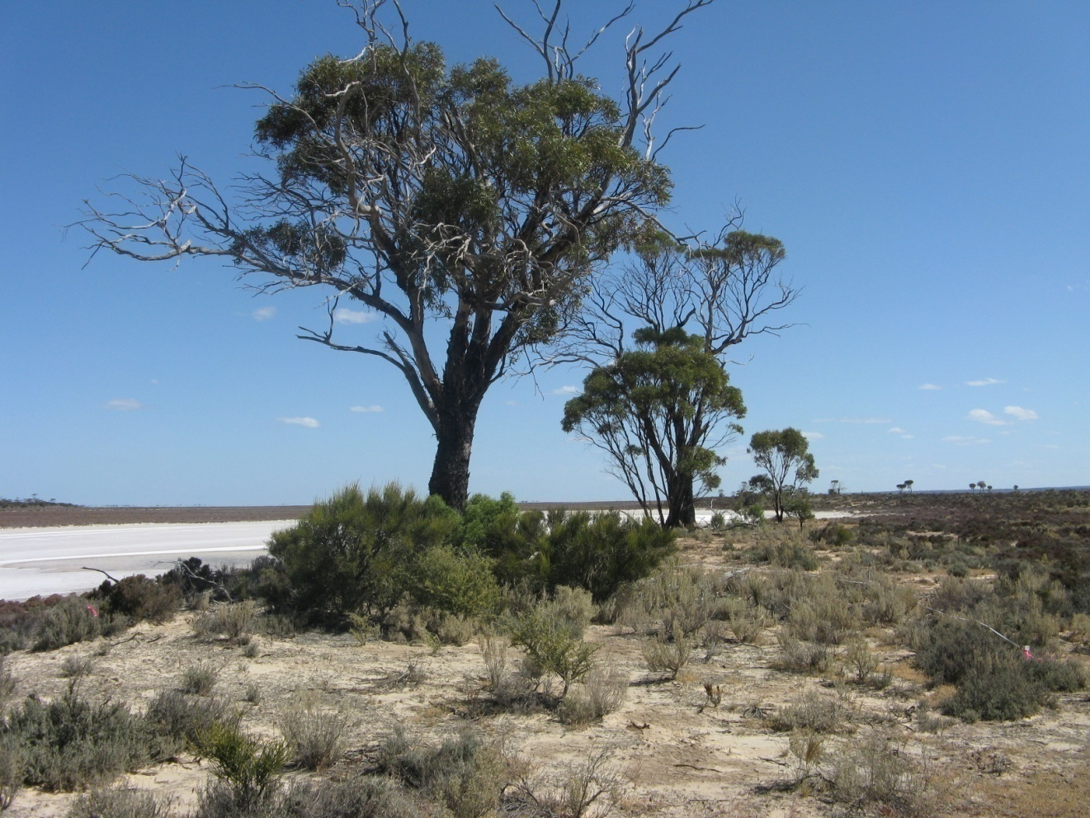
Photograph 12 GYP006
Quadrat GYP007 (G225) Date Surveyed: 21-10-2009

Location: Lake Cobham

Topography: Slight rise on lake bed

Soils: 5-15cm 54% gypsum

Quadrat orientation: SE

Photograph reference and orientation: IMG_1564 SE IMG_1565 NE

GPS (WGS 84) 33° 27’ 26.2” 119° 17’ 14.3”

Diagnosis (Muir 1977): Dwarf Scrub D

Condition: Excellent. Some disturbance including an old track and minor weed invasion.

Comments: Frankenia sp. southern gypsum (M.N. Lyons 2864) is a P1 priority species.

Life Form | Species | Height cm | % canopy cover
Shrub | Tecticornia moniliformis | 40 | 25
Shrub | Tecticornia syncarpa
Shrub | Tecticornia halocnemoides subsp. caudata
Shrub | Tecticornia halocnemoides subsp. Lake Grace
Shrub | Frankenia sp. southern gypsum (M.N. Lyons 2864) | 10 | 1
Sub shrub | Disphyma crassifolium | 5 | 1
Herb | Senecio glossanthes | 20 | <1
Herb | Brachyscome exilis | 10 | <1
Herb | Isotoma scapigera | 8 | <1
Herb | Calandrinia ?sp. Meckering (F. Obbens 42/02) | 8 | <1
Grass | *Parapholis incurva | 5 | <1

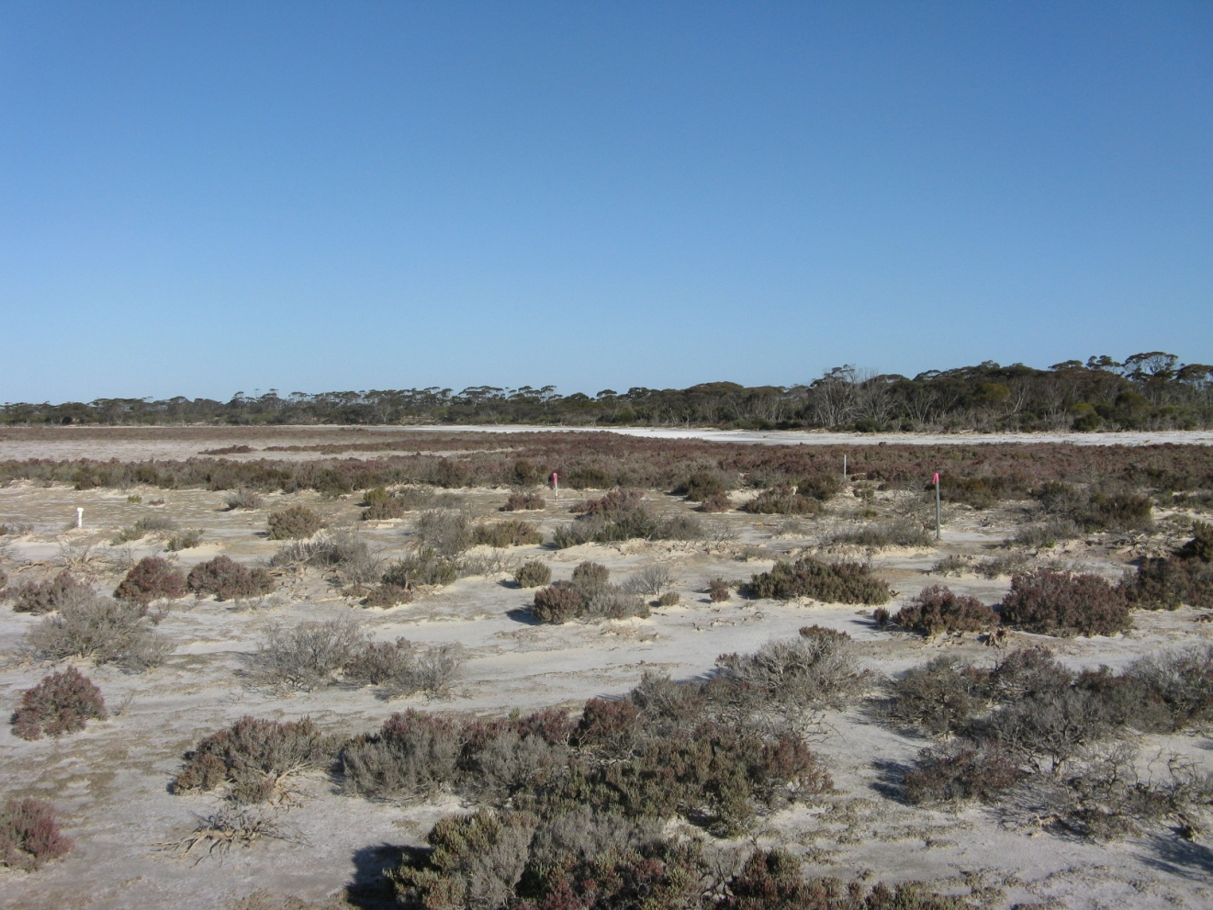
Photograph 13 GYP007
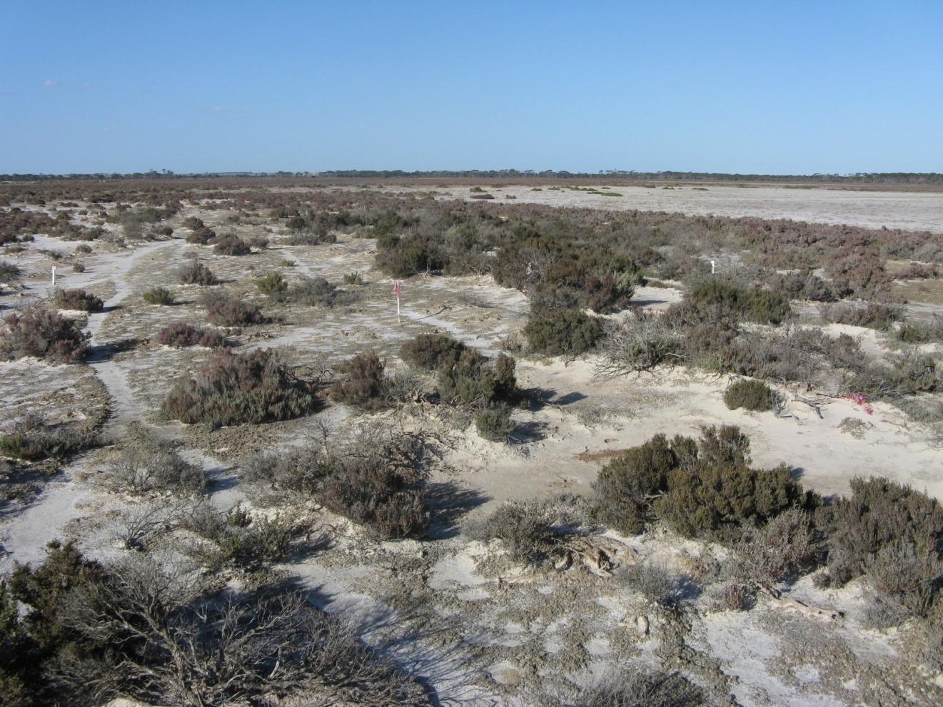
Photograph 14 GYP007
Quadrat GYP008 Date Surveyed 22-10-2009

Location Lake Magenta (north)

Topography: Large dune. NW slope and top. 290.4 +/- 4.7 m

Soils: 5-15cm 93% gypsum 50cm 92% gypsum

Quadrat orientation:

Photograph reference and orientation: IMG_1582 IMG_1584

GPS (WGS 84) NW corner 33° 25′ 16.7″ 119° 11′ 32.0″

Diagnosis (Muir 1977): Low Woodland B (patchy) over Dwarf Scrub D (scattered Tecticornia to 1.0 m)

Condition: Excellent

Life Form | Species | Height cm | % canopy cover
Tree | Eucalyptus spathulata subsp. spathulata | 400 | 30
Shrub | Tecticornia moniliformis | 50 | 5
Shrub | Darwinia halophila ms | 40 | 5
Shrub | Maireana oppositifolia | 30 | 5
Shrub | Lawrencia squamata | 30 | 1
Shrub | Atriplex paludosa | 60 | <1
Shrub | Frankenia tetrapetala | 10 | 1
Shrub | Frankenia sp. southern gypsum (M.N. Lyons 2864) | 10 | <1
Shrub | Disphyma crassifolium | 5 | 1
Twining | Comesperma volubile | 15 | <1
Grass | Austrostipa puberula | 15 | <1
Grass | Austrostipa pycnostachya | 15 | <1
Perennial herb | Zygophyllum glaucum | prostrate | <1
Twining | Thysanotus manglesianus |  | <1
 | Adjacent to quadrat
Twining | Billardiera lehmanniana
Shrub | Exocarpos aphyllus
Shrub | Maireana erioclada
herb | Trichanthodium skirrophorum

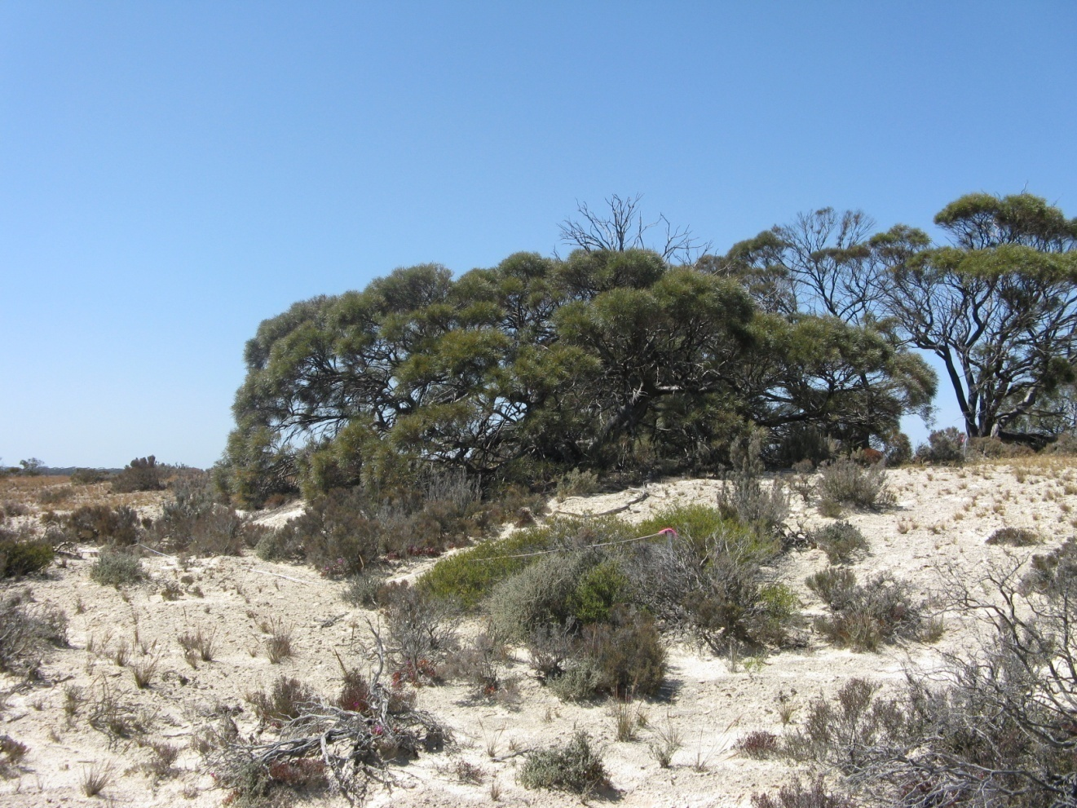
Photograph 15 GYP008
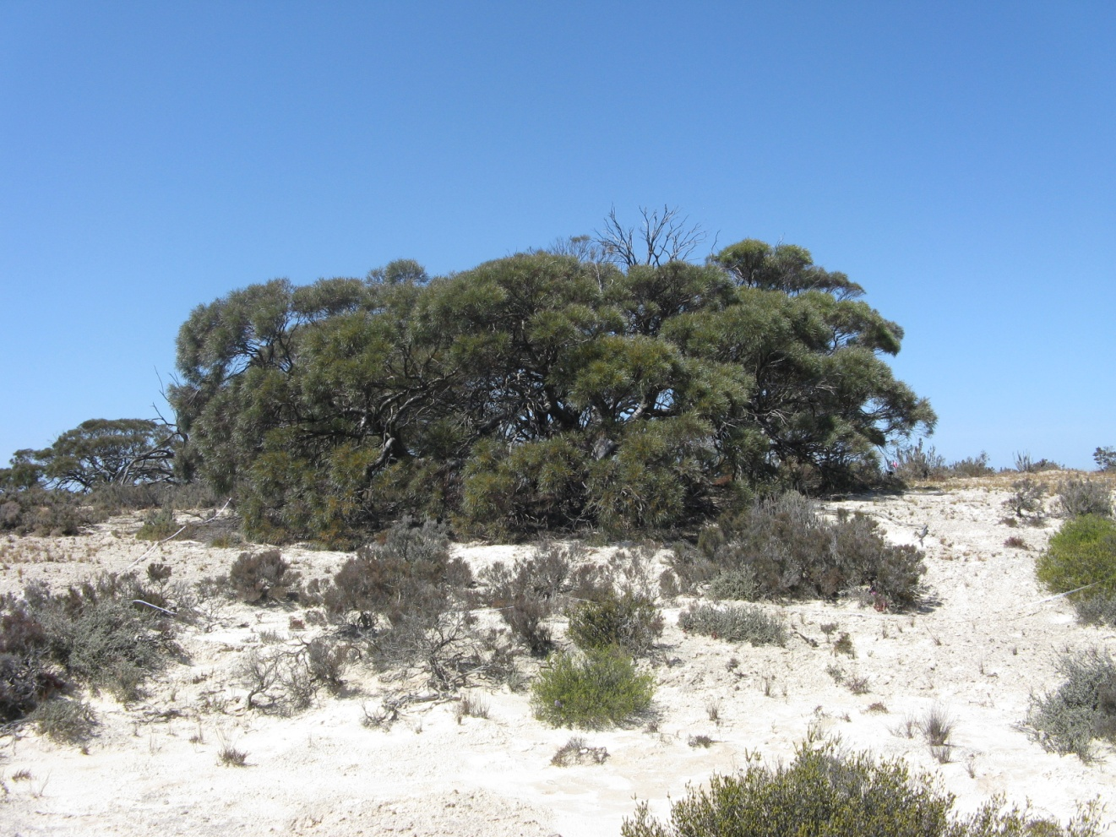
Photograph 16 GYP008
Quadrat GYP009 Date Surveyed 22-10-2009

Location Lake Magenta (north)

Topography: Very gentle slope from lake bed to base of dune. 288.8 +/- 5.0 m

Soils: 5-15cm 92% gypsum

Quadrat orientation: S

Photograph reference and orientation: IMG_1593 SE IMG_1594 S

GPS (WGS 84) NW corner 33° 25′ 18.1″ 119° 11′ 32.2″

Diagnosis (Muir 1977): Dwarf Scrub D

Condition: Excellent. Some dead plants.

Life Form | Species | Height cm | % canopy cover
Shrub | Tecticornia moniliformis | 50 | 5
Shrub | Tecticornia loriae | 50
Shrub | Lawrencia squamata | 40 | 5
Shrub | Maireana oppositifolia | 40 | 1
Shrub | Frankenia tetrapetala | 10 | <1
Shrub | Frankenia sp. southern gypsum (M.N. Lyons 2864) | 8 | <1
Shrub | Rhagodia crassifolia | 30 | <1
Shrub | Disphyma crassifolium | 5 | <1
Grass | Austrostipa pycnostachya | 15 | <1
Grass | *Parapholis incurva | 5 | <1
 | Adjacent to quadrat
Perennial herb | Calandrinia ?sp. Meckering (F. Obbens 42/02) | 10

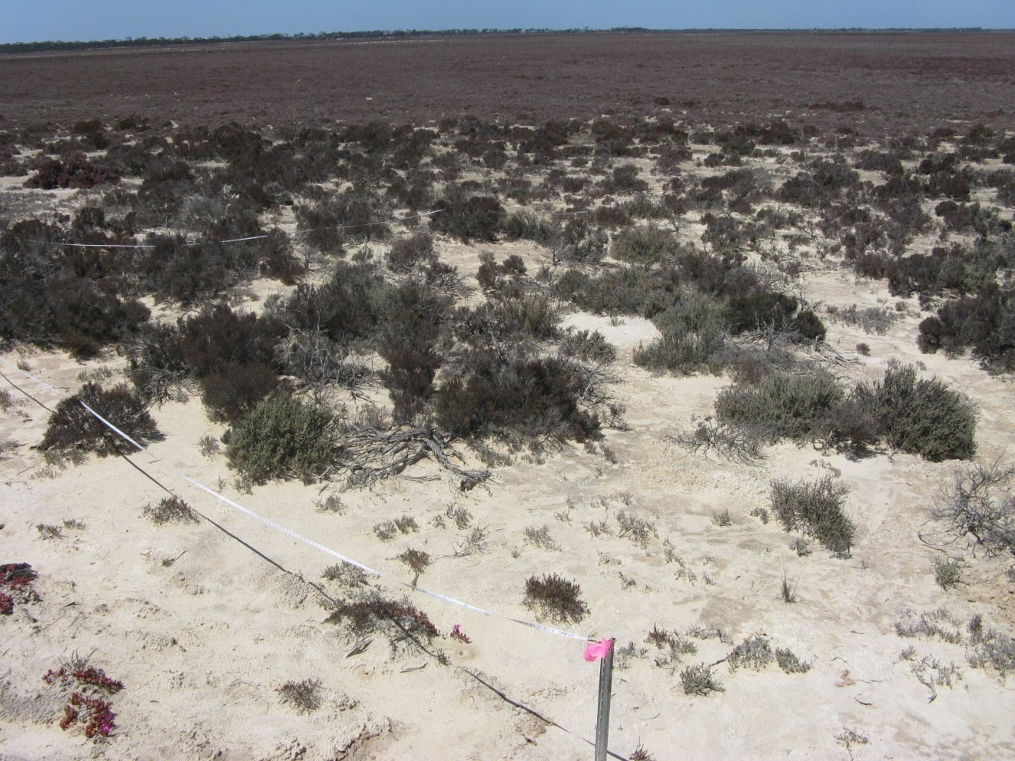
Photograph 17 GYP009
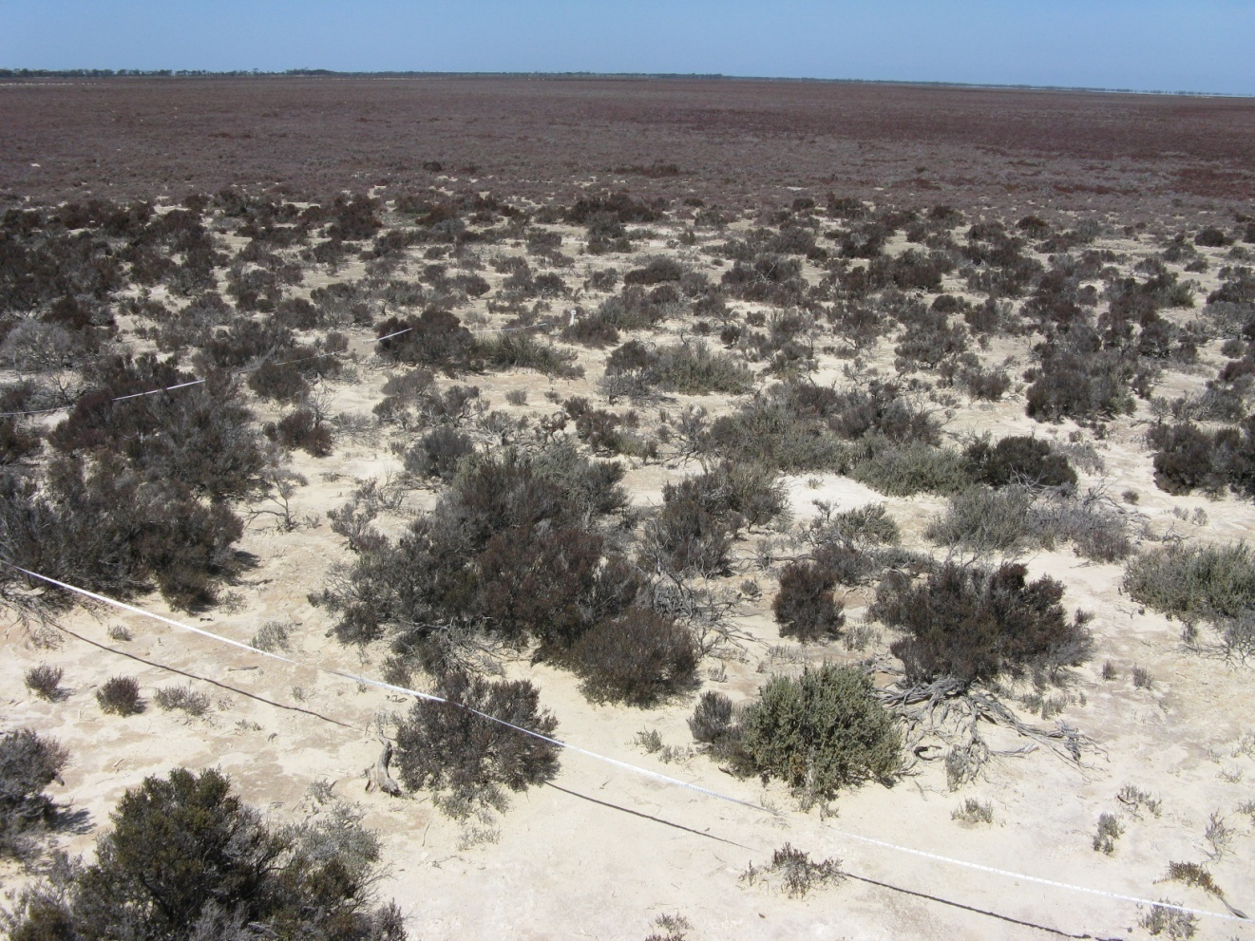
Photograph 18 GYP009
Quadrat GYP010 Date Surveyed 22-10-2009

Location Lake Magenta (north)

Topography: Lower slope of low dune. 290.8 +/- 3.9 m

Soils: 5-15cm 39% gypsum 50cm 55% gypsum

Quadrat orientation: SSW

Photograph reference and orientation: IMG_1596 S IMG_1598 SW side

GPS (WGS 84) NW corner 33° 24′ 18.1″ 119° 11′ 36.5″

Diagnosis (Muir 1977): Open Dwarf Scrub C over Low Heath D

Condition: Excellent. Some weed adjacent to quadrat. Dead shrub. Regeneration - seedlings

Life Form | Species | Height cm | % canopy cover
Shrub | Hakea preissii | 100
Shrub | Atriplex paludosa subsp. baudinii | 50
Shrub | Maireana oppositifolia | 50
Shrub | Lawrencia squamata | 20
Shrub | Enchylaena tomentosa | 5
Shrub | Tecticornia pterygosperma subsp. pterygosperma | 50
Shrub | Frankenia sp. southern gypsum (M.N. Lyons 2864) | 10
Shrub | Lepidium rotundum | 10
Grass | Austrostipa elegantissima | 20
Grass | Austrodanthonia setacea | 15
Grass | Austrostipa drummondii | 15
Grass | Avena barbata | 40
Grass | Parapholis incurva | 5
Annual herb | Brachyscome ciliaris | 10
Annual herb | Trichanthodium skirrophorum | 5
Perennial herb | Isotoma scapigera | 5
Perennial herb | Dianella brevicaulis | 50

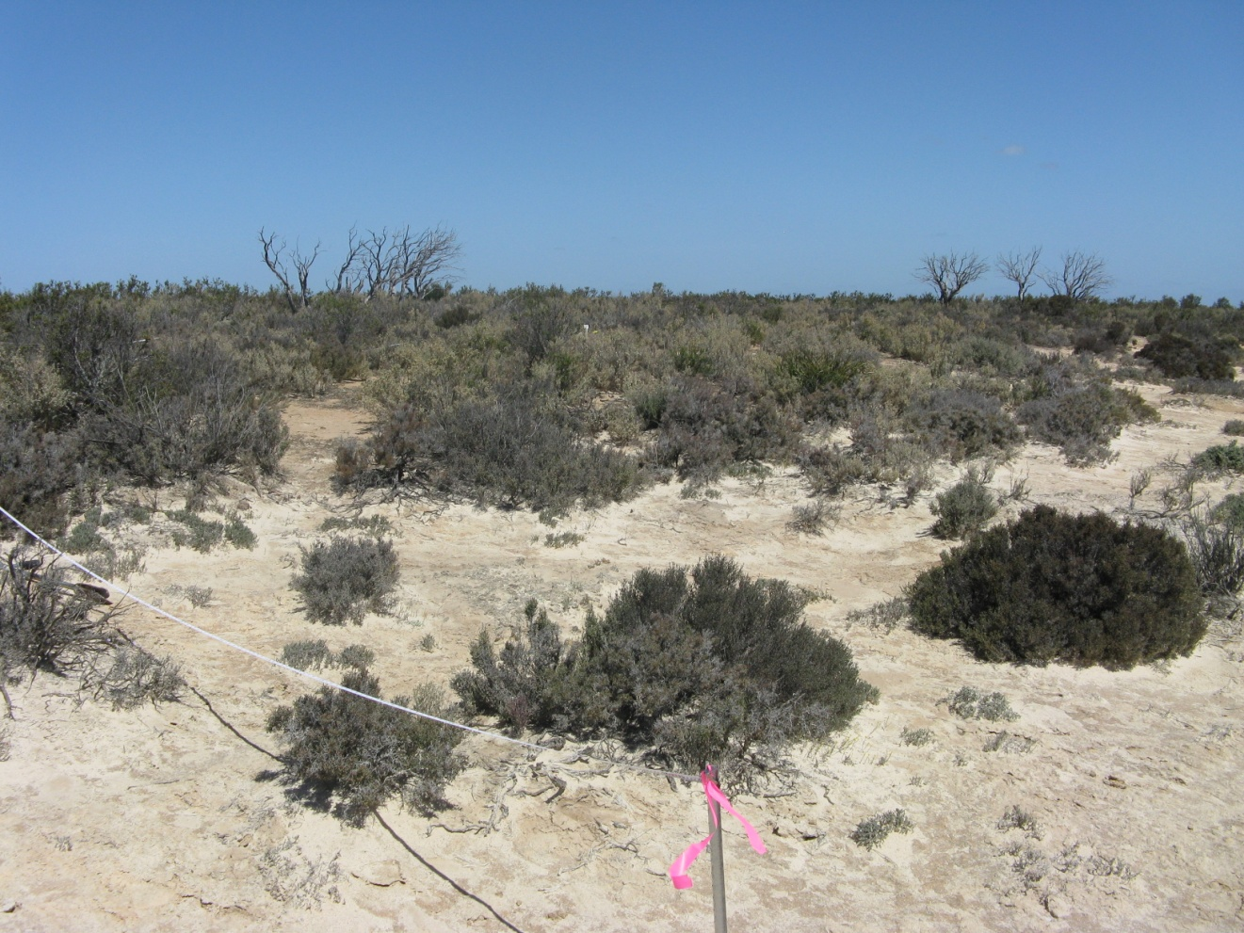
Photograph 19 GYP010
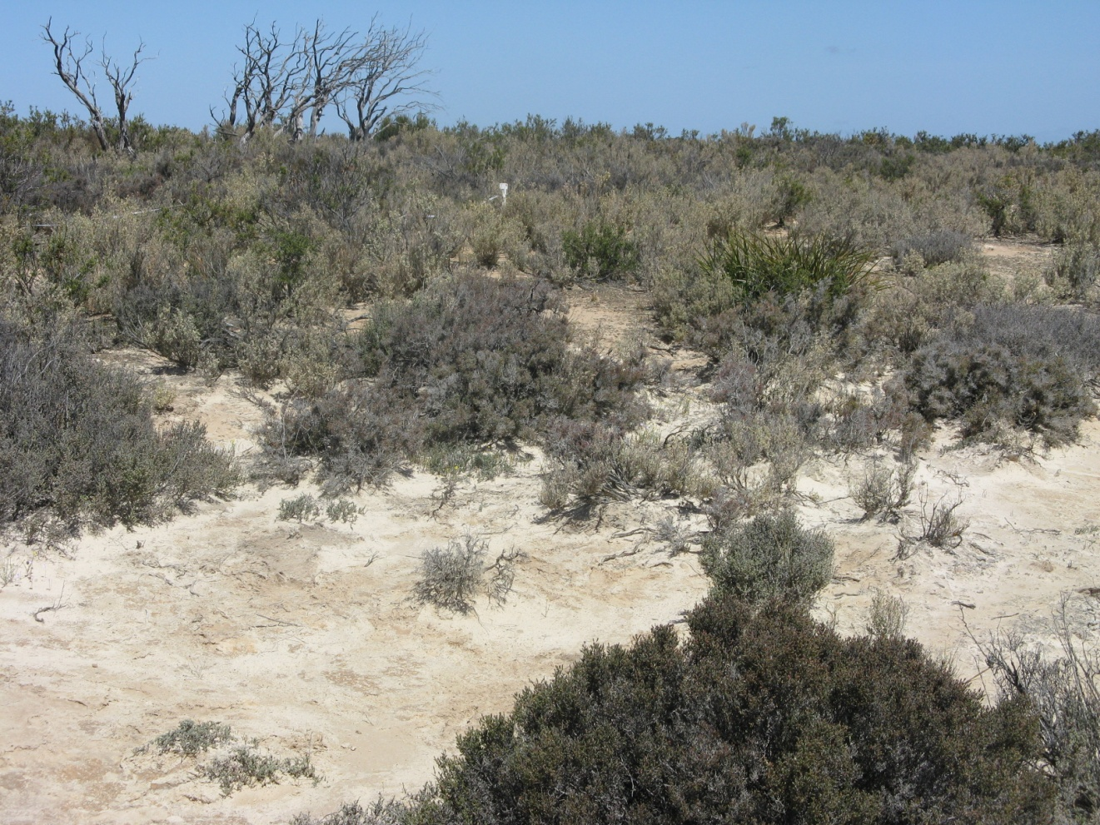
Photograph 20 GYP010
Quadrat GYP011 Date Surveyed 23-10-2009

Location: Lake Buchan

Topography: Slight rise - edge of salt lake. 288.3 +/- 4.3 m

Soils: 5-15cm 80% gypsum

Quadrat orientation: SW

Photograph reference and orientation: IMG_1622 S IMG_1623 side SW

GPS (WGS 84) NW corner 33° 08′ 24.8″ 119° 04′ 46.4″

Diagnosis (Muir 1977): Dwarf Scrub D (scattered grasses and herbs)

Condition: Excellent to Very Good. Some weed. Regeneration – seedlings present.

Life Form | Species | Height cm | % canopy cover
Shrub | Melaleuca halmaturorum | 50 | 1
Shrub | Tecticornia pergranulata subsp. pergranulata | 30 | 30
Shrub | Tecticornia syncarpa | 30
Shrub | Maireana oppositifolia | 40 | 1
Shrub | Frankenia cinerea | 10 | <1
Herb | Isotoma scapigera | 5 | <1
?herb | Lawrencia glomerata | 10 | <1
?herb | Atriplex spongiosa | 8 | <1
?herb | *Mesembryanthemum nodiflorum | 5 | <1
Grass | *Avena barbata | 20 | <1
Grass | *Parapholis incurva | 5 | <1

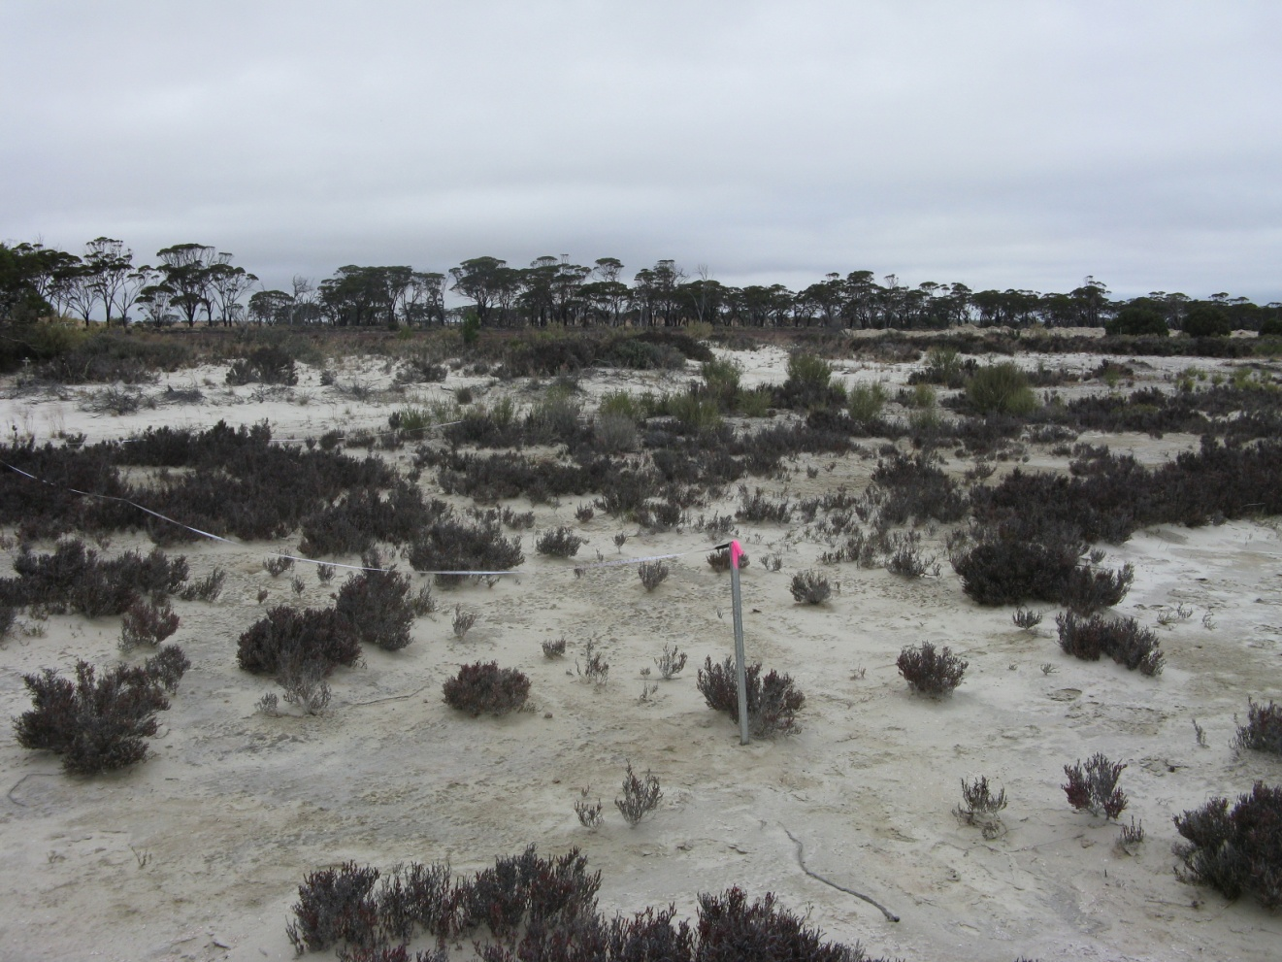
Photograph 21 GYP011
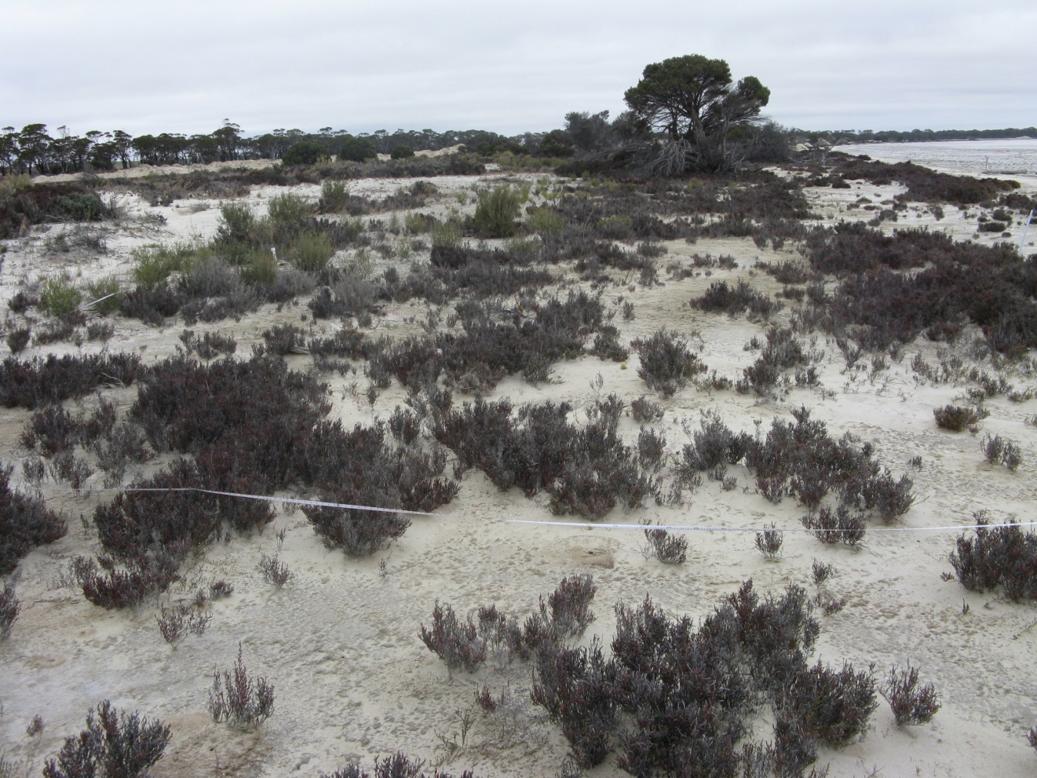
Photograph 22 GYP012
Quadrat GYP012 Date Surveyed: 23-10-2009

Location Lake Buchan

Topography: Low dune ~1.0 m in height, ~20m from lake edge. 289.5 +/- 5.3 m

Soils: 5-15cm 88% gypsum 50cm 90% gypsum

Quadrat orientation: SW

Photograph reference and orientation: IMG_1638 corner E IMG_1639 side NE

GPS (WGS 84) NW corner 33° 08′ 25.1″ 119° 04′ 46.9″

Diagnosis (Muir 1977): Scrub (patches across dune) over Dwarf Scrub D. (scattered shrubs to 1.0 m, scattered grasses and herbs)

Condition: Excellent to Very Good. Weeds including Avena barbata and Lolium rigidum. Rabbits. Gypsum mining adjacent

Life Form | Species | Height cm | % canopy cover
Shrub | Melaleuca halmaturorum | 400 | 30
Shrub | Tecticornia pergranulata subsp. pergranulata | 40 | 25
Shrub | Tecticornia pterygosperma subsp. pterygosperma | 40
Shrub | Tecticornia syncarpa | 40
Shrub | Maireana oppositifolia | 50 | 1
Shrub | Atriplex paludosa subsp. baudinii | 70 | 1
Shrub | Enchylaena tomentosa | 15 | <1
Grass | Austrostipa pycnostachya | 20 | <1
Grass | Austrostipa drummondii | 15 | <1
Grass | Avena barbata | 20 | <1
Grass | Lolium rigidum | 20 | <1
Grass | Bromus rubens | 10 | <1
Grass | Parapholis incurva | 5 | <1
Herb | Brachyscome ciliaris | 10 | <1
Herb | Mesembryanthemum nodiflorum | 5 | <1
Herb | Isotoma scapigera | 8 | <1
 | Adjacent to quadrat
?Herb | Zygophyllum aurantiacum

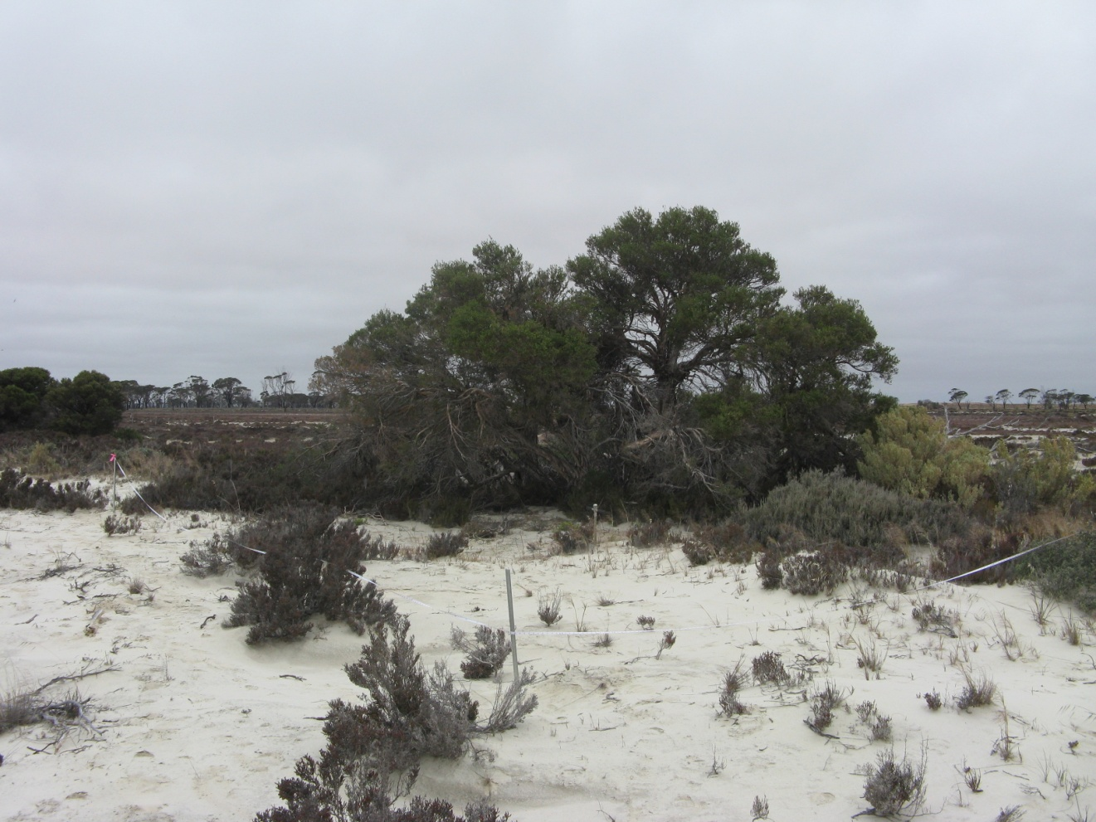
Photograph 23 GYP012
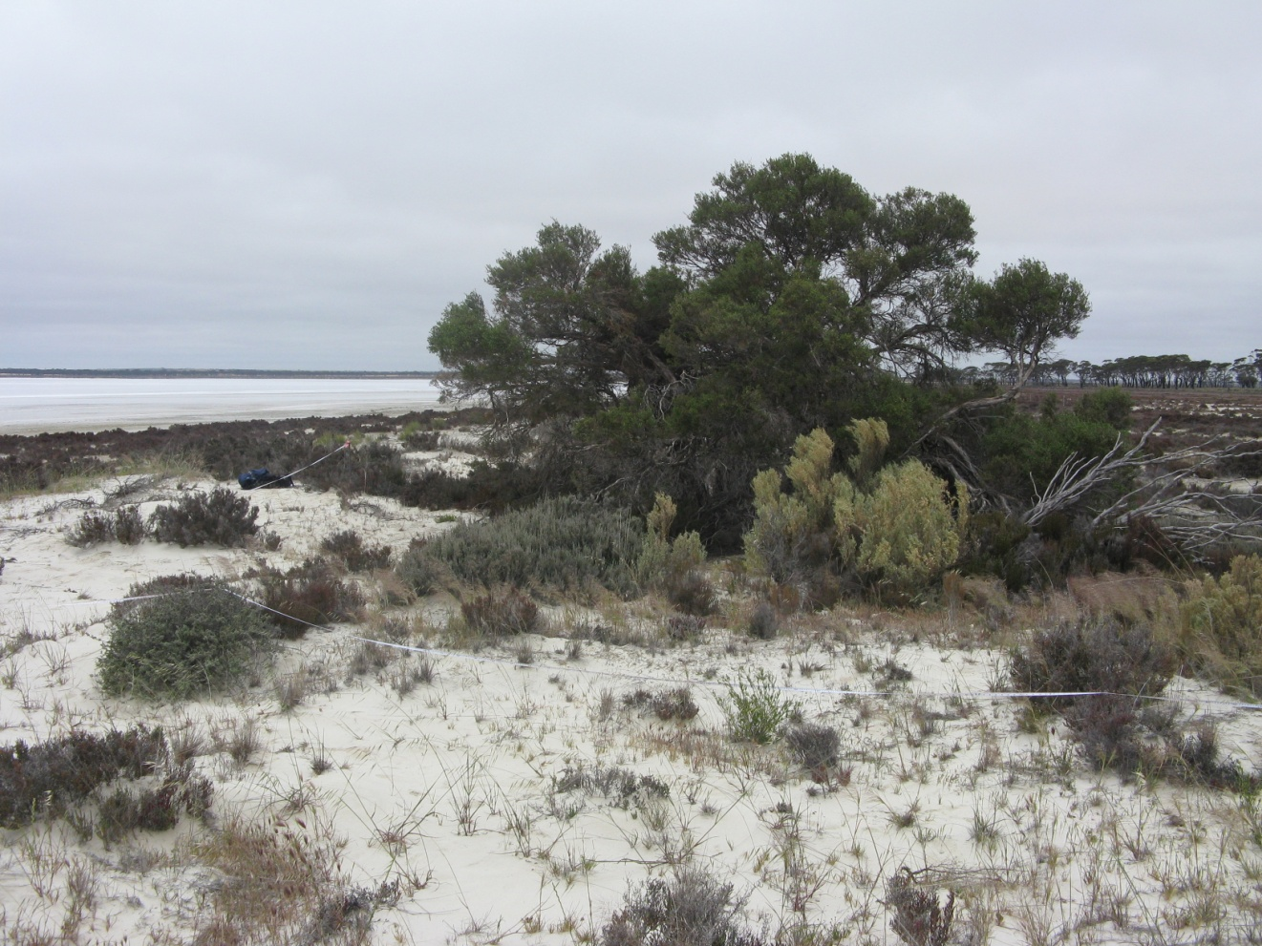
Photograph 24 GYP013
Quadrat GYP013 Date Surveyed: 23-10-2009

Location : Lake Burkett

Topography: NW facing slope of low gypsum dune. Quadrat from near lake bed to top of dune (ridge). 292.1 +/- 4.4 m

Soils: 5-15cm 94% gypsum 50cm 93% gypsum

Quadrat orientation: WSW

Photograph reference and orientation: IMG_1641 S IMG_1642 S

GPS (WGS 84) NW corner 33° 06′ 03.6″ 119° 02′ 20.3″

Diagnosis (Muir 1977): Scrub (over dune area) over Dwarf Scrub D (scattered shrubs to 1.0 m, scattered grasses and herbs)

Condition: Excellent. Rubbish from dump on western side of lake. Rabbits and foxes. Some weed. Regeneration - seedlings

Life Form | Species | Height cm | % canopy cover
Shrub | Melaleuca halmaturorum | 300 | 25
Shrub | Tecticornia moniliformis | 30 | 25
Shrub | Sarcocornia quinqueflora subsp. quinqueflora | 20 | 5
Shrub | Tecticornia pergranulata subsp. pergranulata | 20
Shrub | Tecticornia halocnemoides subsp. aff. caudata | 30
Shrub | Atriplex paludosa subsp. baudinii | 80 | <1
Shrub | Threlkeldia diffusa | 15 | <1
Shrub | Zygophyllum aurantiacum | 5 | <1
Shrub | Frankenia sp. southern gypsum (M.N. Lyons 2864) | 5 | <1
Shrub | Disphyma crassifolium | 5 | <1
Shrub | Carpobrotus modestus | 5 | <1
Herb | Isotoma scapigera | 5 | <1
Herb | *Mesembryanthemum nodiflorum | 2 | <1
Grass | *Parapholis incurva | 5 | <1
 | Adjacent to quadrat
Grass | Austrodanthonia setacea | 15
Grass | Austrostipa hemipogon | 20
Grass | *Avena barbata | 30

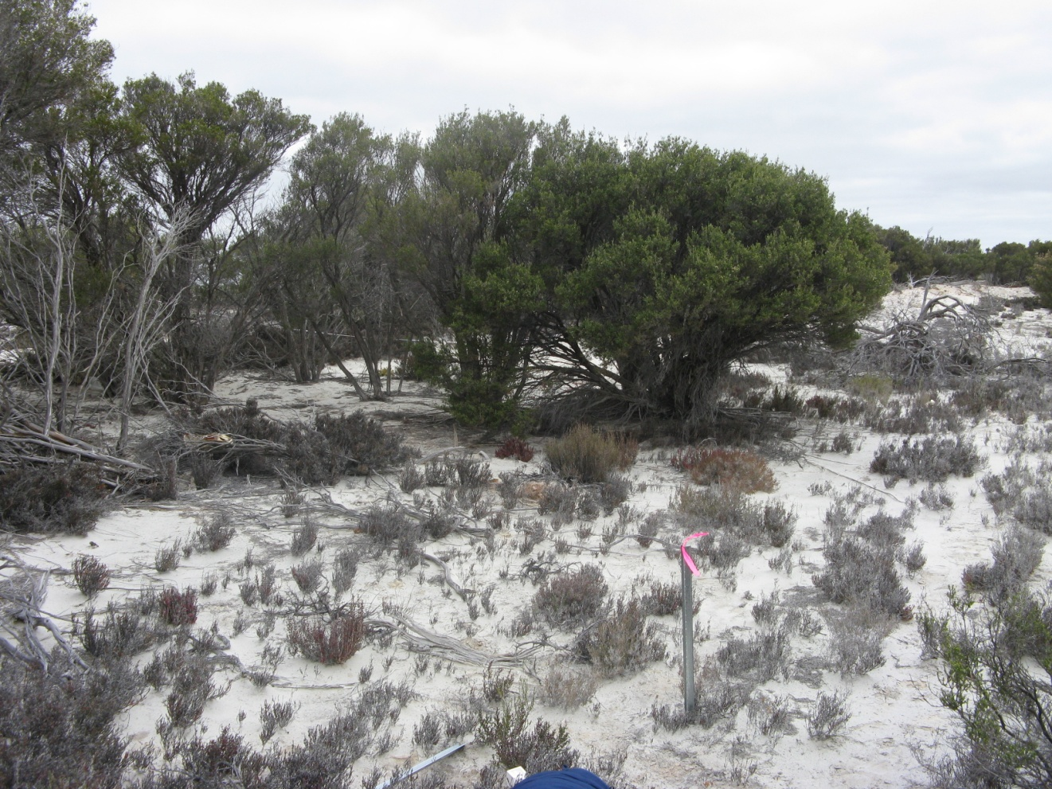
Photograph 25 GYP013
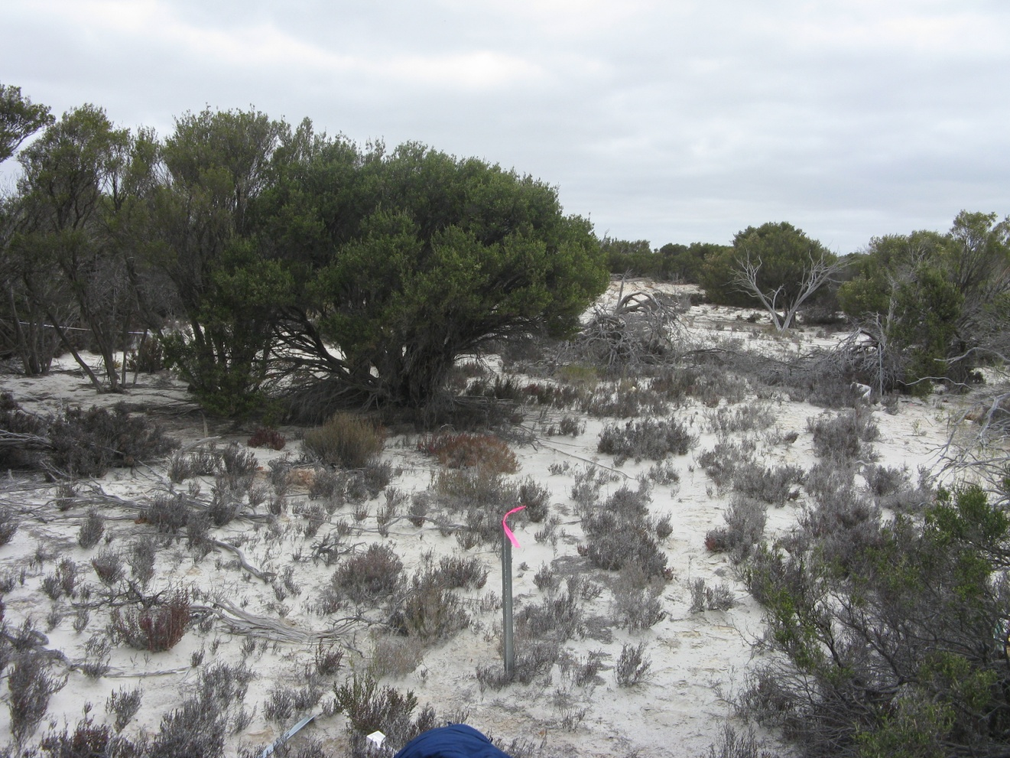
Photograph 26 GYP013
Quadrat GYP014 Date Surveyed: 23-10-2009

Location Lake Burkett

Topography: Ridge (Low rise on lake bed). 291.0 +/- 4.6 m

Soils: 5-15cm 97% gypsum 50cm 94% gypsum

Quadrat orientation:

Photograph reference and orientation: IMG_1657 IMG_1658

GPS (WGS 84) NW corner 33° 06′ 07.1″ 119° 02′ 18.4″

Diagnosis (Muir 1977): Low Heath D (Melaleuca stays to 1.5 m)

Condition: Excellent. Dead shrubs of Melaleuca halmaturorum . Dead from inundation. Seedlings adjacent.

Life Form | Species | Height cm | % canopy cover
Shrub | Melaleuca halmaturorum | Stays to 150 seedlings 15 | Seedlings <1
Shrub | Tecticornia moniliformis | 25 | 40
Shrub | Tecticornia syncarpa | 20
Shrub | Tecticornia pergranulata subsp. pergranulata | 20
Shrub | Frankenia sp. southern gypsum (M.N. Lyons 2864) | 5 | 1

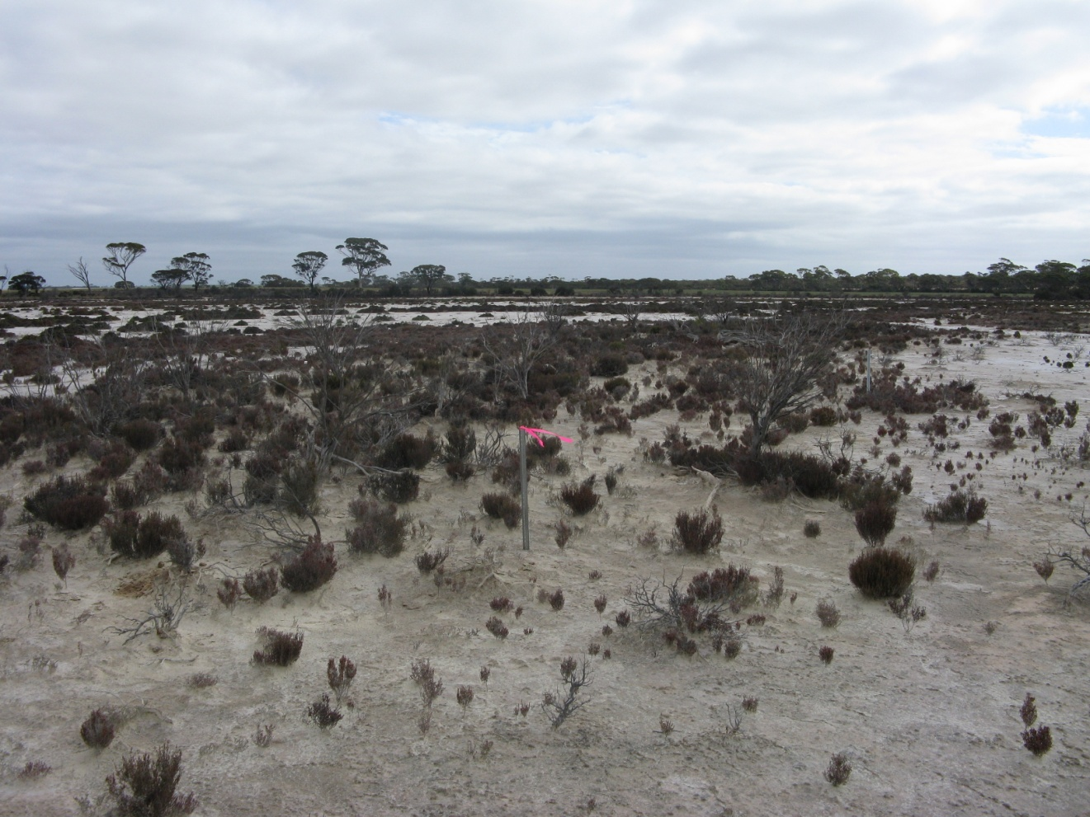
Photograph 27 GYP014
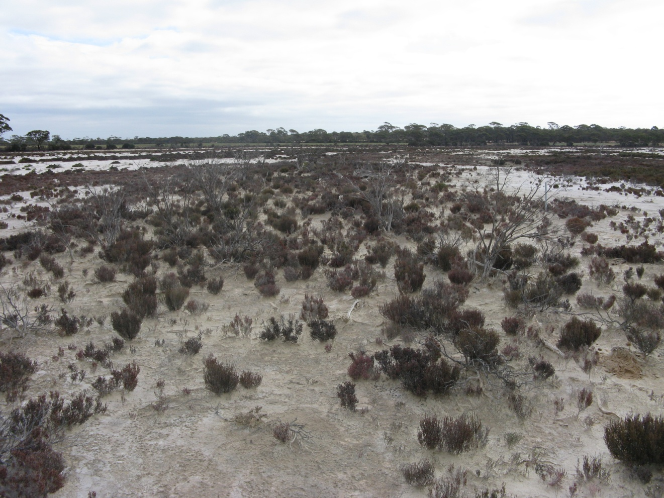
Photograph 28 GYP014

Quadrat GYP015 Date Surveyed: 28-10-2009

Recorders: Margaret, Brian, Pat and Anne

Location Lake Magenta (middle)

Topography: Dune ~ 1.5 m. 287.2 +/- 5.0 m

Soils: 5-15cm 91% gypsum 50cm 95% gypsum

Quadrat orientation: S

Photograph reference and orientation: Mark Brundrett photos 29768, 29677
E and ES

GPS (WGS 84) NW corner 33° 29′ 37.2″ 119° 09′ 20.8″

Diagnosis (Muir 1977): Open Scrub (over dune area) over Open Dwarf Scrub C over Low Heath D

Condition: Pristine. Regeneration - seedlings

Life Form | Species | Height cm | % canopy cover
Shrub | Melaleuca hamulosa | 300 seedlings 20 juvenile 60 | 15
Shrub | Scaevola spinescens | 40 | 1
Shrub | Rhagodia drummondii | 15 | 1
Shrub | Frankenia tetrapetala | 20 | 2
Shrub | Frankenia sp. southern gypsum (M.N. Lyons 2864) | 15 | <1
Shrub | Maireana oppositifolia | 30 | 15
Shrub | Disphyma crassifolium | 10 | 4
Shrub | Tecticornia moniliformis | 15-60 | 10
Grass | Austrodanthonia setacea | 10 | <1
Grass | Austrostipa ?pycnostachya | 10 | <1
Annual Herb | Brachyscome ciliaris | 10 | <1
PerennialHerb | Dianella brevicaulis | 30 | <1
Perennial Herb | Lomandra micrantha subsp. teretifolia | 40 | <1
 | Adjacent to quadrat
Grass | Austrostipa puberula
Grass | *Parapholis incurva
Grass | *Rostraria cristata

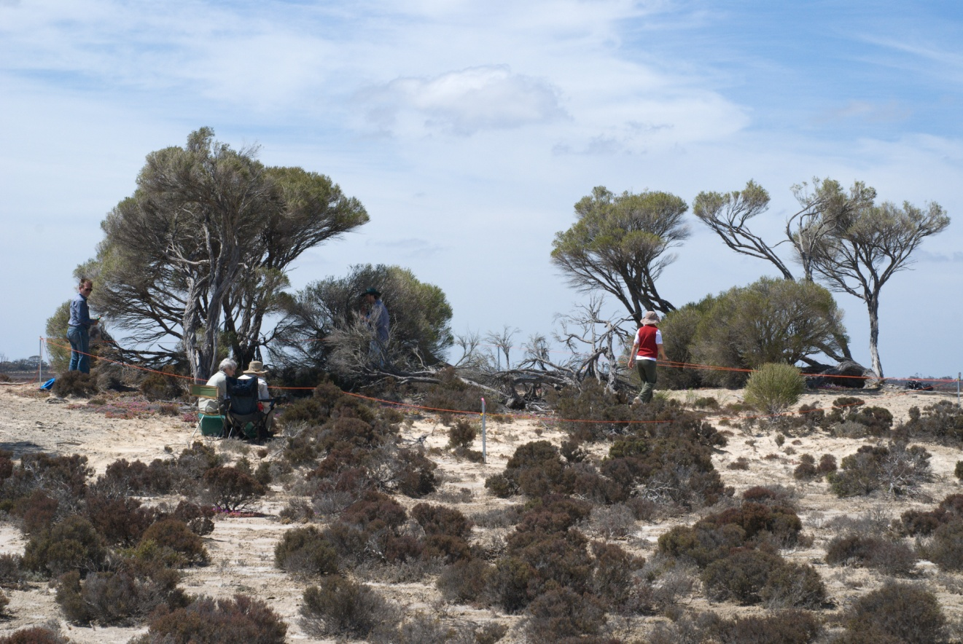
Photograph 29 GYP015
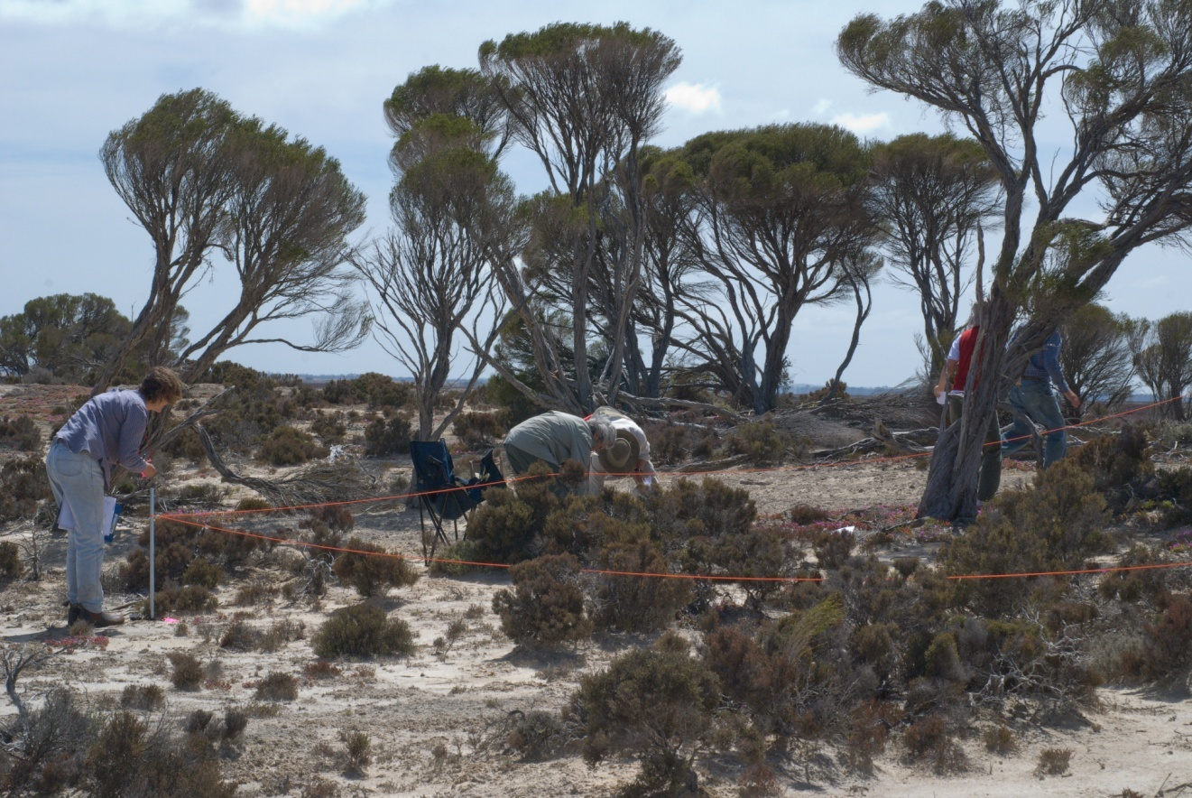
Photograph 30 GYP015

Quadrat GYP016 Date Surveyed: 28-10-2009

Recorders: Hazel, Elizabeth, Alice, Phyllis, Arthur

Location: Lake Magenta (middle) (G223 Mattiske)

Topography and elevation: Slope of dune. 287.3 +/- 6.6 m

Soils: 5-15cm 91% gypsum 50cm 93% gypsum

Quadrat orientation: S

Photograph reference and orientation: Mark Brundrett. 29600, 29667
E and SE

GPS (WGS 84) NW corner 33° 29′ 37.6″ 119° 09′ 20.7″

Diagnosis (Muir 1977): Scrub over Open Dwarf Scrub C over Dwarf Scrub D

Condition: Pristine. Rabbits, dry season. Regeneration - seedlings

Life Form | Species | Height cm | % canopy cover
Shrub | Melaleuca hamulosa | 300 | 25
Shrub | Rhagodia drummondii | 40 | 5
Shrub | Disphyma crassifolium | 5 | 10
Shrub | Tecticornia moniliformis | 45 | 2
Shrub | Frankenia tetrapetala | 10 | 10
Shrub | Frankenia sp. southern gypsum (M.N. Lyons 2864) | 5 | 2
Grass | Austrodanthonia setacea | 20 | 1
Grass | Austrostipa puberula | 20 | 1
Grass | *Bromus rubens | 10 | 2
Herb | Brachyscome ciliaris | 10 | <1
Herb | Calandrinia ?sp. Meckering (F. Obbens 42/02) | 12 | <1
Herb | Crassula colorata | 5 | <1
Herb | Isotoma scapigera | 8 | <1
Herb | Calandrinia eremaea | 5 | <1
Herb | *Hypochaeris glabra | 10 | <1
Herb | *Erodium botrys | 5 | <1
 | Adjacent to quadrat
Shrub | Maireana oppositifolia
Herb | Senecio glossanthus

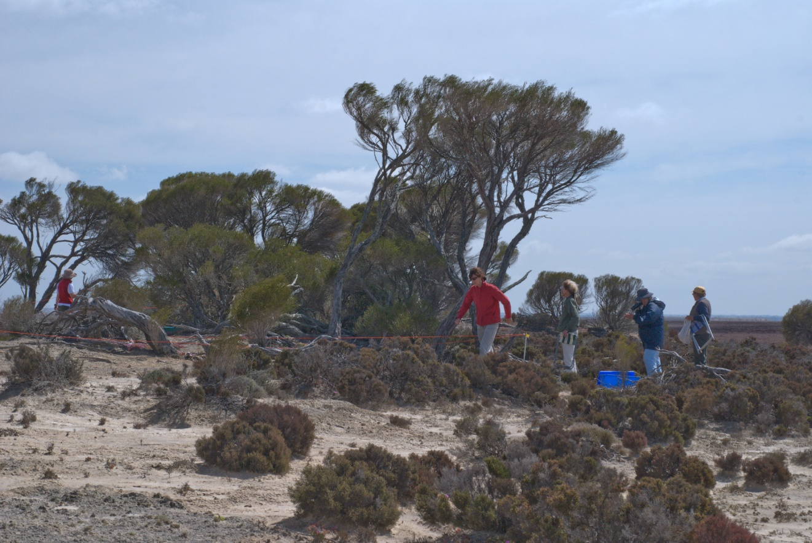
Photograph 31 GYP016
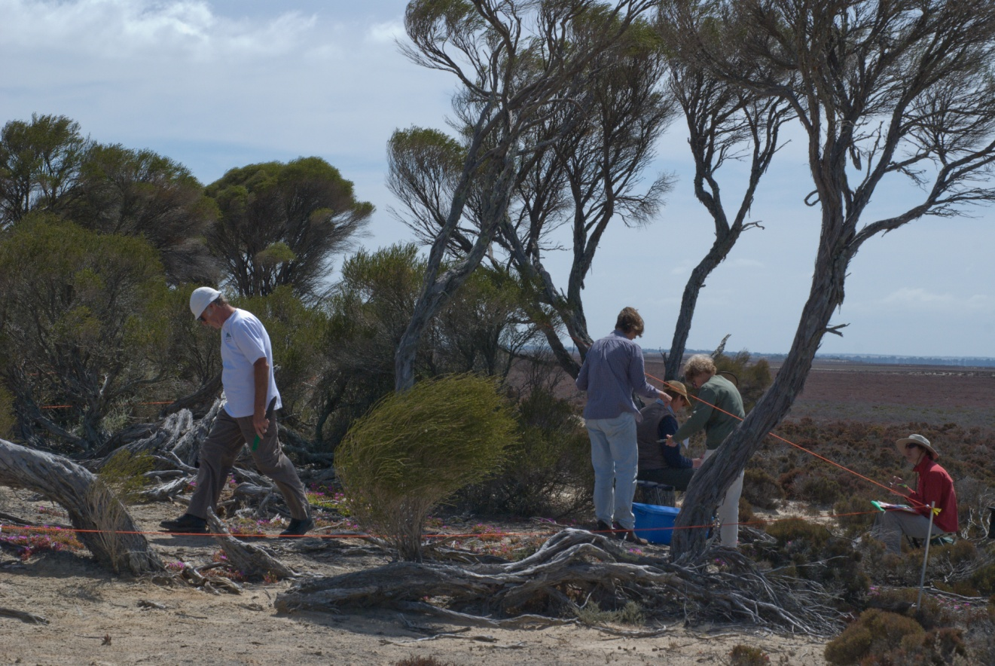
Photograph 32 GYP016

Quadrat GYP017 Date Surveyed: 28-10-2009

Recorders: Pat, Anne, Margaret, Brian

Location : Lake Magenta (middle)

Topography: Slight rise (ridge) on the lake bed. 285.4 +/- 5.0 m. Subject to inundation

Soils: 5-15cm 88% gypsum

Quadrat orientation: S

Photograph reference and orientation: Mark Brundrett 29872, 29875

GPS (WGS 84) NW corner 33° 29′ 39.2″ 119° 09′ 21.2″

Diagnosis (Muir 1977): Low Heath D

Condition: Pristine. Dry season

Life Form | Species | Height cm | % canopy cover
Shrub | Tecticornia moniliformis | 35 | 10
Shrub | Tecticornia loriae | 30 | 15
Shrub | Maireana oppositifolia | 30 | 4
Shrub | Frankenia sp. southern gypsum (M.N. Lyons 2864) | 15 | <1
Grass | *Parapholis incurva | 10 | <1
Herb | Calandrinia ?sp. Meckering (F. Obbens 42/02) | 15 | <1
 | Adjacent to quadrat
Shrub | Tecticornia syncarpa | 35

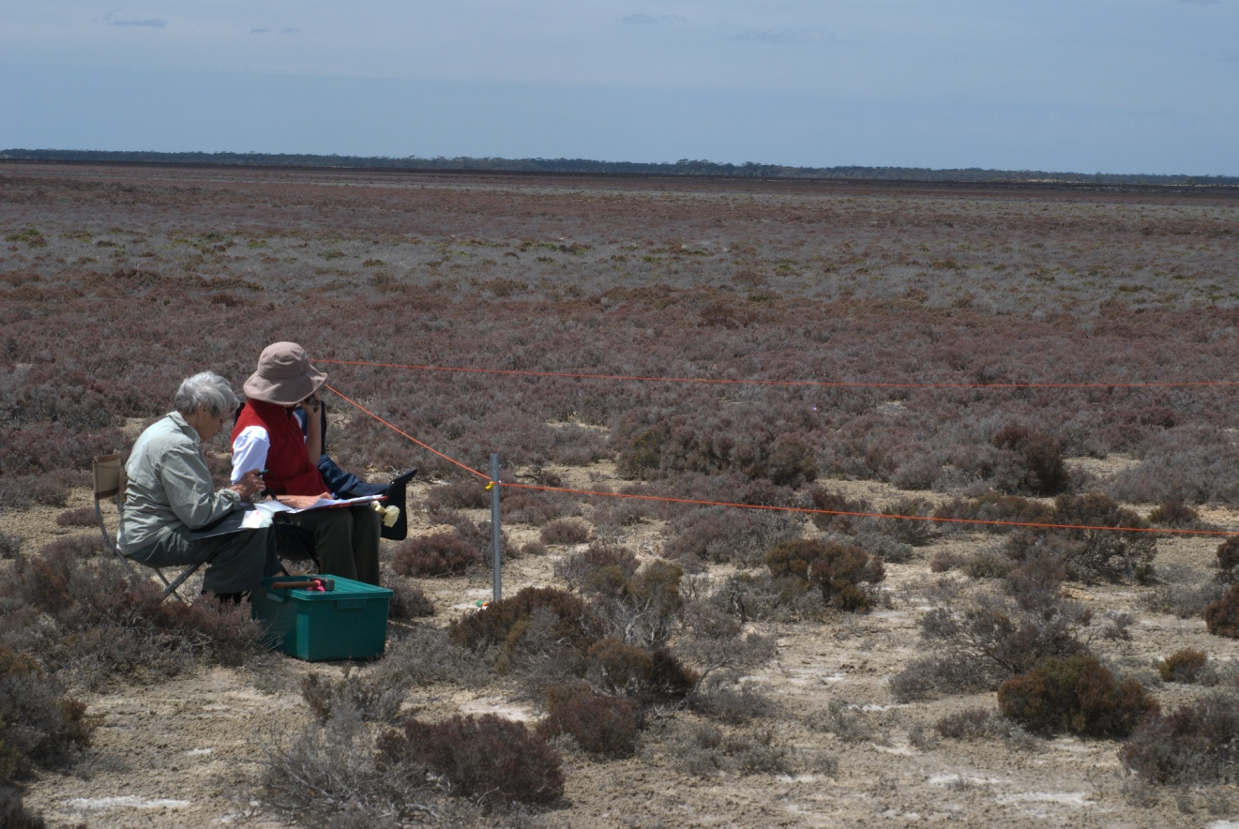
Photograph 33 GYP017
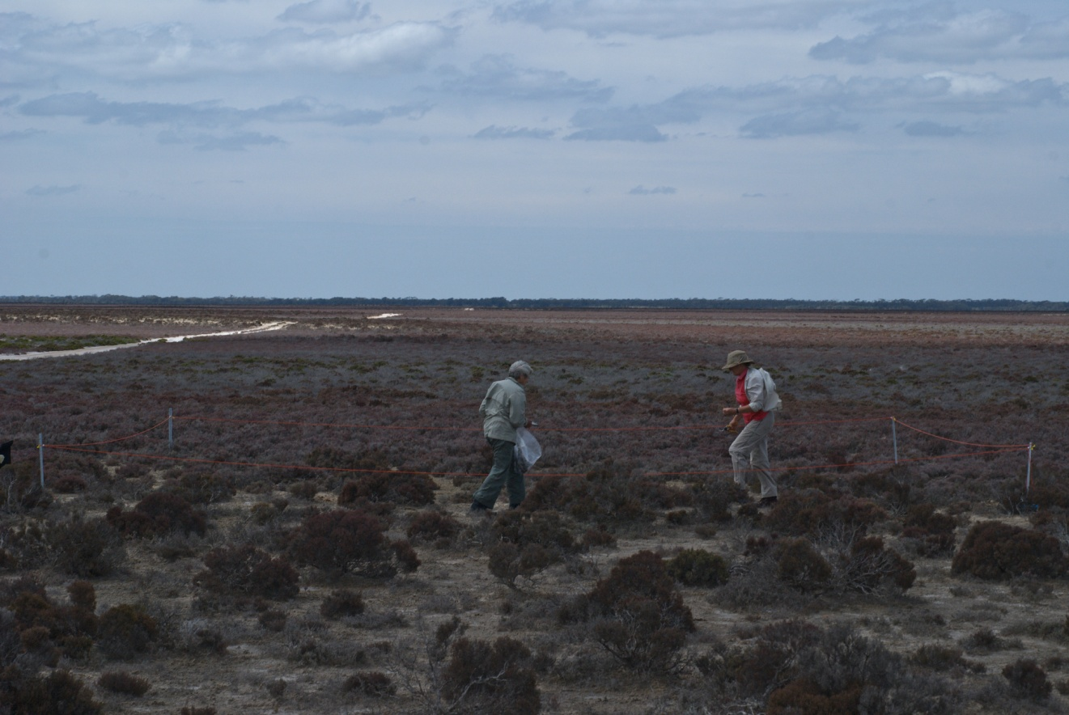
Photograph 34 GYP 017

Quadrat GYP018 Date Surveyed: 28-10-2009

Recorders: Hazel, Elizabeth, Phyllis, Alice, Arthur

Location Lake Magenta (middle)

Topography and elevation: Salt lake bed. Slight depression. No gypsum? 287.0 +/- 5.0 m. Subject to inundation

Soils: 5-15cm 3.1% gypsum. Grey brown loamy sand.

Quadrat orientation: SSW

Photograph reference and orientation: Mark Brundrett 29845

GPS (WGS 84) NW corner 33° 29′ 40.5″ 119° 09′ 21.4″

Diagnosis (Muir 1977): Low Heath D

Condition: Pristine. Dry year

Life Form | Species | Height cm | % canopy cover
Shrub | Tecticornia moniliformis | 40 | <1
Shrub | Tecticornia doleiformis | 30 | 40
Shrub | Tecticornia indica subsp. bidens | 30 | <1
Shrub | Atriplex paludosa | 40 | <1
Shrub | Sclerolaena diacantha | 15 | <1
Shrub | Frankenia tetrapetala | 15 | 30
Shrub | Frankenia sp. southern gypsum (M.N. Lyons 2864) | 15 | <1
 | Adjacent to quadrat
Shrub | Tecticornia syncarpa
Shrub | Tecticornia loriae
Shrub | Atriplex vesicaria
Shrub | Maireana oppositifolia
Grass | Austrostipa elegantissima
Herb | Calandrinia ?sp. Meckering (F. Obbens 42/02)

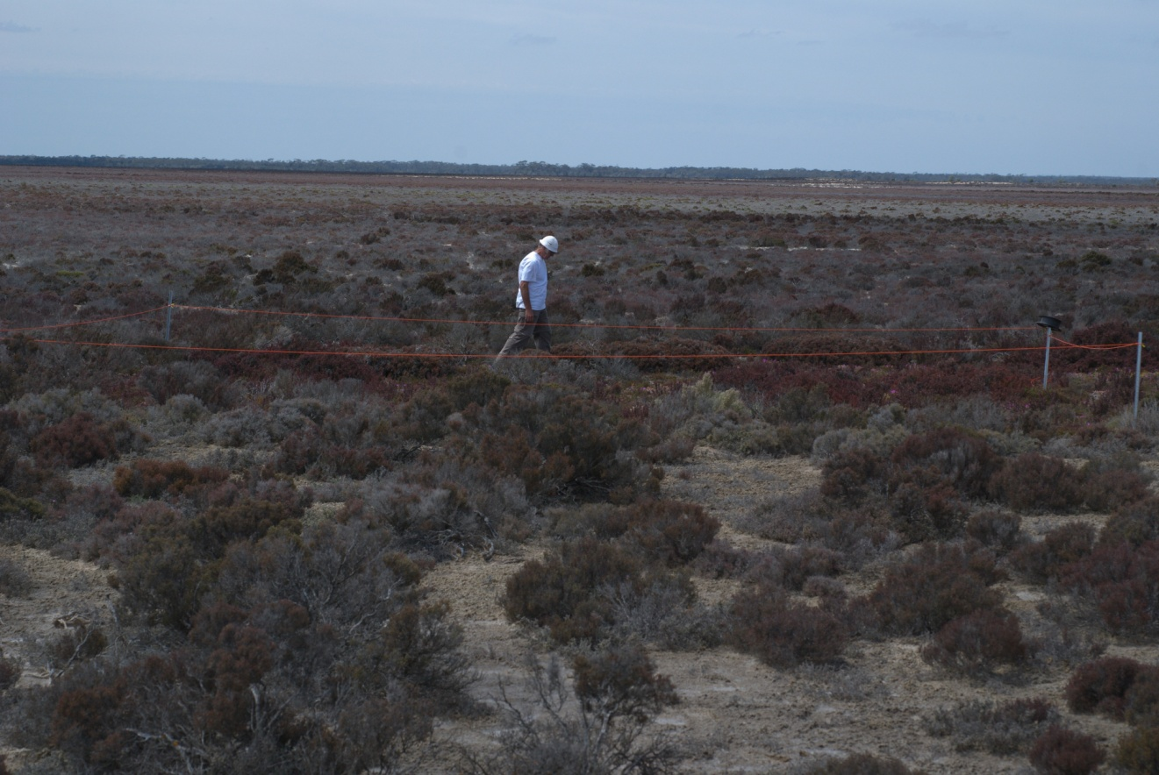
Photograph 35 GYP018
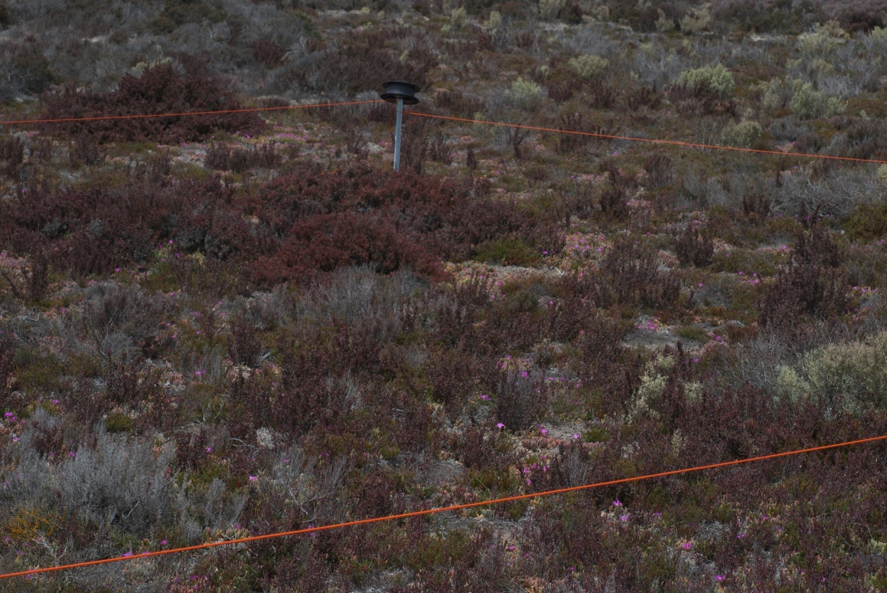
Photograph 36 GYP018

Quadrat GYP019 Date Surveyed: 28-10-2009

Recorders:

Location: Lake Magenta (middle)

Topography: Developed dune. Gentle slope. 289.6 +/- 4.7 m

Soils: Sandy loam, gypsum at depth? 5-15cm 0.5% gypsum 50cm 40% gypsum

Quadrat orientation: WSW

Photograph reference and orientation: Mark Brundrett

GPS (WGS 84) NW corner 33° 30′ 00.4″ 119° 10′ 09.3″

Diagnosis (Muir 1977): Open Shrub Mallee over Open Scrub over Open Low Scrub B over Low Heath D over Very Open Low Grass

Condition: Excellent. 2-10% mixed weeds. Rabbits.

Life Form | Species | Height cm | % canopy cover
Shrub Mallee | Eucalyptus aff. quadrans | 500 | 15
Shrub | Maireana oppositifolia | 40 | 4
Shrub | Pittosporum angustifolium | 150 | 4
Shrub | Exocarpos aphyllus | 100 | 1
Shrub | Lycium australe | 100 | 1
Shrub | Atriplex vesicaria | 50 | 5
Shrub | Rhagodia crassifolia | 40 | 10
Shrub | Threlkeldia diffusa | 10 | 1
Shrub | Enchylaena tomentosa | 15 | <1
Herb | Vittadinia gracilis | 10 | <1
Shrub | Actinobole uliginosum | 1 | <1
Shrub | Crassula colorata | 5 | <1
Shrub | Calandrinia eremaea | 5 | <1
Shrub | *Sonchus oleraceus | 10 | <1
Shrub | *Trifolium arvense | 3 | 1
Shrub | *Trifolium tomentosum | 3 | 1
Grass | Austrodanthonia setacea | 10 | <1
Grass | Austrostipa drummondii | 20 | <1
Grass | *Pentaschistis airoides | 10 | <1
Grass | *Bromus rubens | 10 | <1
 | Adjacent to quadrat
Herb | Lomandra effusa | 30
Sedge | Gahnia ancistrophylla | 30

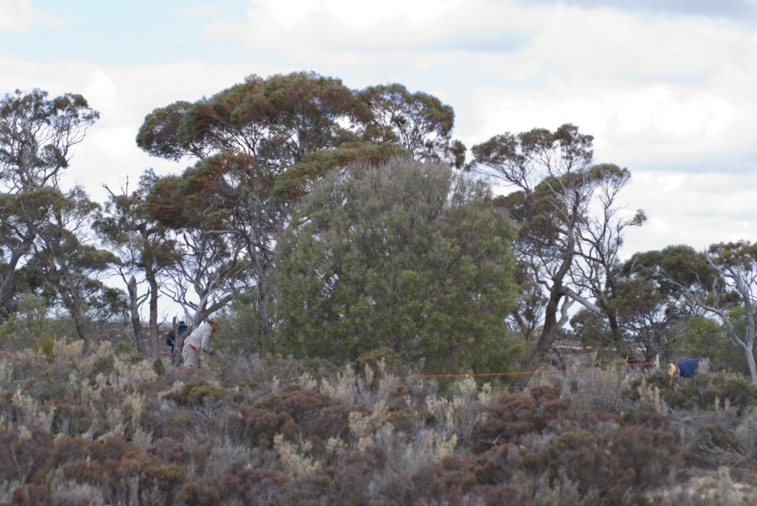
Photograph 37 GYP019

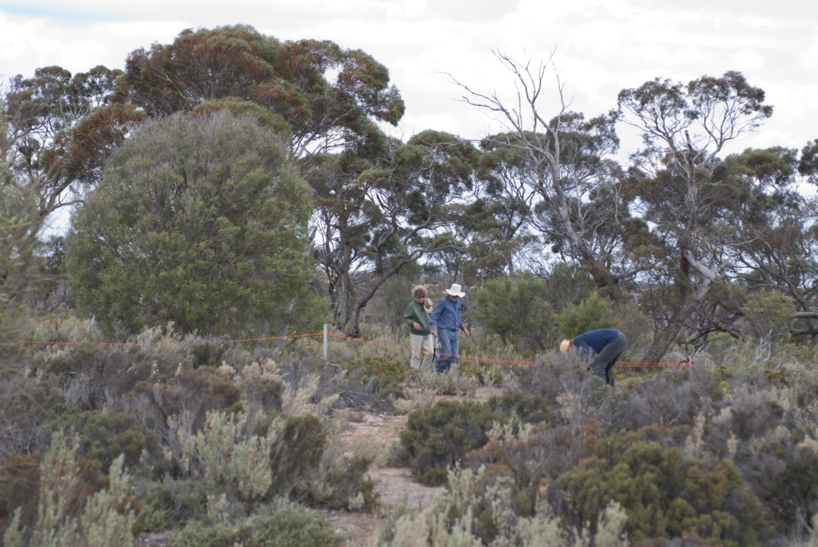
Photograph 38 GYP019

Quadrat GYP020 Date Surveyed: 28-10-2009

Recorders:

Location: Lake Magenta (middle) G225 Mattiske site
Topography: Top of low dune. 288.2 +/- 5.2

Soils: Gypsum light yellow 5-15cm 88% gypsum 50cm 92% gypsum

Quadrat orientation: S

Photograph reference and orientation: Mark Brundrett

GPS (WGS 84) NW corner 33° 29′ 37.8″ 119° 10′ 06.9″

Diagnosis (Muir 1977): Low Heath D

Condition: Excellent. Dry year some dead shrubs.

Life Form | Species | Height cm | % canopy cover
Shrub | Tecticornia moniliformis | 30 | 15
Shrub | Tecticornia syncarpa | 10 | 15
Shrub | Maireana oppositifolia | 10 | <1
Shrub | Frankenia sp. southern gypsum (M.N. Lyons 2864) | 10 | <1
Herb | Calandrinia ?sp. Meckering (F. Obbens 42/02) | 5 | <1
 | Adjacent to quadrat
Shrub | Tecticornia halocnemoides subsp. caudata | 20

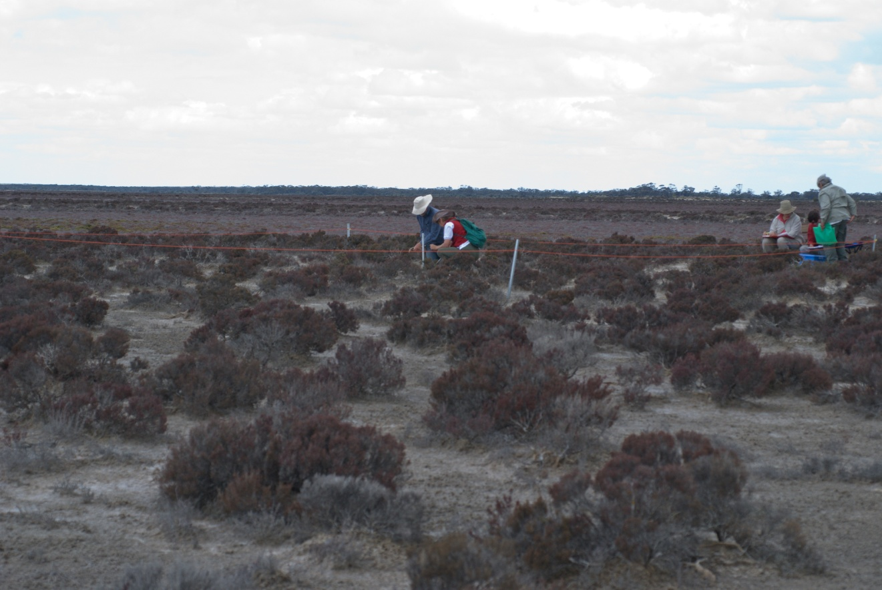
Photograph 39 GYP020
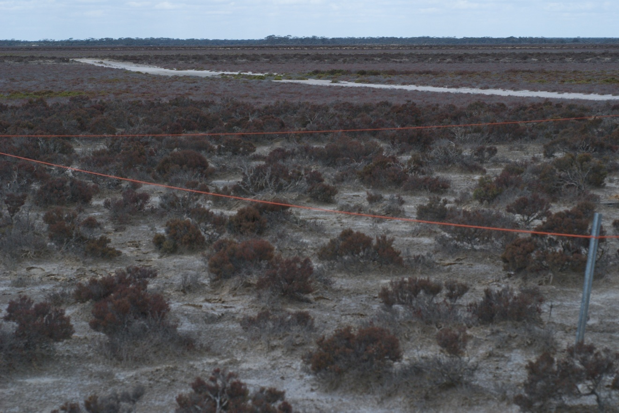
Photograph 40 GYP020

Quadrat GYP021 Date Surveyed: 30-10-2009

Location: Lake Lockhart Mattiske site G240 - gypsum 90%
Topography: Top of low dune

Soils: 5-15cm 20% gypsum 50cm 27% gypsum

Quadrat orientation: SW

Photograph reference and orientation: IMG_1746 S IMG_1747 SSW

GPS (WGS 84) NW corner 33° 14′ 22.4″ 119° 03′ 45.1″

Diagnosis (Muir 1977): Low Heath D

Condition: Excellent. Some weed adjacent and dead plants – dry year

Life Form | Species | Height cm | % canopy cover
Shrub | Tecticornia syncarpa | 30-40 | 30
Shrub | Maireana oppositifolia | 45 | 20
Shrub | Disphyma crassifolium | 5 | <1
Herb | Calandrinia ?sp. Meckering (F. Obbens 42/02) | 10 | <1
 | Adjacent to quadrat
Shrub | Atriplex paludosa

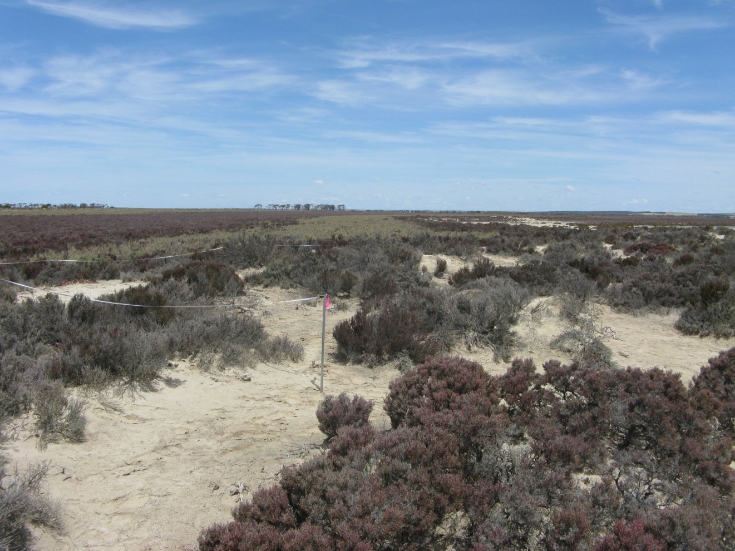
Photograph 41 GYP021
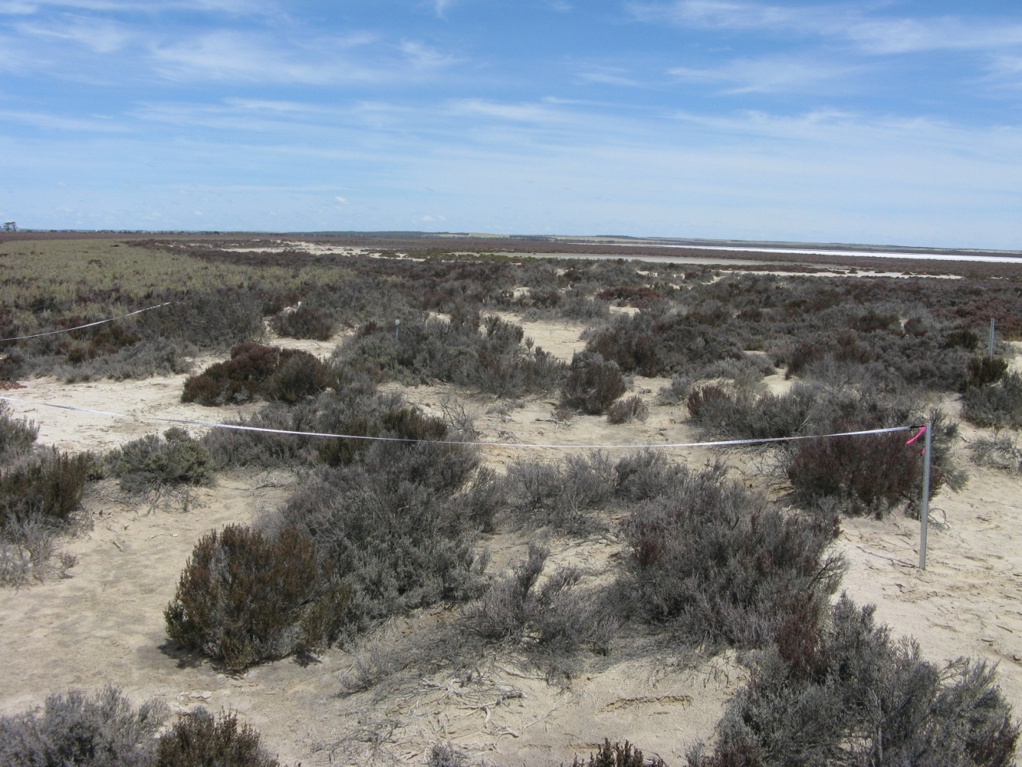
Photograph 42 GYP022
Quadrat GYP022 Date Surveyed: 31-10-2009

Location : Lake Lockhart . Mattiske site G238

Topography and Elevation: Large dune – eastern side. 294.5 +/- 5.0 m

Soils: 5-15cm 90% gypsum 50cm 90% gypsum - from Mattiske (1995)

Quadrat orientation: S

Photograph reference and orientation: IMG_1749 SE IMG_1751 S

GPS (WGS 84) NW corner 33° 15′ 36.8″ 119° 03′ 35.1″

Diagnosis (Muir 1977): Scrub over Open Low Scrub A over Dwarf Scrub D

Condition: Excellent. Rabbits, foxes and some minor weeds.

Life Form | Species | Height cm | % canopy cover
Shrub | Melaleuca hamulosa | 200-400 | 2
Shrub | Exocarpos aphyllus | 200 | 2
Shrub | Pittosporum angustifolium | 150 | <1
Shrub | Rhagodia crassifolia | 100 | <1
Shrub | Tecticornia pterygosperma subsp. pterygosperma | 50 | 20
Shrub | Frankenia tetrapetala | 10 | 1
Shrub | Atriplex paludosa | 30 | <1
Shrub | Maireana oppositifolia | 30 | <1
Grass | Austrostipa drummondii | 15 | <1
Grass | Austrostipa elegantissima | 100 | 1
Grass | Austrostipa pycnostachya | 20 | <1
Herb | Brachyscome ciliaris | 8 | <1
Herb | Crassula exserta | 5 | <1
Herb | Isotoma scapigera | 5 | <1
 | Adjacent to quadrat
Shrub | Lycium australe | 150
Shrub | Billardiera lehmanniana
Shrub | Frankenia sp. southern gypsum (M.N. Lyons 2864) | 10
Herb | Lomandra effusa | 25
Shrub | Enchylaena tomentosa | 15
Shrub | Threlkeldia diffusa | 15
Grass | *Bromus rubens | 5

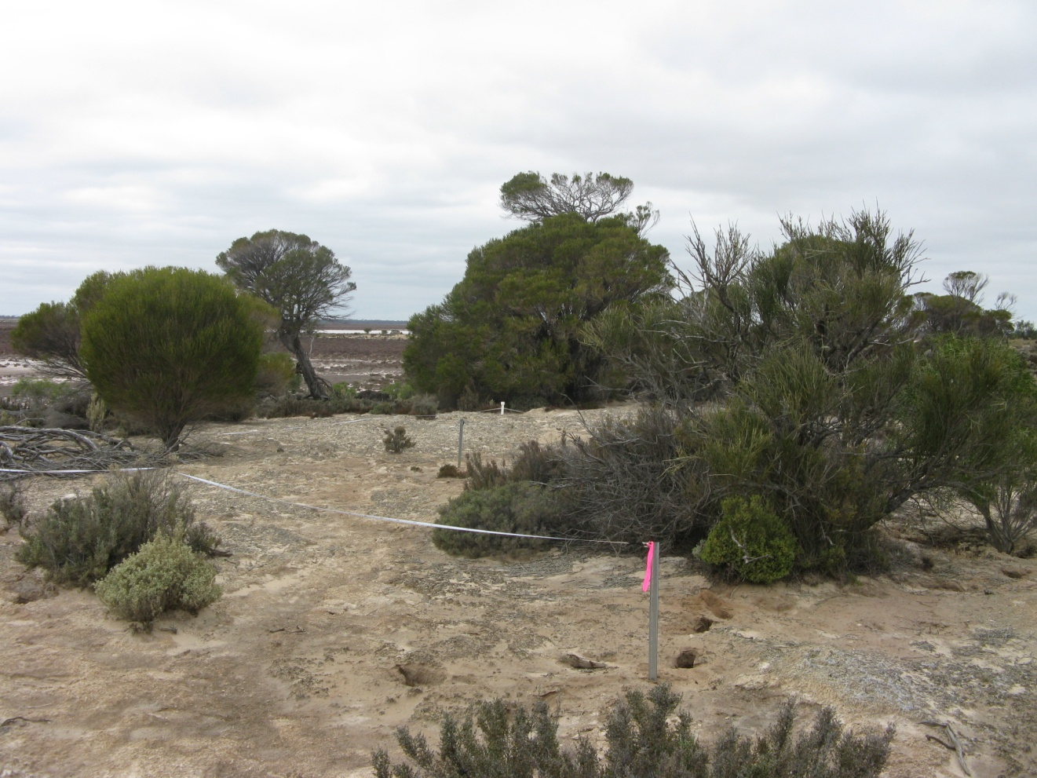
Photograph 43 GYP022
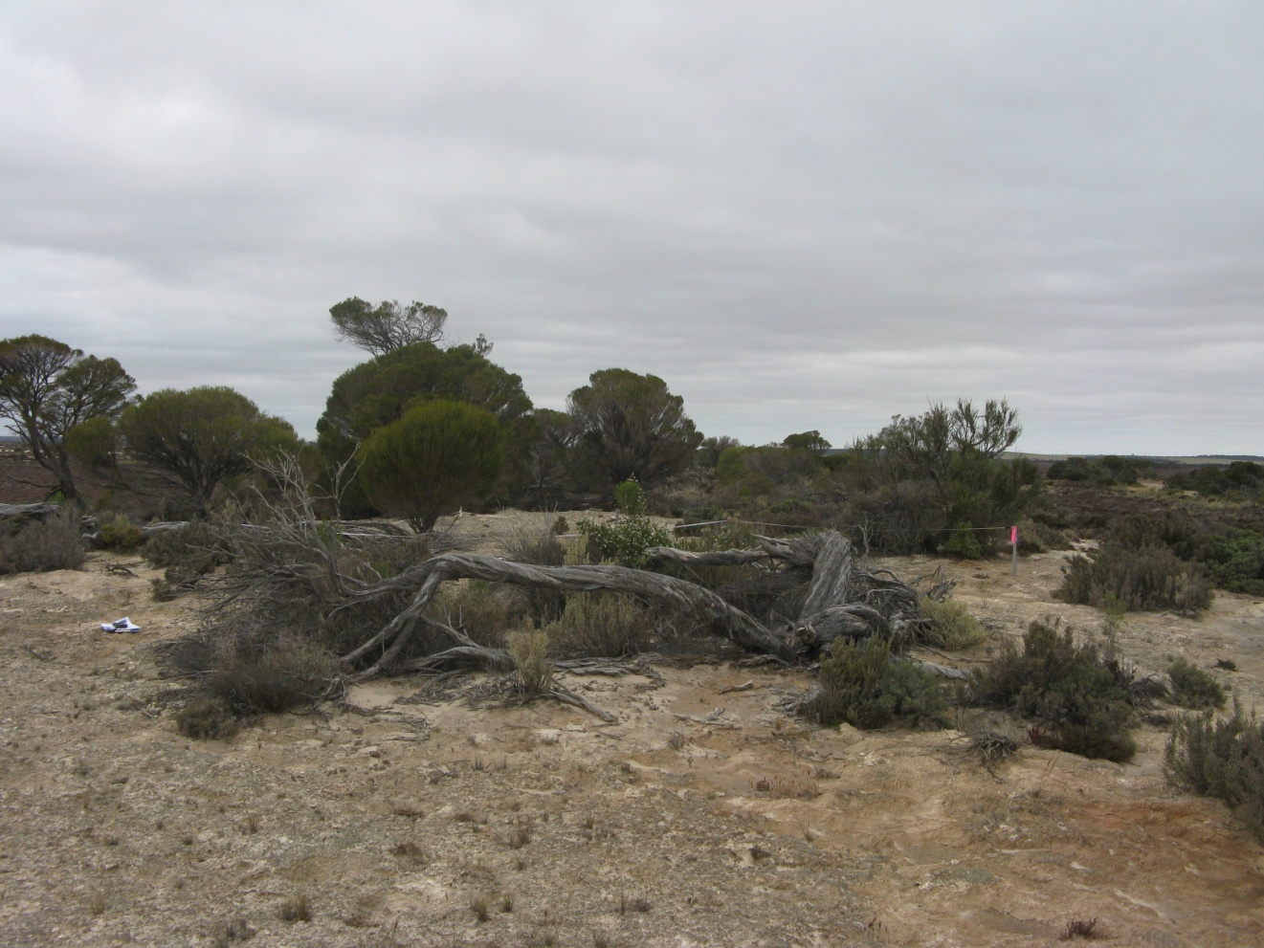 Photograph 44 GYP022
Quadrat GYP024 Date Surveyed: 31-10-2009

Location : Lake Lockhart Mattiske site G239

Topography and Elevation: End of large dune. 291.3 +/- 5.3

Soils: From Mattiske (1995) 5-15cm 60% gypsum 50cm 60% gypsum

Quadrat orientation: SSW

Photograph reference and orientation: IMG_1768 S IMG_1769 SSW

GPS (WGS 84) NW corner 33° 15′ 31.6″ 119° 03′ 37.9″

Diagnosis (Muir 1977): Scrub over Dwarf Scrub D (scattered shrubs to 1.5 m, scattered grasses)

Condition: Excellent. Rabbits, foxes, some weed adjacent.

Life Form | Species | Height cm | % canopy cover
Shrub | Melaleuca thyoides | 280 | 2
Shrub | Tecticornia moniliformis | 50 | 30
Shrub | Tecticornia syncarpa | 40
Shrub | Maireana oppositifolia | 30 | 2
Shrub | Frankenia cinerea | 10 | <1
Shrub | Enchylaena tomentosa | 30 | <1
Shrub | Pittosporum angustifolium | 150 | <1
Shrub | Threlkeldia diffusa | 10 | <1
Shrub | Lawrencia squamata | 30 | <1
Grass | Austrostipa trichophylla | 20 | <1
Grass | Austrostipa elegantissima | 100 | <1
Grass | *Bromus rubens | 10 | <1
 | Adjacent to quadrat
Shrub | Carpobrotus modestus | 10
Shrub | Rhagodia crassifolia | 60
Shrub | Atriplex paludosa | 50
Herb | Lomandra effusa | 20
Herb | Calandrinia ?sp. Meckering (F. Obbens 42/02) | 15

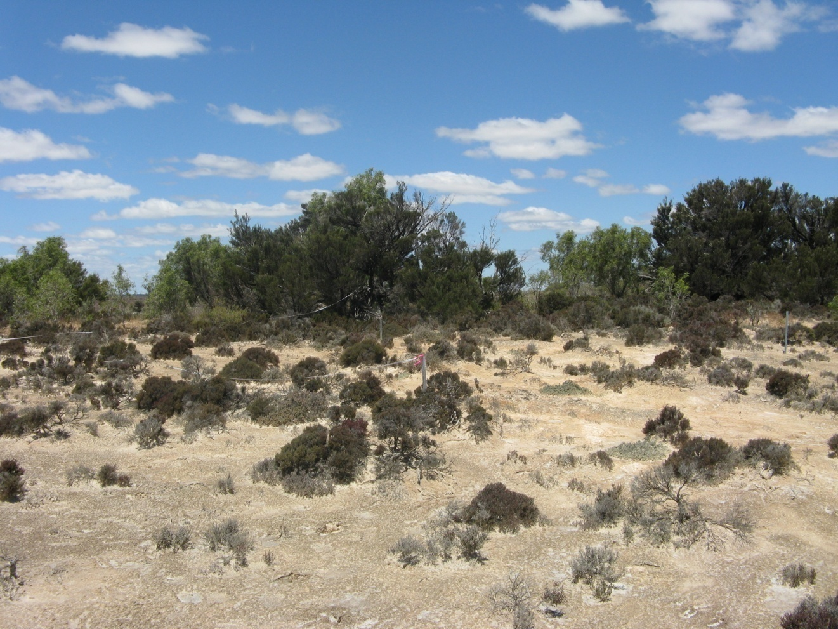
Photograph 45 GYP024
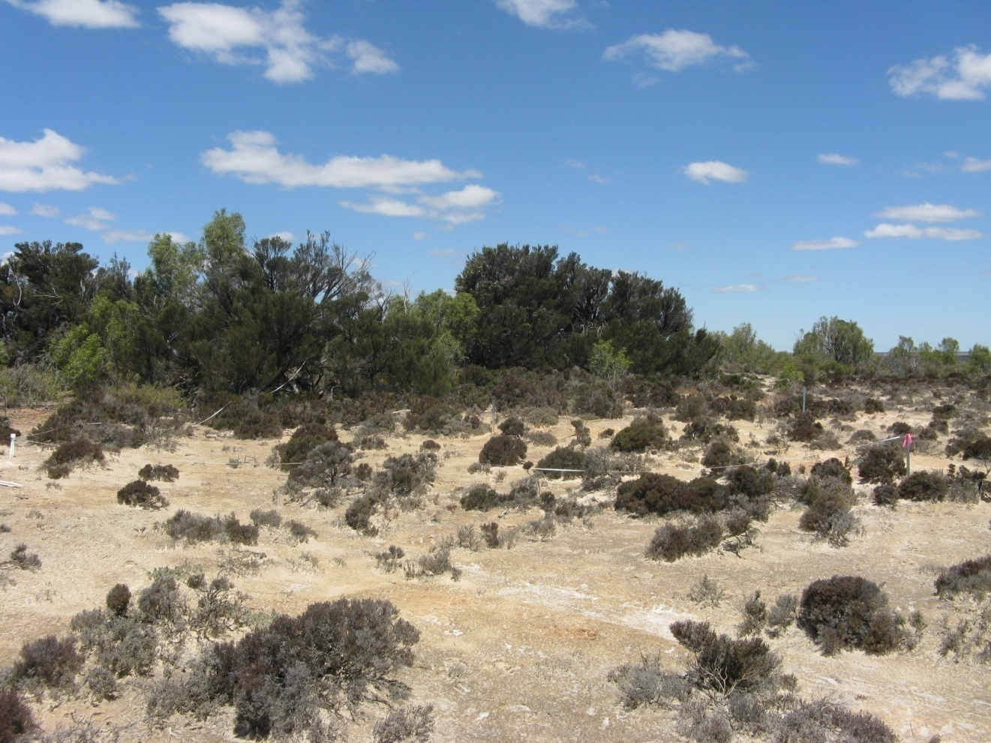
Photograph 46 GYP024
Quadrat GYP025 Date Surveyed: 31-10-2009

Location: Lake Lockhart.

Topography and Elevation: Slight rise on lake bed. Subject to inundation.
289.1 +/- 5.1

Soils: 5-15cm 78% gypsum

Quadrat orientation:

Photograph reference and orientation: IMG_1776 IMG_1777

GPS (WGS 84) NW corner 33° 15′ 05.9″ 119° 03′ 37.0″

Diagnosis (Muir 1977): Low Heath D

Condition: Pristine

Life Form | Species | Height cm | % canopy cover
Shrub | Tecticornia halocnemoides subsp. caudata | 50 | 50
Shrub | Tecticornia loriae | 50
Shrub | Frankenia sp. southern gypsum (M.N. Lyons 2864) | 10 | 1

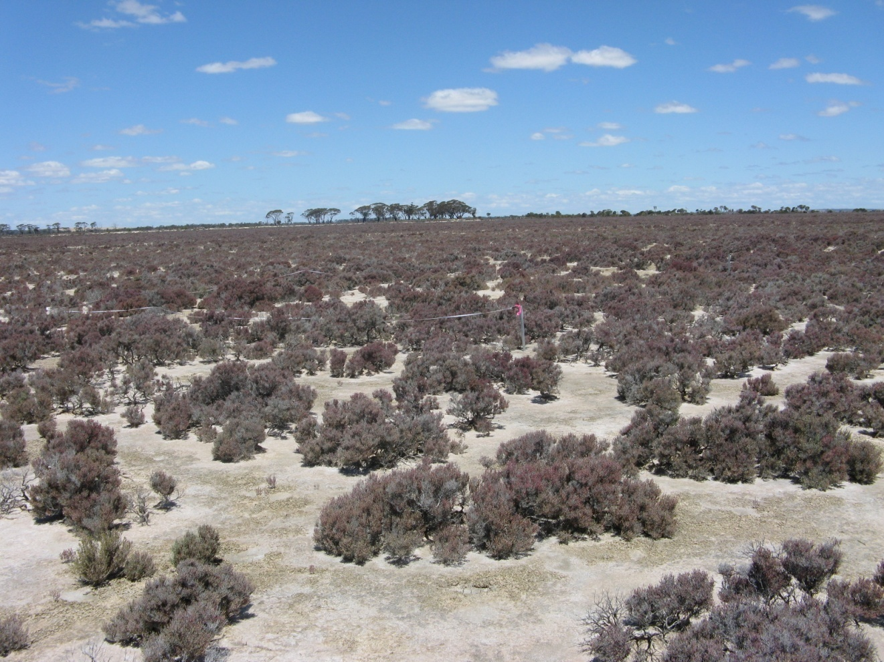
Photograph 47 GYP025
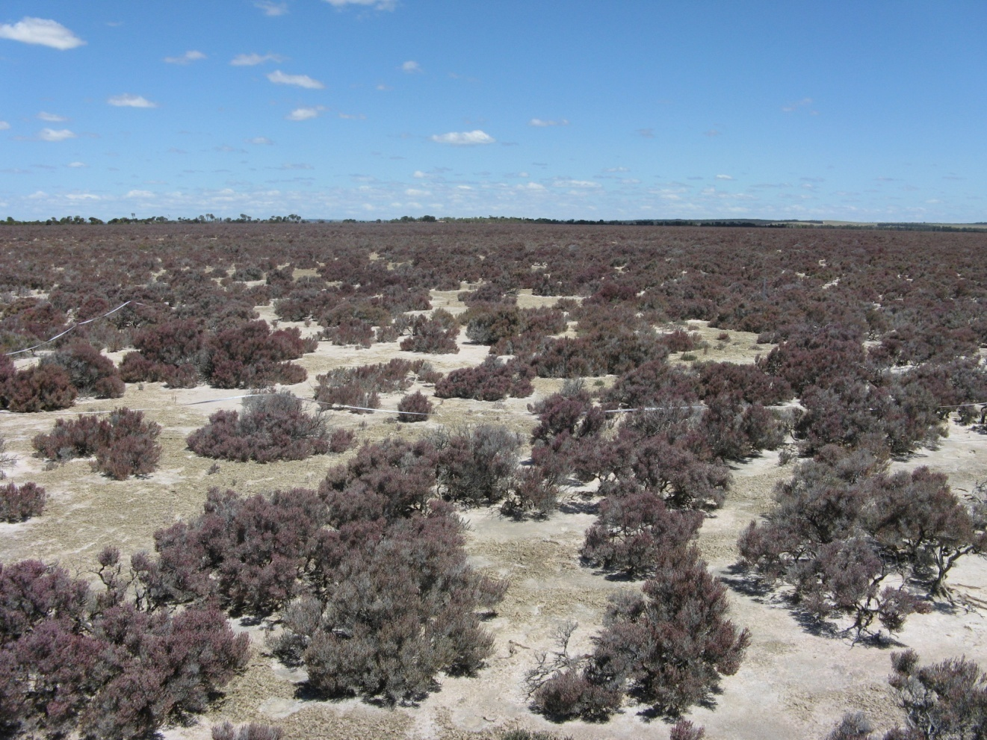
Photograph 48 GYP025
Quadrat GYP026 Date Surveyed: 1/11/2009

Location: Small lake south of Lake Altham

Topography: Dune ~1.0 m. Quadrat down ESE facing slope

Soils: 5-15cm 88% gypsum 50cm 92% gypsum

Quadrat orientation:

Photograph reference and orientation: IMG_1543 NE IMG_1544 NNE

GPS (WGS 84) NW corner 33° 25′ 45.8″ 118° 26′ 07.1″

Diagnosis (Muir 1977): Low Heath D (Clumps of dead grass)

Condition: Excellent to Very Good. Rabbits, some dead plants from a dry season.

Life Form | Species | Height cm | % canopy cover
 | Tecticornia moniliformis | 50 | 15
 | Tecticornia aff. syncarpa | 50 | 5
 | Tecticornia halocnemoides subsp. caudata | 50
 | Atriplex paludosa | 50 | 15
 | Lawrencia squamata | 30 | <1
 | Maireana oppositifolia | 30 | <1
 | Disphyma crassifolium | 10 | <1
 | Erymophyllum tenellum | 8 | <1
 | *Bromus rubens | 5 | <1
 | Austrostipa juncifolia (dead in places) | 50 | 1
 | *Parapholis incurva | 5 | <1
 | *Avena barbata | 25 | <1
 | Adjacent to quadrat
 | Lycium australe | 120
 | Frankenia tetrapetala | 10
 | Frankenia cinerea | 5
 | Maireana erioclada | 20
 | Pittosporum angustifolium | 150

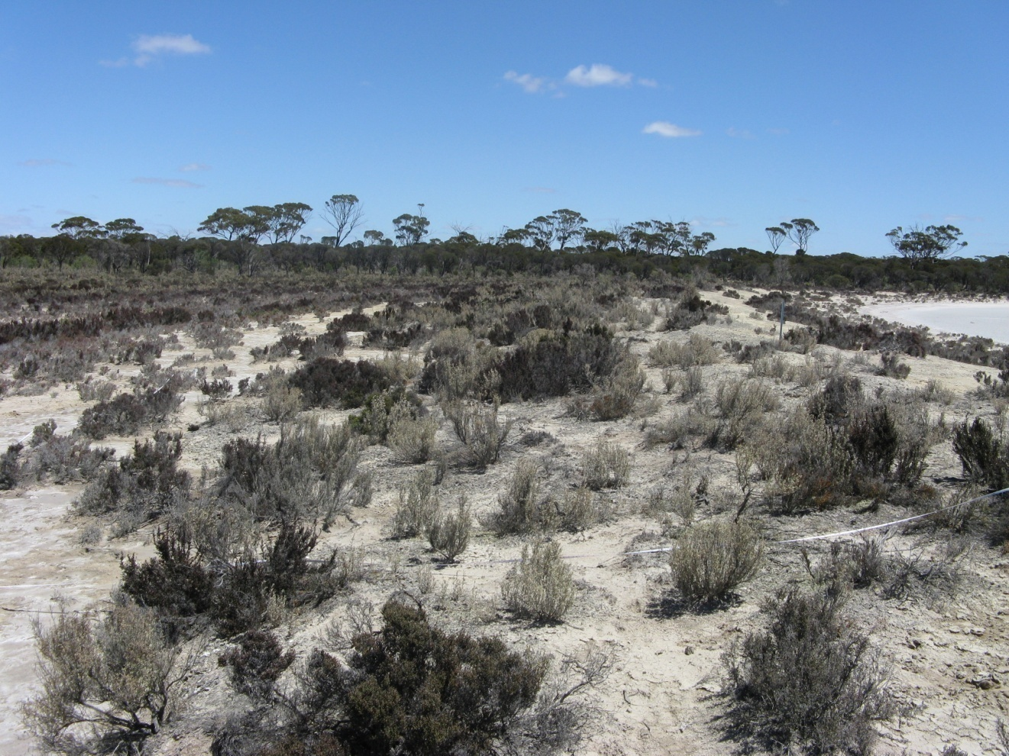
Photograph 49 GYP026
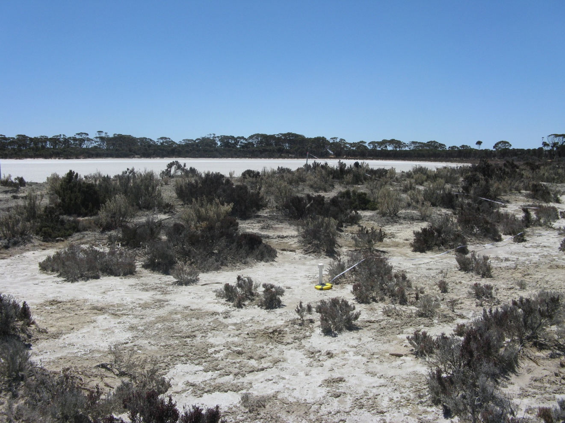
Photograph 50 GYP026
Quadrat GYP027 Date Surveyed: 3-11-2009

Location : Lake Biddy

Topography and Elevation: Large dune. Peg indicating extent of old mining lease in quadrat. 297.9 +/- 5.7 m

Soils: 5-15cm 26% gypsum 50cm 22% gypsum

Quadrat orientation:

Photograph reference and orientation: IMG_1799 IMG_1805

GPS (WGS 84) NW corner 33° 00′ 12.2″ 118° 56′ 32.7″

Diagnosis (Muir 1977): Very Open Shrub Mallee over Scrub over Open Low Scrub B over Dwarf Scrub D. (scattered trees to 7 m)

Condition: Excellent. Rabbits and foxes.

Life Form | Species | Height cm | % canopy cover
Tree | Eucalyptus ?salicola | 700
Shrub | Melaleuca carrii | 150
Shrub | Allocasuarina acutivalvis | 150
Shrub | Leucopogon sp. Kau Rock (M.A. Burgman 1126) | 50
Shrub | Alyxia buxifolia | 40
Shrub | Daviesia benthamii | 80
Shrub | Santalum acuminatum | 40
 | Adjacent to quadrat
Shrub Mallee | Eucalyptus eremophila | 400
Shrub | Callitris preissii | 300
Shrub | Allocasuarina corniculata | 200
Shrub | Scaevola bursariifolia | 30
Shrub | Hakea newbeyana | 150
Shrub | Melaleuca hamata | 150
Shrub | Tecticornia lylei | 50

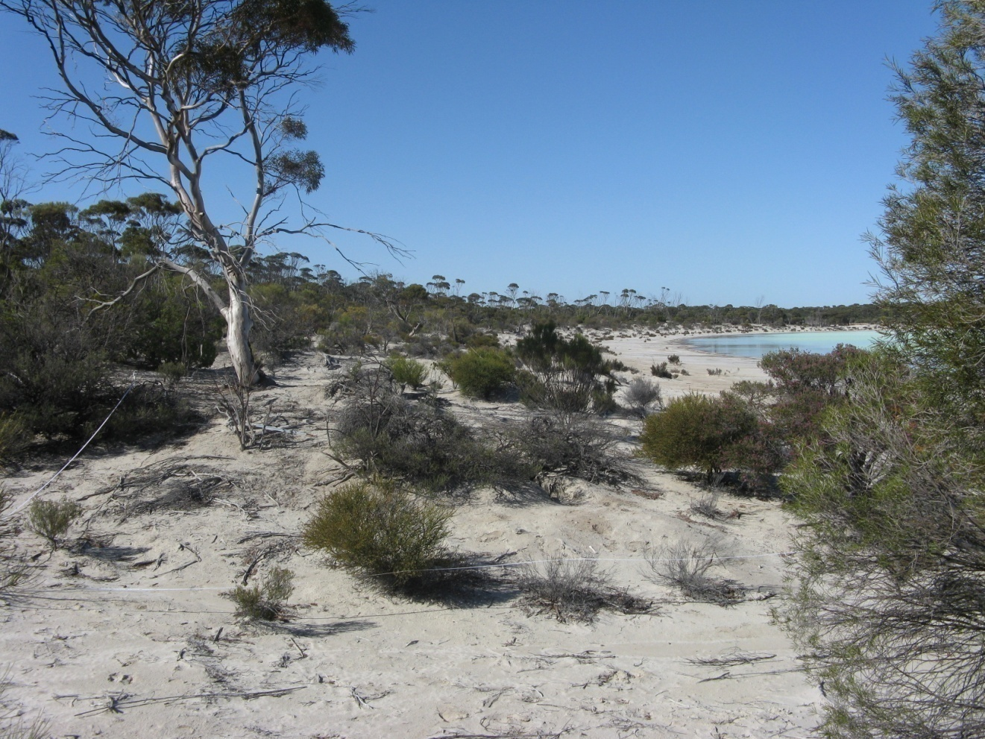
Photograph 51 GYP027
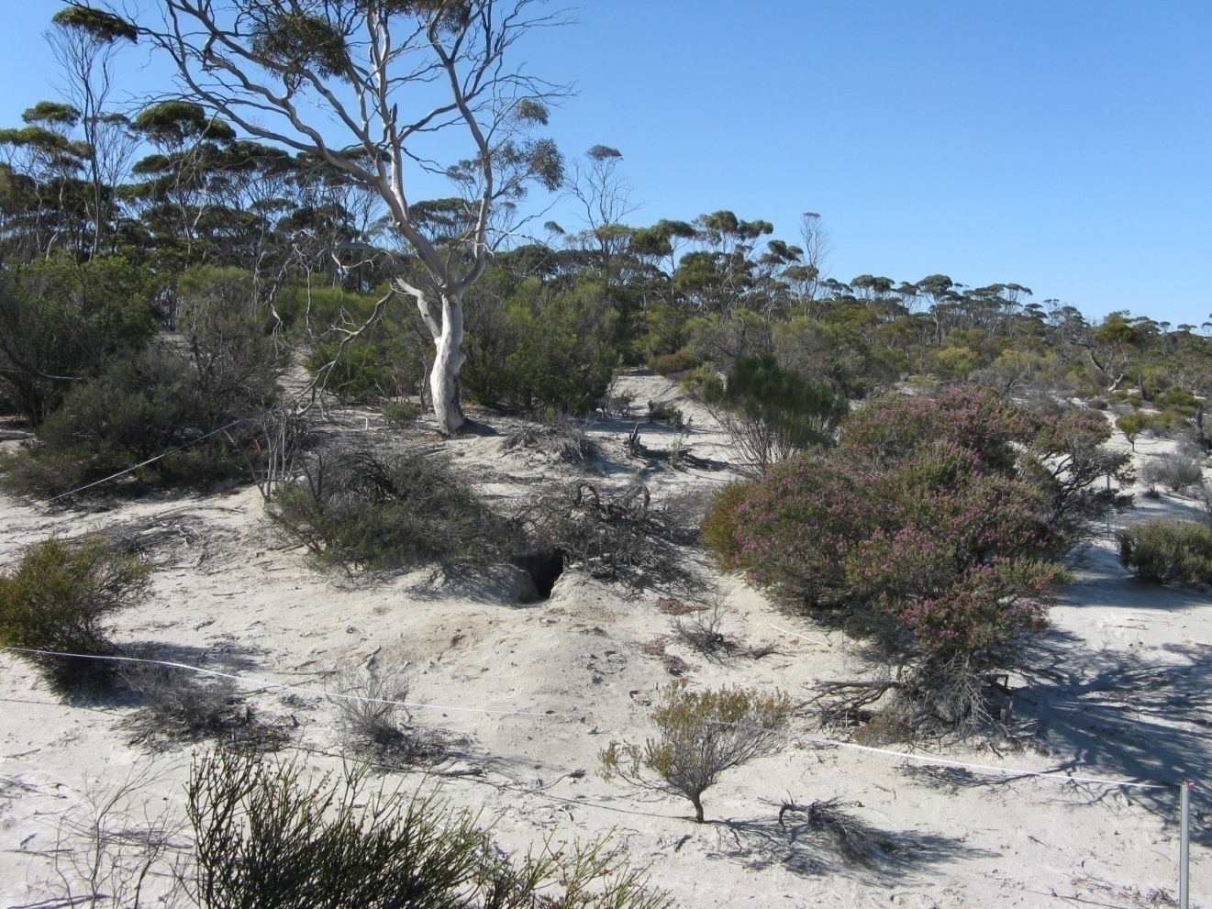
Photograph 52 GYP027

