Project Title: Seeds in airtight storage conditions age faster than seeds in oxygen-abundant conditions for some wild Western Australian species

Author: Rebecca Jonas

Research supervisors: Dr. David Merrit, Dr. Emma Dalziell, Prof. Erik Veneklaas

# Executive summary:

Seed banking is a conservation method used to store seeds long-term for future use in restoration or research. Understanding how long seeds live in storage is crucial for managing diverse collections in seed banks. Comparative longevity is a common method for estimating seed longevity. It involves subjecting seeds to warm and moist conditions to accelerate the ageing process. However, these conditions differ from actual storage conditions used for conservation seed banking. In particular, seeds stored for conservation are sealed within airtight containers (such as laminated foil bags) with limited exposure to oxygen, whereas rapid ageing is commonly conducted in oxygen-abundant containers. My project compared the longevity of seeds using the standard method of rapid ageing with a modified protocol whereby seeds were aged within sealed foil bags to better reflect typical storage conditions. Seeds from thirteen different Western Australian species were examined. Unexpectedly, seeds of many species aged faster within the sealed foil bags compared to those aged in the oxygen-abundant boxes, although this effect varied between species. These results highlight the importance of accurately predicting seed longevity for the management of seed banks.

# Introduction:

Storing seeds in seed banks is a critical part of plant conservation strategies for wild species in Australia. There are around 1750 seed banks globally, storing up to 55 000 taxa (Walters and Pence, 2020). Many seed banks store wild relatives of crop species to use in plant breeding programmes. Others, like Kings Park, store seeds of wild native species, with the goal to use them for research or restoration projects.

Seed banking standards dictate that seeds should be dried to low moisture contents at 5-20°C and 10-25% relative humidity (RH), before being stored in an airtight container at -18°C (FAO, 2014). However, even under these conditions, seeds do not live forever in storage. How long seeds live for in storage is termed seed longevity, and it is usually different for different species, or even different collections of the same species (Nadarajan et al., 2023). Seed longevity is influenced by many factors including the conditions the mother plant is subject to during seed development, seed maturity at harvest time, and post-harvest handling and storage (Hay and Probert, 2013). Understanding this complex trait is very important to effectively manage seed banks with large numbers of diverse collections of seeds (Hay et al., 2022).

The best method currently available to identify longer- or shorter-lived seeds is the comparative longevity protocol, or rapid ageing. Rapid ageing involves subjecting seeds to warm and moist conditions (45°C and 60% RH) to accelerate the ageing process. Seeds are removed from the ageing conditions at intervals, and germination tests are conducted to monitor viability. The seed longevity of different species can be ranked based on metrics such as P50, which is how long seeds take to decline to 50% viability (MSBP, 2022).

Apart from the temperature and humidity, a major difference between storage conditions used for conservation seed banking and the rapid ageing conditions is the oxygen availability. In rapid ageing experiments, seeds are stored in large, sealed boxes with ample air space, and extra oxygen is introduced at frequent intervals when boxes are opened to remove seeds for viability monitoring. In typical seed banking conditions, seeds are stored in sealed foil bags which minimise airspace and oxygen availability, and are not frequently opened.

My project modified the typical comparative longevity protocol to conduct the experiment inside sealed foil bags, instead of large containers, to better reflect real storage conditions in conservation seed banks such as Kings Park. The presence of oxygen is thought to play a major role in seed ageing due to oxidation (Hay and Probert, 2013). Therefore, it was expected that seeds aged in the foil bags (a more ‘closed’ system) would live longer than seeds aged in the large boxes (a more ‘open’ system).

# Materials and methods:

Seeds of thirteen herbaceous Western Australian species were collected from locations in the Pilbara, John Forest National Park, and Kings Park bushlands, within 6 months of experimental work beginning. Initial germination tests were conducted on agar plated with water, gibberellic acid, or karrikinolide, to determine an appropriate germination protocol.

In the ‘open’ rapid ageing system, seeds were first pre-hydrated for two weeks at 47% RH and 20°C for two weeks, and then were then transferred to ageing boxes at 60% RH and 45°C (MSBP, 2022).

In the ‘closed’ system, each seed sample was stored individually inside foil bags. Prior to storage, seed moisture content (MC) was manipulated to ensure seeds were stored at the equivalent of 60% RH to match the open system. Isotherms were constructed at 20°C to determine the MC for each species corresponding to 60% RH at 45°C. Seeds of each species were pre-hydrated for two weeks at the determined RH at 20°C, and then double-sealed inside foil bags and stored inside the incubator at 45°C.

For both systems, one sample of each species were removed on days 2, 5, 9, 19, 30, 40, 51, and 75 for germination testing to assess viability. Seeds were sterilised using bleach and plated onto agar petri dishes containing suitable germination stimulant for each species. Germination was scored for four weeks, and then viability was calculated.

Statistical modelling was used to compare viability decline between the open and the closed system. P50 (time taken for viability to fall to 50%) and P85 (time taken for viability to fall to 85%) were compared between each species.

# Results:

As expected, there was an overall decrease in viability the longer seeds remained in the ageing conditions in both the open and the closed system. Two species were not included in the analysis as they did not decline in viability in either system (*Polycarpaea longiflora* and *Podotheca gnaphalioides*).

Overall, modelling suggested that seeds would be longer-lived in the open system than in the closed system, although the effect varied when looking at species individually. For *Cyperus vaginatus, Pterochaeta paniculata,* *Trachymene coerulea, Waitzia suaveolens*, and *Podolepis aristata,* seeds were longer-lived in the open system than the closed system. For *Actinotus superbus* and *Stylidium affine*, seeds were longer-lived in the closed system than in the open system. (Figure 1).

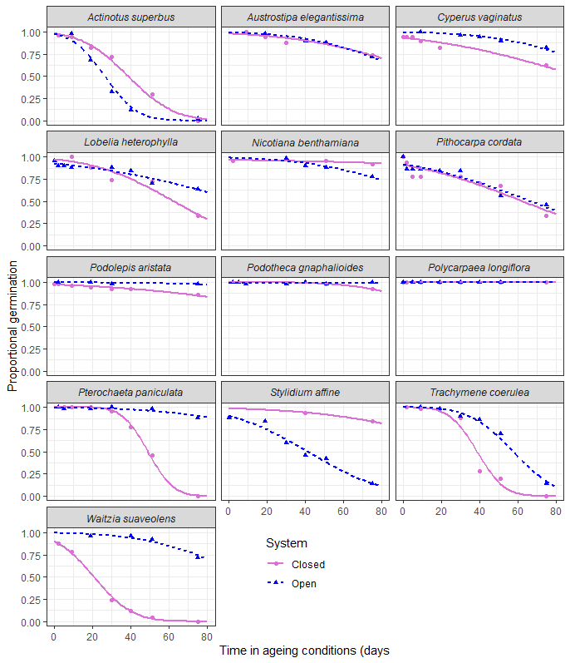

**Figure 1** Seed survival curves for 13 Western Australian plant species stored over non-saturated LiCl solutions (open) or sealed in laminated foil bags (closed), at 45°C and 60% RH.

# Discussion:

My study involved conducting a modified version of the comparative longevity protocol inside airtight sealed foil bags to better reflect the oxygen environment of seeds stored long-term in seed banks (MSBP, 2022). Seeds aged in more open conditions were expected to decline in viability faster than those aged in closed conditions, however this expectation was not met. Overall, more species declined faster in the closed system than the open system, although this effect varied for each species.

Only two species, *Actinotus superbus* and *Stylidium affine*, behaved as expected and aged significantly more quickly in the open system than in the closed system. Five species aged more quickly in the closed system than the open system, contradicting the initial hypothesis. Four species did not show any significant decline in viability within the timeframe of the experiment.

Oxidative stress is thought to be a major mechanism of seed deterioration, and many studies have demonstrated an increase in seed longevity when seeds are stored in low-oxygen conditions (Ellis and Hong, 2007; Schwember and Bradford, 2011). Ellis and Hong (2007) investigated seed longevity between open and closed storage environments in a similar manner to this experiment and found longevity was extended in airtight storage, compared to open storage. However, this was most evident for seeds stored at low RHs. When seeds were stored at higher RHs, similar to those used in my project, there was not a significant difference in longevity between open and closed storage environments. This could indicate that at high storage RHs, such as 60%, the oxygen content of the storage environment may not be expected to influence longevity significantly.

Seed longevity is a complex trait influenced by many interacting mechanisms, so it is difficult to pinpoint the underlying cause in the variation in the species response to the open and closed storage environments (Nadarajan et al., 2023; Fu et al., 2015). Many studies investigating the relationship between seed longevity and oxygen in the storage environment were conducted using crop species (Ellis and Hong, 2007; Schwember and Bradford, 2011; Ibrahim and Roberts, 1983). Wild species can have significantly different seed compositions than cultivated species (Wang et al., 2010; Bell et al., 2012) and different responses between species to the rapid ageing storage environment may be due to differences in seed composition (Hay et al., 2022).

# Conclusion:

Comparative longevity testing, or rapid ageing, is used to inform viability monitoring schedules in long-term seed storage, by estimating whether seeds of different species may be short- or long-lived. It is also useful to determine very short-lived species which should be prioritised for prompt post-harvest processing and storage (Martyn Yenson et al., 2021). Being able to predict longevity more accurately is vital to ensure valuable collections of native species can be effectively managed to ensure availability for important conservation work.

These results suggest the typical comparative longevity method may over-estimate longevity for some wild species. If this is the case, viability monitoring schedules will be mis-informed, and viability testing may not be conducted frequently enough, leading to seed collections with lower viability than anticipated. This may result in the mis-management of potentially important collections of threatened species. Therefore, continuing to refine methods of seed longevity testing, and working to understand the mechanisms of ageing for diverse wild species is important to improve outcomes for conservation seed banking.

Thank you to the Australian Seed Bank Partnership for providing much of the funding that supported the experimental work in my honours project. Despite the many questions raised by the results of my study, valuable information about many Western Australian species was collected. None of these species had undergone comparative longevity testing previously, therefore these results will be used to inform viability testing schedules for these species stored within the Kings Park seed bank. Complete isotherms were also successfully constructed for ten of the species, which will be very useful information for future research involving these species.

# References

**Bell, L. W., Ryan, M. H., Bennett, R. G., Collins, M. T., and Clarke, H. J.** (2012). Growth, yield and seed composition of native Australian legumes with potential as grain crops*. Journal of the Science of Food and Agriculture.* **92**(7), 1354–1361.

**Ellis, R. H., and Hong, T. D.** (2007). Seed longevity – moisture content relationships in hermetic and open storage. *Seed Science and Technology*. **35**(2), 423–431.

**Food and Agriculture Organisation of the United Nations (FAO)** (2014*). Genebank standards for plant genetic resources for food and agriculture.* Red. ed. Rome.

**Fu, Y.-B., Ahmed, Z., and Diederichsen, A.** (2015). Towards a better monitoring of seed ageing under ex situ seed conservation. *Conservation Physiology*. **3**(1), cov026–cov026.

**Hay, F. R., and Probert, R. J.** (2013). Advances in seed conservation of wild plant species: a review of recent research. *Conservation Physiology*. **1**(1), cot030–cot030.

**Hay, F. R., and Probert, R. J.** (2013). Advances in seed conservation of wild plant species: a review of recent research. *Conservation Physiology*. **1**(1), cot030–cot030.

**Hay, F. R., Davies, R. M., Dickie, J. B., Merritt, D. J., and Wolkis, D. M**. (2022). More on seed longevity phenotyping. *Seed Science Research*. **32**(3), 144–149.

**Ibrahim, A. E., and Roberts, E. H.** (1983). Viability of lettuce seeds: I. Survival in hermetic storage. *Journal of Experimental Botany*. **34**(5), 620–630.

**Martyn Yenson, A. J., Offord, C. A., Meagher, P. F., Auld, T., Bush, D., Coate,s D. J., Commander, L. E., Guja, L. K., Norton, S. L., Makinson, R. O., Stanle,y R., Walsh, N., Wrigley, D., and Broadhurst, L.** (2021). *Plant Germplasm Conservation in Australia: strategies and guidelines for developing, managing and utilising ex situ collections. Third edition.* Australian Network for Plant Conservation, Canberra.

**Millennium Seed Bank Partnership.** (2022). Protocol for comparative seed longevity testing. Royal Botanic Gardens, Kew.

**Nadarajan, J., Walters, C., Pritchard, H. W., Ballesteros, D., and Colville, L.** (2023). Seed Longevity-The Evolution of Knowledge and a Conceptual Framework. *Plants (Basel)*. **12**(3), 471–.

**Schwember, A. R., and Bradford, K. J.** (2011). Oxygen interacts with priming, moisture content and temperature to affect the longevity of lettuce and onion seeds. *Seed Science Research*. **21**(3), 175–185.

**Walters, C., and Pence, V. C.** (2021). The unique role of seed banking and cryobiotechnologies in plant conservation. *Plants, People, Planet*. **3**(1), 83–91.

**Wang, M. L., Barkley, N. A., Chinnan, M., Stalker, H. T., and Pittman, R. N.** (2010). Oil content and fatty acid composition variability in wild peanut species. *Plant Genetic Resources: Characterization and Utilization.* **8**(3), 232–234.

**Western Australian Herbarium.** (2023). Florabase—the Western Australian Flora. Department of Biodiversity, Conservation and Attractions. https://florabase.dbca.wa.gov.au/ (Accessed 6 September 2023).

# Appendix

Table 1: Taxa supported by the project.

|  |  |  |  |
| --- | --- | --- | --- |
| Family | Species | Region | How it was supported by the research |
| Apiaceae | *Actinotus superbus* | SWWA | Complete isotherm constructed, germination stimulant data, longevity estimation from rapid ageing data |
| Asteraceae | *Waitzia suaveolens* | SWWA | Partial isotherm constructed, germination stimulant data, longevity estimation from rapid ageing data |
| Asteraceae | *Podotheca gnaphalioides* | SWWA | Complete isotherm constructed, germination stimulant data |
| Asteraceae | *Podolepis aristata* | SWWA | Complete isotherm constructed, germination stimulant data, longevity estimation from rapid ageing data |
| Asteraceae | *Pterochaeta paniculata* | SWWA | Complete isotherm constructed, germination stimulant data, longevity estimation from rapid ageing data |
| Stylidiaceae | *Stylidium affine* | SWWA | Complete isotherm constructed, germination stimulant data, longevity estimation from rapid ageing data |
| Poaceae | *Austrostipa elegantissima* | SWWA | Complete isotherm constructed, germination stimulant data, longevity estimation from rapid ageing data |
| Araliaceae | *Trachymene coerulea* | SWWA | Complete isotherm constructed, germination stimulant data, longevity estimation from rapid ageing data |
| Asteraceae | *Pithocarpa cordata* | SWWA | Complete isotherm constructed, germination stimulant data, longevity estimation from rapid ageing data |
| Campanulaceae | *Lobelia heterophylla* | Pilbara | Partial isotherm constructed, germination stimulant data, longevity estimation from rapid ageing data |
| Caryophyllaceae | *Polycarpaea longiflora* | Pilbara | Partial isotherm constructed, germination stimulant data |
| Cyperaceae | *Cyperus vaginatus* | Pilbara | Complete isotherm constructed, germination stimulant data, longevity estimation from rapid ageing data |
| Solanaceae | *Nicotiana benthamiana* | Pilbara | Complete isotherm constructed, germination stimulant data, longevity estimation from rapid ageing data |